CenturyLINK EASE VFO

LSR User Guide

Version – Revision History

All versions of this document are listed in chronological order:

LSOG Version | Date | Description
LSOG2Q19 v1.0 | 03/18/20 | DRAFT
LSOG2Q19 v1.0 | 05/15/20 | FINAL
LSOG2Q19 v1.1 | 06/19/20 | Revision for Address Preorder by WTN
LSOG2Q19 v1.2 | 07/17/20 | Revision for Address Preorder by WTN
LSOG2Q19 v1.3 | 09/01/20 | Revision for Facility Availability
LSOG2Q19 v1.4 | 09/17/20 | Revisions to Feature/Service Availability  Revisions to Appointment Scheduling  Revisions to Telephone Number Listings
LSOG2Q19 v1.5 | 11/12/2020 | Revisions to Feature/Service Availability
LSOG2Q19 v1.6 | 11/12/2020 | Revisions to Appointment Scheduling
LSOG2Q19 v1.7 | 02/19/21 | Revision to Customer Service Inquiry
LSOG2Q19 v1.8 | 04/15/21 | Revision to Whom to Call and When

This document has been through a formal review process. To the best of our knowledge, it is accurate. There may be further modifications and we reserve the right to make those modifications. The content of the document may change after issuance.

Table of Contents

Documentation Overview 8
Whom to Call and When 8
CenturyLink IT Wholesale Systems Help Desk Roles and Responsibilities 9
Limitations for CenturyLink LSR Support 9
Hours of Availability for EASE 9
Change Management Process 9
Service Level Agreements 10
EASE Ordering Systems Information Guide 11
Record Retention Policy 11
Browser Guidelines 11
Password Rules 12
Methods for submitting an LSR 12
EASE VFO (Virtual Front Office) 12
EASE VFO Standards 13
EASE UOM Ordering Interface 13
Implementing UOM Pre-Order, UOM Ordering, and/or EASE VFO 14
Historical Information 14
EASE VFO LSR Overview 15
Navigating in EASE 15
EASE Local 16
EASE Login Instructions 18
EASE Home Page ICONs 21
Managing the User Profile 22
Modifying the User Profile Information 22
Filtering Information for the Order List 23
EASE Home Page Tabs 24
Order Status 25
Order Status ICONs 26
ORDER Tab 27
New 27
Search 27
Available Search Options 28
Using the Search Function 28
No Records Found 29
Save As Order 29
Save As Order from the Main Order Menu 30
Using the Save As Order within an active Order 31
Reassign Order 34
External APP Data Overview 34
TN Assignment 35
Available Services 36
COLES look up 37
Archival GUI 38
Available Pics 41
Existing Services 42
LSR ORCH Notes 43
View Directory Name 43
Summary Report 44
PREORDER Tab 46
To start a Pre-order inquiry 46
Viewing the Saved Pre-orders 47
Searching for a Saved Pre-order 49
Address Validation Inquiry 51
Starting the Address Validation Inquiry 51
Viewing the results from an address validation inquiry 56
Telephone Number Inquiry 59
Starting the Telephone Number Inquiry 59
Viewing the results from the Telephone Number Inquiry Screen 62
Feature / Service Availability 65
Starting the Address Validation Inquiry - 65
Viewing the Results from the Feature / Service Availability Screen 67
Appointment Scheduling 68
Starting the Address Validation Inquiry - 68
Viewing results from the Appointment Scheduling Screen 71
Reserving an Appointment 72
Customer Service Information 74
Starting the Customer Service Information inquiry 74
Viewing results from the Customer Service Information Screen 76
Loop Qualification 78
Starting the Address Validation Inquiry 78
Viewing results from the Loop Qualification Screen 80
Validate CFA 82
Starting the Validate CFA Inquiry 82
Viewing results from the Validate CFA Screen 84
Facility Availability 85
Starting the Address Validation Inquiry - 85
Viewing results from the Facility Availability Screen 87
Raw Loop Data 89
Starting the Raw Loop Data Inquiry - 89
Viewing the results from the Raw Loop Data Screen 90
Listing for Telephone Number 93
Starting the Listing for Telephone Number Inquiry 93
Viewing results from the Telephone Number Listings Screen 95
Meet Point Query 98
Starting the Meet Point Query 98
Viewing the results from the Meet Point Inquiry Screen 99
View DLR 101
Starting the View DLR Inquiry 101
Viewing the results from View DLR 103
TEMPLATE Tab 106
Creating a NEW Template 107
Using SEARCH in the Template Tab 109
Viewing the Template List 110
Selecting a Template 110
Deleting a Template 111
Creating an Order in EASE VFO 112
EASE Helpdesk contact information 112
Additional Resources 112
Navigating the Order Screen 115
ORDER Tab 116
PREORDER Tab 119
Order ICONs 119
Order Header Information 120
Associated LSR forms 121
Navigating within the Created Order 122
Entering the field data 122
Viewing the Field Help Text 122
Hyperlinking to Pre-order Capability 123
Adding a new section in EASE 123
Copying a new section in EASE 124
Deleting section(s) in EASE 125
Validating the order 126
Viewing the order errors 128
Resolving the errors 128
Validate within the order 129
Search Pre-Order 130
Submitting the Order 131
Appendix 1 - Order Status 132
Appendix 2 - Order Types 141
Appendix 3 – EASE UOM Implementation Guidelines 143
Initial Communication 143
Project Plan Development / Negotiation 143
Project Plan Development / Negotiation Activities 143
Requirements Review 144
Requirements Review Activities 144
Establishing Connectivity Testing Activities for EASE VFO 145
Implementation/Industry Upgrade Testing Process 146
Implementation/Industry Upgrade Testing Activities 146
Test Plan 147
Test Case Review 148
Deployment Planning 148
Detailed Project Plan 148
Backout Plan 149
Implement Window 149
Shakeout Testing 149
Shakeout Testing Data 149
Escalation 149
Code Lock 149
GO/NO GO 149
Deployment Execution 149
Post Implementation Review 150

Documentation Overview

Overview | This User guide provides additional information on the implementation process, business and configuration parameters, and provides the user with instruction for using the EASE system to preform Pre-Order Activities as well as create, modify, cancel, and submit Local Service Requests (LSRs). This guide is meant for a generic order representation only.  The EASE ordering process follows the Locals Service Request Ordering Guidelines (LSOG) located at http://www.atis.org . The Customer is responsible for obtaining permissions and rights to the ATIS documentation. The LSOG and custom business rules should be referenced for specific guidelines in the population of fields for specific order submission.  The content of the document may change after issuance. To notify CLECs/IXCs of any changes to EASE, CenturyLink will issue an Addendum to the document. The Addendum will be placed on the CenturyLink website and a Release Notification will be distributed to the CLECs/IXCs. Additionally, the Order Technical Specifications Document will be updated as required to correct for documentation and/or system bugs. Information specific to each LSOG Industry Upgrade is made available to the CLEC/IXC/WSP based on CMP guidelines and summarized in the schedule in  Table 1.

PUBLICATION | SCHEDULED DELIVERY
Draft Order/Pre-Order Technical Specifications | 73 days before Industry Upgrade Date
Draft EASE LSR Technical Specifications | 73 days before Industry Upgrade Date
Final Order/Pre-Order Technical Specifications | 45 days before Industry Upgrade Date
Final EASE LSR Technical Specifications | 45 days before Industry Upgrade Date
Table 1

Whom to Call and When | If you need an account created or changes to your CCNA permissions or personal information (name, email address, etc.), contact your EASE system administrator at Helpdesk.EASE@CenturyLink.com. For LSR Ordering Systems Information, go to http://ease.centurylink.com/. Requirement updates and additional questions and answers can be found at the CenturyLink LSR Ordering Systems web site at http://ease.centurylink.com/.  For all other problems, call the Wholesale Systems Help Desk:  1-888-796-9102, option 3 for LSR  Monday-Friday 6:00 a.m. to 5:30 p.m. (M Mountain Time)  Saturday 7:00 a.m. to 2:00 p.m. (Mountain Time)

CenturyLink IT Wholesale Systems Help Desk Roles and Responsibilities | CenturyLink IT Wholesale Systems Help Desk (WSHD) personnel will provide information and resolution for EASE Pre-order transaction processing problems that are caused by failure of CenturyLink environment hardware or software components. This resolution may be in the form of direct action or through escalation to the appropriate individuals within CenturyLink.  If the WSHD cannot resolve the issue during the initial phone call, they will escalate to Tier 2 Production Support. The Tier 2 Support Team will then resolve and close the issue directly with the person that reported the issue.

Limitations for CenturyLink LSR Support | The CenturyLink IT Wholesale Help Desk is not designed to provide assistance with transaction failure caused wholly or in part by failure of any component of the CLEC/IXC/WSP LSR processing environment.  Questions regarding Order content, Order writing procedures or transaction status should be referred to the CLEC CenturyLink Service Manager or refer to the Industry LSOG documents.

Hours of Availability for EASE | The hours of availability can be found at: http://www.centurylink.com/wholesale/cmp/ossHours.html

Change Management Process | CenturyLink facilitates a regularly scheduled forum in which CenturyLink and the CLECs/IXCs communicate about Operational Support System (OSS) interface changes, release lifecycles, release notifications, and communication intervals. The CenturyLink CLEC/IXC/WSP Industry change management forum is referred to as the Change Management Process (CMP).  CenturyLink encourages CLECs implementing EASE to participate in the CMP process. Online registration can be found on the CMP website page. Release notifications, team meeting information, and change requests are also provided to all registered team members via e-mail. For further CMP information, please refer to the following website: http://www.centurylink.com/wholesale/cmp/index.html  During testing with CLECs/IXCs, situations may occur that require CenturyLink to submit a Change Request internal to CenturyLink to fix an issue in CenturyLink's Test systems. When an issue is discovered that substantially impacts a CLEC'/IXC’s ability to send an LSR transaction, notification will be distributed via e-mail within three (3) business-days. Notification of any production issues will follow the CMP guidelines section 2.0. Please refer to the following URL for more information: http://www.centurylink.com/wholesale/cmp/whatiscmp.html CenturyLink will notify all CLECs/IXCs that have subscribed to the unplanned event notifications and Test environment notifications. It is the CLEC/IXC/WSP’s responsibility to subscribe to those notifications they wish to receive. The notification will include a description of the problem and, if known, a potential fix date. If a fix date is not known, CenturyLink will update all impacted CLECs/IXCs with the fix date when known.

Service Level Agreements | Outside of the CenturyLink Interconnect Agreement, CenturyLink does not maintain separate service level agreements with CLECs, nor will CenturyLink have a service level agreement with any Service Bureau directly. However, a CLEC may have specific contractual date and time frames for service delivery stated in their Interconnection Agreement with CenturyLink. In this situation, those contractual date and time frames for service extend to the Service Bureau, who is acting as an Agent for the CLEC.

EASE Ordering Systems Information Guide

Overview | CenturyLink ordering systems is based on guidelines maintained by the American Telecommunication Industry Standards (ATIS) Ordering and Billing Forum (OBF). CenturyLink utilizes information within the Local Service Order Guidelines (LSOG) to determine industry and custom requirements for all access orders. Additional information regarding ATIS can be found at: http://www.atis.org .  CenturyLink follows the Local Service Ordering Guidelines (LSOG) for ordering. These guidelines define order attributes as well as the published implementation date for implementation of the industry standards. In addition to the Summary of Changes that outlines the industry changes, CenturyLink will also provide all company specific differences and custom rules. The CenturyLink schema, including all customizations supported by CenturyLink can be found online at the EASE website: EASE > Guide > LSR > CenturyLink 2Q19 or access thru the URL: https://ease.centurylink.com/guide_lsog_2q19_help.shtml.  The CenturyLink Business Rules Differences List is comprised of the differences in CenturyLink’s implementation to the industry guidelines.

Record Retention Policy | LSRs that have been submitted to CenturyLink and accepted will be retained in the database for a period of 2 years. CenturyLink will perform a purge of these records twice annually in January and July. The purge date will be based on the date of the last activity transmitted on the LSR. For example, if the date the C/NR form for completion or cancellation of the LSR is November 2015, the deletion of this record would occur in January 2018 and once purged will no longer be accessible to you.  Requests that have been created but not submitted to CenturyLink will not be purged from the database regardless of the date created. However, unsubmitted LSRs that have not been modified for more than 2 years whose "Last Edited User" is no longer a valid user in the system may be purged at CenturyLink's discretion.

Browser Guidelines | Your browser may ask whether you want passwords and information you type to be saved for future use. If you see a message asking you to save your password or other information, do not do so. Saving your password may create security problems. Saving other information may not work as intended within the system.

Password Rules | Customer users can change their own passwords using the following rules:  Passwords chosen must:  - Be at least 8 characters in length but not more than 16 characters  - Contain at least one character from any three of the following four categories  - Uppercase alphabets (A-Z)  - Lowercase alphabets (a-z)  - Numbers (0-9)  - Special characters (~ ` ! @ # $ % ^ & * ( ) - _ = + { } [ ] \ | ; : ‘ “ , . < > / ?)  Passwords chosen must not:  - Contain a space  - Be “password” itself  - Be the same as the login user name  Be the same as the old password that is being changed

Methods for submitting an LSR | The CenturyLink EASE LSR ordering system currently supports 3 methods of order submission: Paper, EASE VFO (Virtual Front Office), EASE UOM Ordering Interface.  Please note: All paper orders received by CenturyLink will be entered into VFO.

EASE VFO (Virtual Front Office) | - The Electronic Administration & Service Exchange Virtual Front Office (EASE VFO) is the on-line GUI application for the EASE LSR.  - VFO will support Internet Explorer version 11 and Google Chrome. Users will receive the following prompt when trying to use any other version:  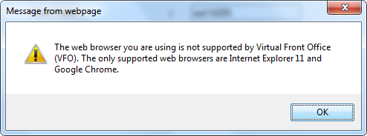  - EASE VFO is an online application GUI that provides Wholesale customers the ability to submit LSR order and pre-order transactions to CenturyLink over the internet. Because this is a GUI application, form and field edits are performed upfront giving the user an opportunity to correct any errors before the transaction is submitted. Responses are returned to the customer’s GUI in real time.  - Because this is a web services interface, there are no dedicated circuit requirements for access. The CLEC/IXC/WSP must have internal policies and processes in place to support sending and receiving pre-order transactions over the public internet. Because this is a web services interface, there are no dedicated circuit requirements for access. The CLEC/IXC/WSP must have internal policies and processes in place to support sending and receiving pre-order transactions over the public internet.  - Information obtaining access to EASE VFO can be found on the CenturyLink Wholesale Business website at http://www.centurylink.com/wholesale/systems/ossconsolid.html.  - Internal CenturyLink employees will have access to VFO for order submission and tracking.  Orders submitted to CenturyLink can be tracked in VFO.

EASE VFO Standards | Following are standard guidelines to follow when working in EASE VFO  - UPPERCASE must be used when creating orders. Failure to use UPPERCASE may cause issues with an order not routing properly, or not routing at all.  - A user can edit all fields unless they are grayed out. Fields that are systematically populated cannot be edited.  - Avoid copying/pasting text from other applications (Word, Excel, PDF, and so on) into fields. Doing so may introduce "garbage characters" (carriage returns, tabs, line feeds, unsupported non-ASCII characters, and so on) that cannot be interpreted or translated properly when the data is transferred. Once a situation like this occurs, the only workaround is to perform a copy-to-new function and fix the offending field prior to requesting a validation, which forces the user to submit the LSR under a different PON. The workaround is cumbersome, and data could be unrecoverable if the situation occurs on a SUP.

EASE UOM Ordering Interface | - The UOM XML is developed according to industry guidelines provided by OBF. The UOM XML Interface is based on Telecommunications XML standards found in the UOM (Unified Order Model) document.  - Access to the EASE UOM XML functions will be over the public internet. XML Pre-Order uses a web services interface using http basic authentication with user name and password provided by CenturyLink. Specifics associated with the web service will be provided by CenturyLink as part of the implementation prior to connectivity testing.  - The CenturyLink UOM Schemas for LSR can be found at https://ease.centurylink.com/

Implementing UOM Pre-Order, UOM Ordering, and/or EASE VFO | When you are ready to process orders within the CenturyLink regions, your CenturyLink Service Manager would be happy to refer your company to the appropriate CenturyLink LSR implementation project manager on your behalf to begin the LSR Implementation Process. If a Third-Party Software Vendor or Service Bureau is involved in the testing, they can also be a part of the kick-off meeting.  After initial contact with the service manager, each CLEC/IXC/WSP will be provided with a CenturyLink Implementation Project Manager. The Implementation Project Manager will work with the CLEC/IXC/WSP throughout the implementation and will fill the following roles:  - Project Manager (PM): Responsible for facilitating meetings, coordinating the overall project plan, and is the primary point of contact for CLEC/IXC/WSP during the entire implementation process.  - Business Analyst (BA): Responsible for providing assistance with the business rules that govern the LSR process and are enforced by the EASE Gateways

Historical Information | All historical documentation regarding ordering can be found at: http://www.centurylink.com/wholesale/systems/ossconsolid.html

EASE VFO LSR Overview | CenturyLink’s EASE LSR ordering system currently supports the following industry defined functionality:  Pre-Order Functions  - Address Validation  - Telephone Number Inquiry  - Feature/Service Availability  - Appointment Scheduling  - Customer Service Information  - Loop Qualification  - Validate CFA  - Facility Availability  - Raw Loop Data  - Listings for Telephone Number  - Meet Point Query  - View DLR  Order Functions  - CenturyLink supports all ATIS/OBF-LSO ordering guidelines for the products and services outlined in the various CenturyLink tariffs and product description documents.  - Summary Report  - Provider initiated Order Responses such as:  - Clarification/Notification Requests  - Completion Notification  - Design Layout Record  - Firm Order Confirmation  - Jeopardy Notification  CenturyLink also supports additional custom EASE functionality thru a custom tab entitled External App Data:  - TN Assignment  - Available Services  - COLES Look up  - Available Pics  - Existing Service  - ArchivalGUI  - LSRORCHNotes  - View Directory Name

Navigating in EASE | To navigate in EASE, use the top row of buttons and the system tabs:

Click this button / tab... | To do this...
Home | Return to the Order List page
About | Open a pop-up window that lists login name of current user, current user’s full name, date and time the current version of the application was installed, VFO copyright information
Logout | Logout of VFO and return to the login page
Order | Access functionality to create or search for an order
PreOrder | Initiate, search, and / or submit pre-order transactions
Template | Access functionality to create or search for a template
Administration | Access User Profiles and other security related information. This tab will only be visible if you have sufficient permissions

EASE Local | EASE is accessed via the following URL: http://ease.centurylink.com

TAB | Explanation
Home | The home page of EASE will present with several tabs: Home, VFO, Guide, Schedules, Contact Us, as well as a hyperlink to the Address Validation Utility Tool.  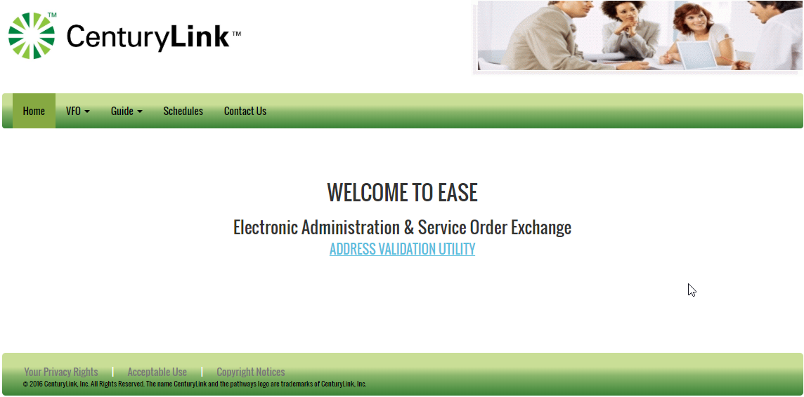
VFO | The VFO - LSR dropdown provides access to the Virtual Front Office (Local Service Request ) and the Reference Table Read Only (Local Service Request).  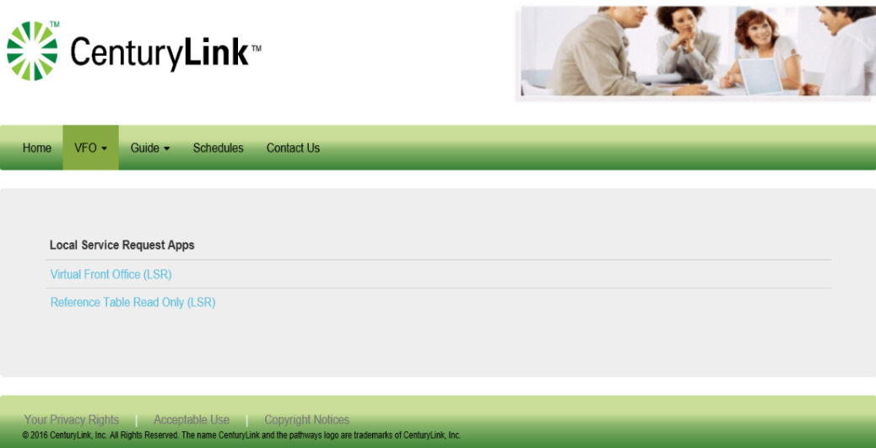
Guide | The Guide dropdown provides access to guides for LSR and LSR. For the purpose of this document, only the LSR portion is discussed. By Selecting the LSR option, a user will have the ability to view several guides housed in EASE.  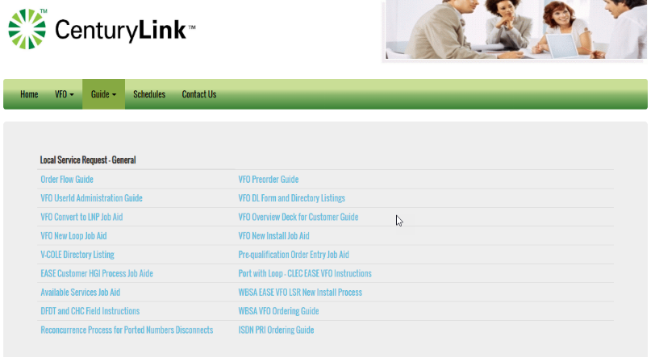  The most current Industry Guideline supported will be available thru several helpful links as shown below.  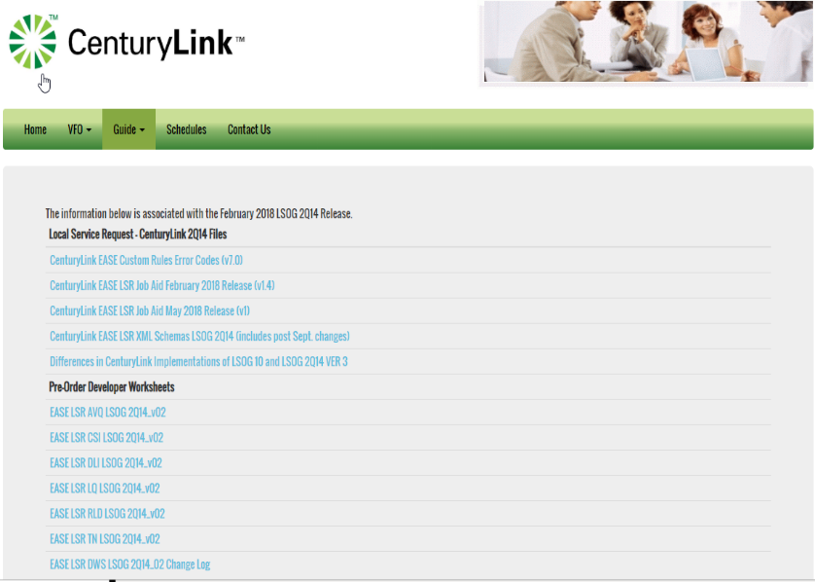
Schedules | The Schedules dropdown provides additional information regarding any upcoming changes.  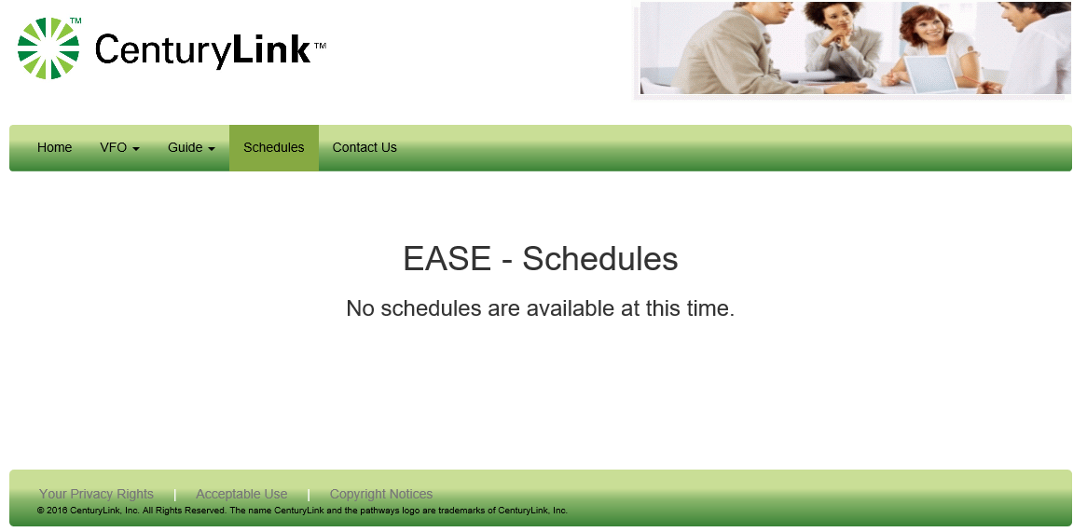
Contact Us | Contact Us provides additional contact information for EASE support as well as ordering and provisioning questions.  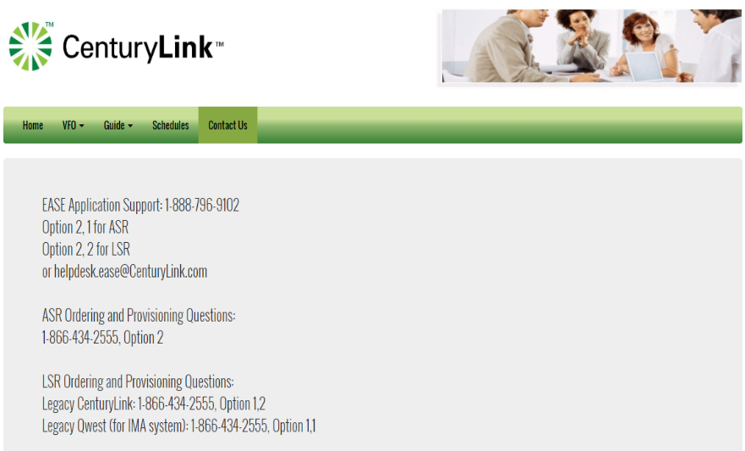

EASE Login Instructions | To Login to the EASE VFO application, please use the following steps:
  STEP | Action
  1 | EASE is accessed via the following URL: http://EASE.centurylink.com  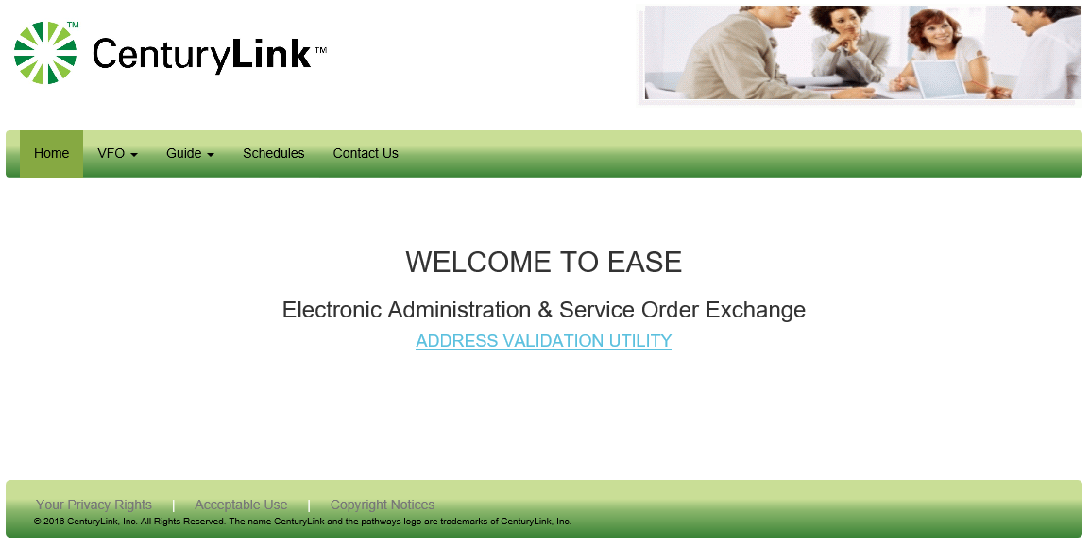
  2 | Select LSR from the VFO drop-down menu  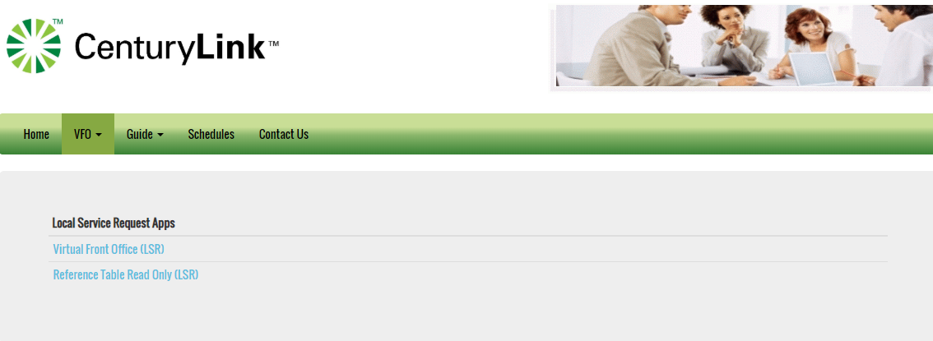
  3 | Select Virtual Front Office (LSR) from the Access Service Request Apps  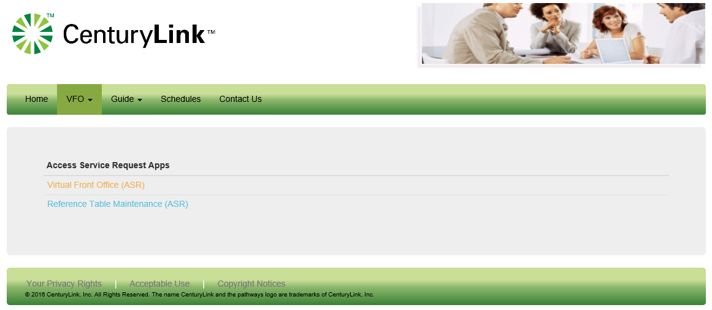
  4 | EASE VFO users are required to login with established credentials.  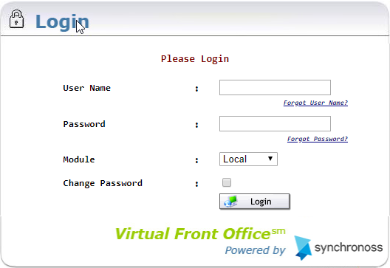  You will be required to enter:  - User Name  - Password  - Select ‘Local” from the Module drop-down  - Click on the login button
  5 | Upon successful login, the user will be taken to the EASE homepage. External customers will only be able to view/access information associated to their specific customer ESP.  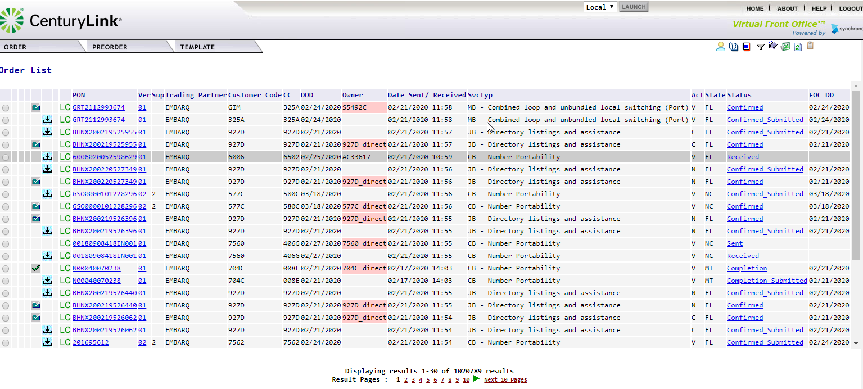

EASE Home Page ICONs | The upper right-hand corner of the VFO Home Page has 6 action icons to select.

ICON | DEFINITION
 | User Profile – provide a link to the User Profile details. Users can use this link to reset their profile email, password and security questions.
  History | Provides a detailed history of an order, including Errored, Confirmed, Clarification, Jeopardy, DLR/Design, Completed, etc.
Create Response | Allows user to create a manual response such as a Jeopardy or Clarification for a selected order
Filter | Provides a way to filter orders from the order list. Clicking this ICON prompts another screen to open and requires the user to filter the criteria. Once filtered, user must clear the filter to return the order list to default view.
Return to Default Sort | Allows user to return the order list to the default sort order
Export to Excel | Exports an order selected from the Order List into an excel document
Refresh | Refreshes the Order List to show the latest order activities including new orders and updates to existing orders. This is NOT used to clear a filter or a sort, but only to update the Order List

Managing the User Profile | Users will have the ability to modify some attributes on their EASE user profile such as Password, Confirm Password, Email Address and Security Questions/Security Answers.  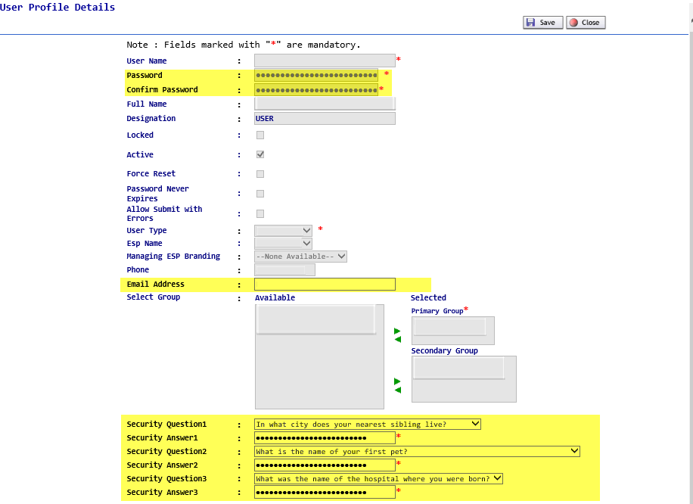

Modifying the User Profile Information | To modify the User Profile Information:
  Step | Action
  1 | Click on the User Profile ICON from the EASE Main Menu to access the User Profile Information.
  2 | Users can alter the following information:  - Password  - Confirm Password  - Email Address  - Security Questions/Answers
  3 | When finished, click on  Save to keep the modified information  Close to exit the User Profile without any modification.

Filtering Information for the Order List | EASE VFO has the ability to filter the Order List information. This allows users the ability to view a subset of information within their ESP. Users can determine the information to be returned on the order list thru the various fields.  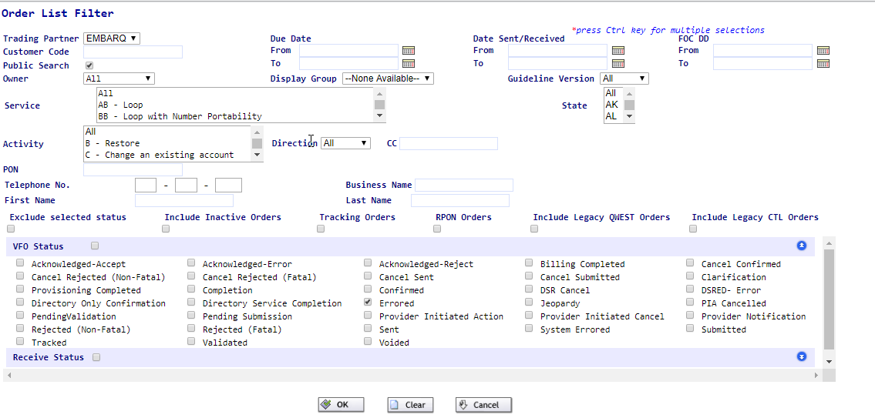  To use the Filter option,
  Step | Action
  1 | To bring up the Order List Filter, click on the filter icon.
  2 | Select the filter options by entering the fields or using the drop-down menus to show the options. Within the drop-down menu, users can select more than one option by holding down the CTRL key while selecting multiple options.
  3a | When the filter criteria has been determined, click on the OK key to start the filter option.  
  4 | The filter screen will be closed. All orders meeting the filter criteria within EASE will be displayed on the Order List Screen.
  4b | To clear the criteria selected, click on the Clear key
  4c | To cancel the filter option, click on the Cancel key. The user will be returned to the Order List screen.

EASE Home Page Tabs | The top menu bar offers three options: Order, Pre-Order, and Template. Each of these tabs contain drop down menus. The user can return to this screen at any time by clicking the Home link in the top right of the screen.

Order | New – Initiate a new order
Order | Search – Search existing orders
Order | Save as Order – Replicate an existing order
Order | Save As Template – Create a template from an existing order
Order | View History – View the history of an existing order
Order | Create Response - Create a manual response for a selected order
Order | Reassign Order – Reassign an order to someone else
Order | External App Data – CenturyLink specific enhanced system functionality  - TN Assignment  - Available Services  - COLES Look up  - Available Pics  - Existing Service  - Archival GUI  - ORCH Notes  - View Directory Name
Order | Summary Report
PreOrder | Ability to initiate NEW inquiries for the following TX Types:
  Selection | Meaning
  A | Address Validation
  B | Telephone Number Inquiry
  C | Feature/Service Availability
  D | Appointment Scheduler
  E | Customer Service Information
  H | Loop Qualification
  K | Validate CFA
  O | Facility Availability
  R | Raw Loop Data
  T | Listings for Telephone Number
  W | MeetPoint Query
  X | View DLR
PreOrder | Search – Search for a preorder that was previously saved.
Template | New – Create an order template
Template | Search – Search for an existing order template

Order Status | The Status column in EASE VFO displays the most current status of orders in the Order List. These statuses also show when viewing the history of an order. Appendix 1 – Order Status List provides a definition, action, and user action for each status.

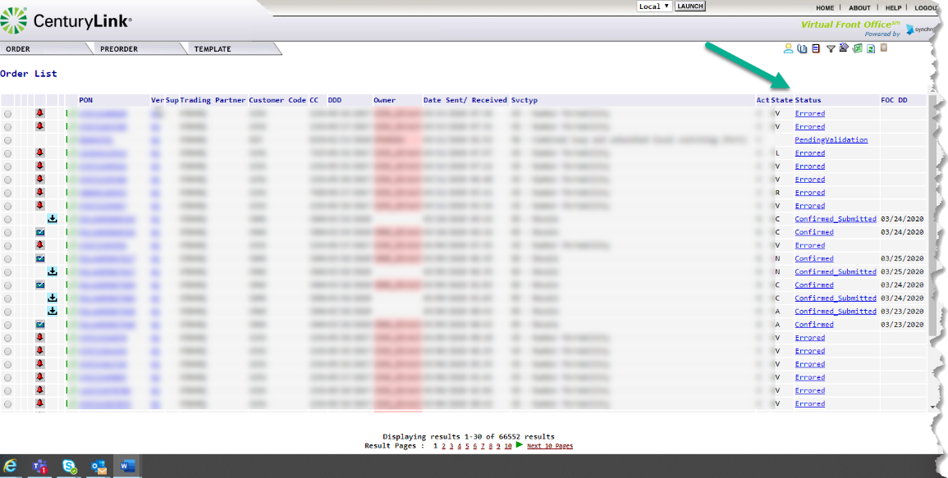

Order Status ICONs | Status ICONs may display to the left of the Receiver Code column on the Order List. These status ICONs are designed to assist with identifying the current status of orders in the Order List. Below is a list of all available status ICONs that may display on the Order List in EASE VFO.

Status ICON | Definition
 | Confirmed
 | Completed
 | Errored
 | Jeopardized
 | Order did not reach trading partner due to business rule violation
 | Rejected
 | Summary of all responses
 | Tracking Only (This means that the order was placed outside of VFO and it is in VFO for tracking only)

ORDER Tab

Overview | In this section, we will review the information contained in the Order Tab. The order tab allows users to create new orders, search for existing orders, view order history as well as many other options.  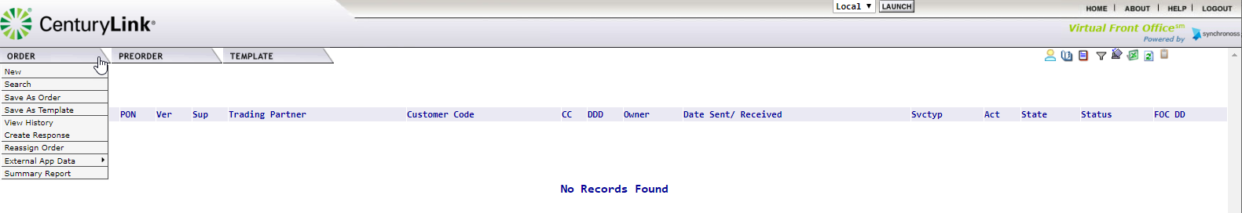

New | This option allows users to create a new order. When this option is selected, users will be taken to the Order Initiation menu shown below.  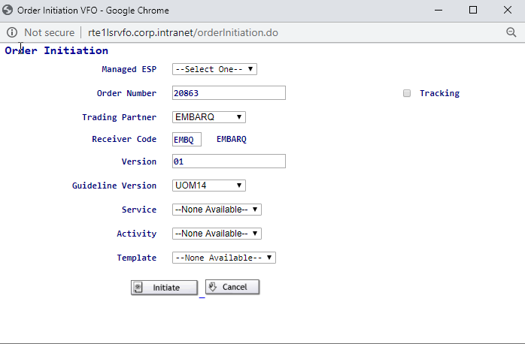  Please note: Additional information on creating a new order can be found in this document in the Creating an Order in EASE VFO Section.

Search | This option will allow users to search the order database thru a variety of methods. The order database houses a 2-year inventory of orders that have been saved, processed or cancelled. When this option is selected, users will be taken to a Search menu.  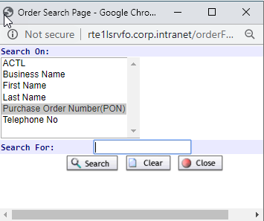

Available Search Options | Search is defined thru the following options. The default search option is Purchase Order Number (PON).
  Search On:
  ACTL
  Business Name
  First Name
  Last Name
  Purchase Order Number EDefault option
  Telephone Number.

Using the Search Function | To use the Search Function,
  Step | Action
  1 | Select the option to Search by
  2 | Place the search details in text box to the right of Search For:  The information provided can be the exact value, part of the value or contain % as a wildcard value.
  3 | Click the Search button from the options on the screen.
  4 | Orders meeting the criteria will be displayed in the order list section.  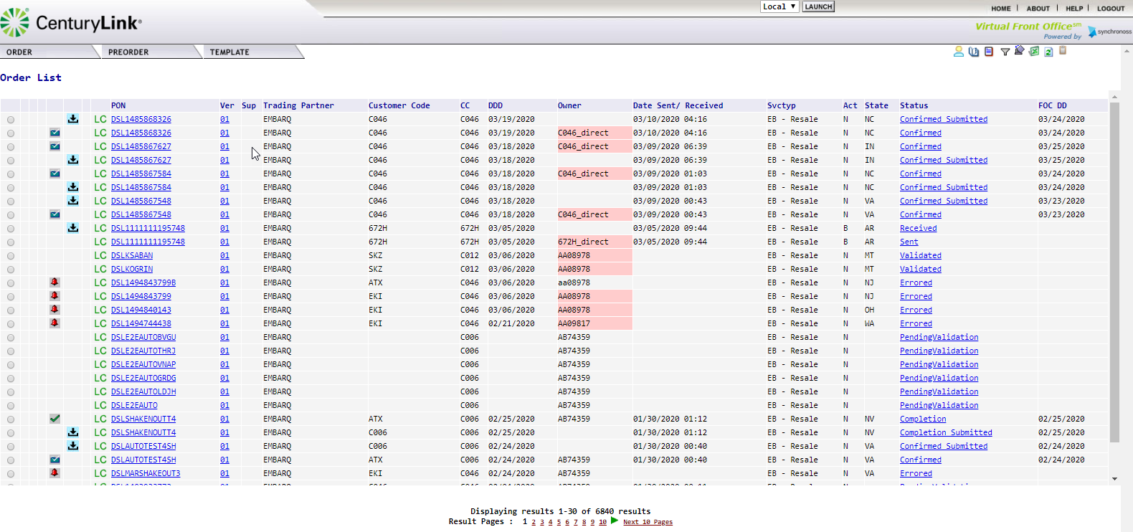  Users will see the total number of results at the bottom of the screen. Up to 10 pages of results are present at any given time. Users can scroll thru the results using the page number and arrow buttons.
  5 | Users can access the order detail by clicking on the PON name. This is a hyperlink that will open the requested order.

No Records Found | When the search criteria is unable any results, users will receive the message “No Records Found”. Users can initiate the Order – Search function to begin a new search.  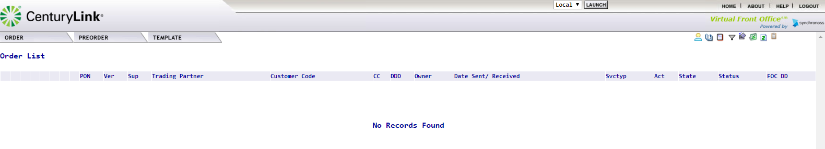

Save As Order | This option allows a user to save an existing order with a different PON. The Save As Order can be done from the main order menu or while a user is working within a PON by selecting Order – Action – Save As Order.

Save As Order from the Main Order Menu | This option can be used to save an order from the main order menu.
  Step | Action
  1 | Locate the PON in the Order List and click the associated radial button the far left-hand side of the PON name.  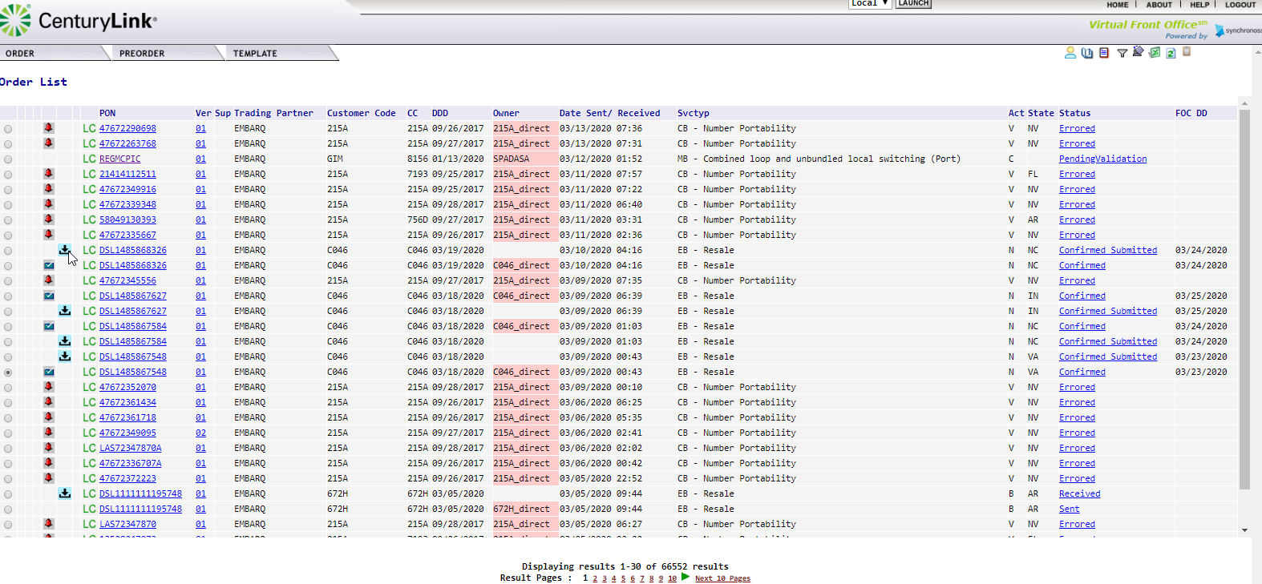  The radial button will now have a black dot in the middle, showing it has been selected.
  2 | From the Order Menu, move the cursor to the Save As Order option and click to select the option.  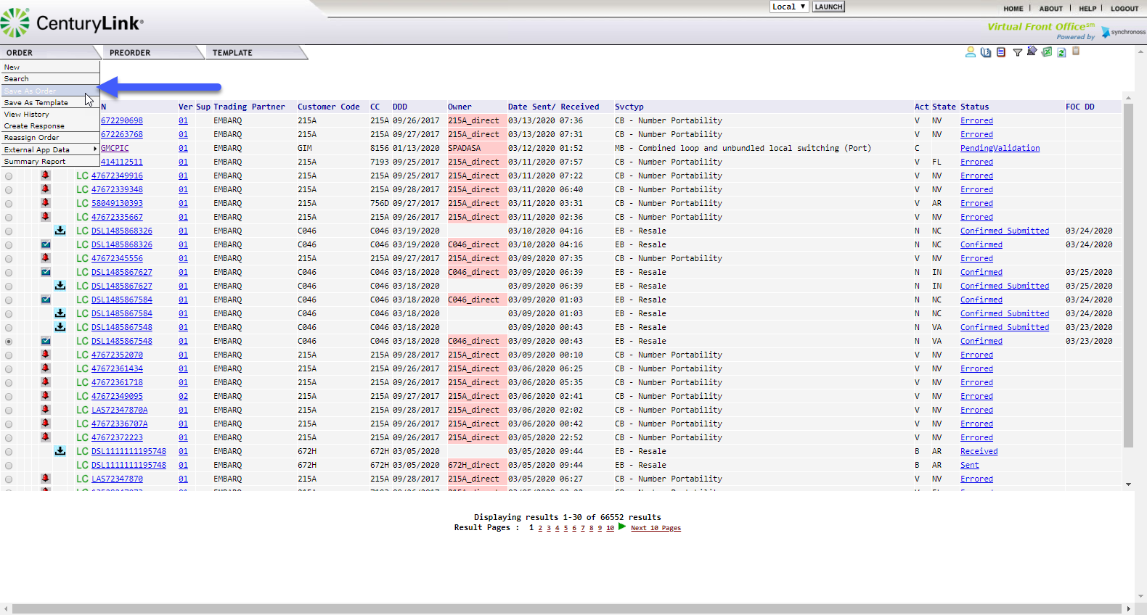
  3 | Users will be taken to the Save as New Order screen.  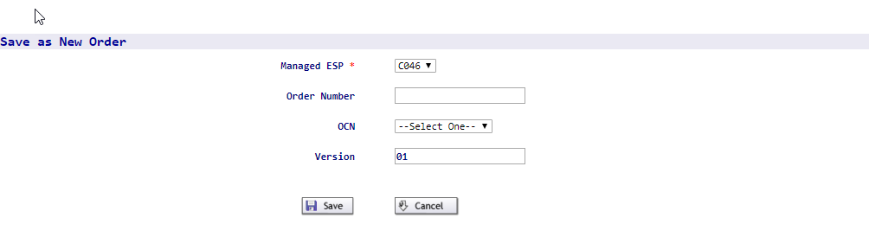
  4 | Users will have the option to change several of the fields listed. Below is a matrix of the field information. In some cases, users are advised not to alter the information provided or are prohibited from changing the field.
    Field | Details
    Managed ESP | This field should remain part of the same ESP group to allow the user to have access to the order.
    Order Number | Assign a 16-digit unique PON number
    OCN | Use the Drop-Down to select the OCN for the new order
    Version | The default should be 01.
  5 | Once all changes have been made, users should select SAVE to create the new order.  
  6 | Users will be taken into the order in the Pending Validation State.  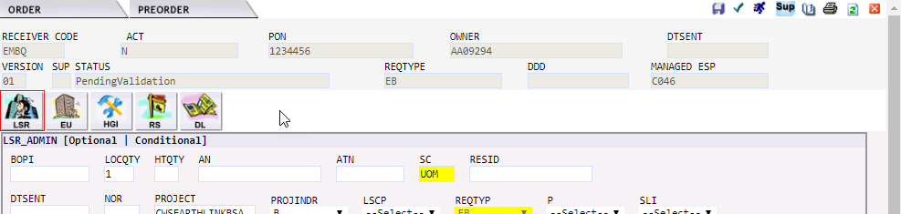  The new order will require users to select a new DDD (Desired Due Date).  Please note: Since existing fields from the original order have been copied over, users are advised to double check existing field entries in the field to ensure that they are applicable to the newly created order.
  7 | Users can click the Cancel button to Cancel the Save As Order Request. If an order is canceled at this stage, users will be returned to the Order List Menu.

Using the Save As Order within an active Order | This option can be used to create a new order while the user is working within an order.
  Step | Action
  1 | Within the working order, click the Order Tab to display the menu drop-down options.  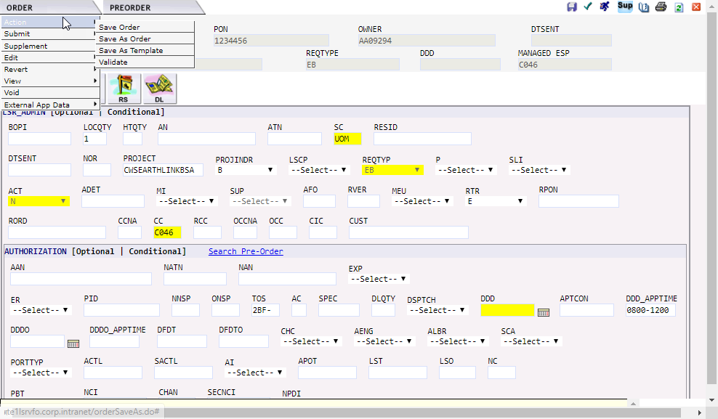
  2 | Select the Save As Order option from the associated drop-down menu.  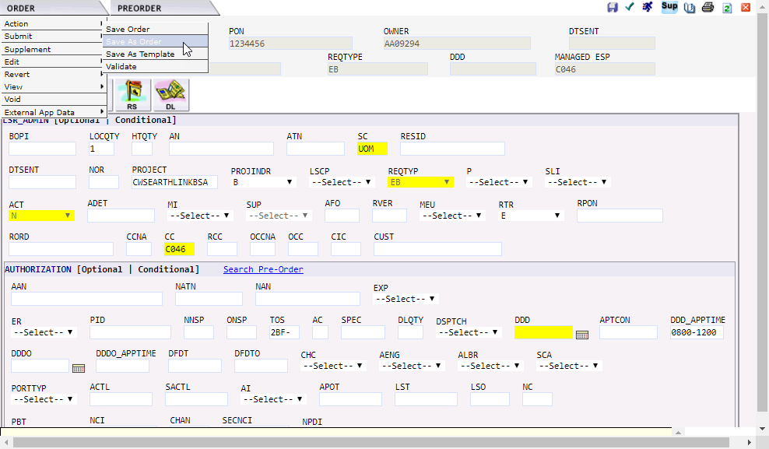
  3 | Users will be taken to the Save as New Order Screen.
  4 | Users will have the option to change several of the fields listed. Below is a matrix of the field information. In some cases, users are advised not to alter the information provided or are prohibited from changing the field.
    Field | Details
    Managed ESP | This field should remain part of the same ESP group to allow the user to have access to the order. This is not the order CCNA.
    Order Number | Assign a 16-digit unique PON number
    OCN | Use the Drop-Down to select the correct OCN for the new order.
    Version | The default should be 01.
  5 | Once all changes have been made, users should select SAVE to create the new order.
  6 | Users will be taken into the order in the PendingValidation State.  The new order will require users to select a new DDD (Desired Due Date).  Please note: Since existing fields from the original order have been copied over, users are advised to double check existing field entries in the field to ensure that they are applicable to the newly created order.
  6 | Users can click the Cancel button to Cancel the Save As Order Request. If an order is canceled at this stage, users will be returned to the Order List Menu.

Reassign Order | This option is only used by a CenturyLink employee to assign an order to a specific user. CenturyLink employees should reference internal documents regarding this process for additional details.

External APP Data Overview
Overview | CenturyLink supports several non-industry defined LSOG APPs to provide additional information to users. Information regarding each of the following options can be found below. These apps are designed to be accessed during the LSR order creation process, allowing users to access the External App Data from the Order menu.  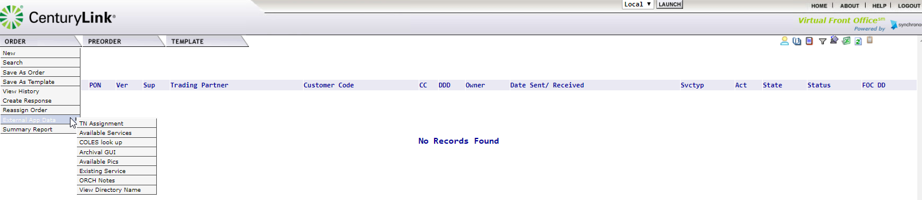  The External App Data supports the following tools:  - TN Assignment  - Available Services  - COLES look up  - Archival GUI  - Available Pics  - Existing Service  - LSR ORCH Notes  - View Directory Name  Although all tools are visible to users, accessing the data within some tools will be available to internal CenturyLink employees only. An overview of each of the tools will be provided below.

TN Assignment | During the LSR order creation, this option allows users to search for available TNs based on the entered criteria. Users will see a hyperlink in the PON that will allow them to LINK to this screen and obtain the needed information.
  Step | Action
  1 | From the Order tab, scroll to the External App Data tab. Move your cursor to the right and select TN Assignment from the displayed screen.  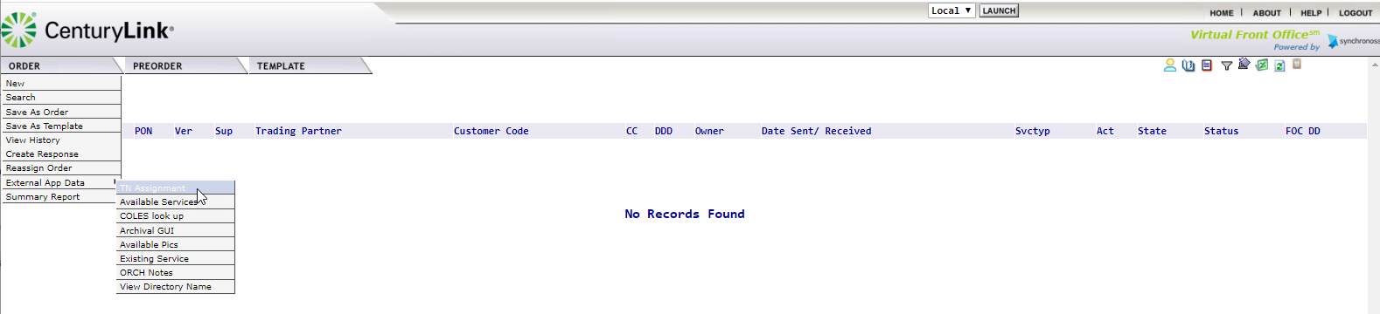
  2. | The TN Assignment Screen will be displayed.  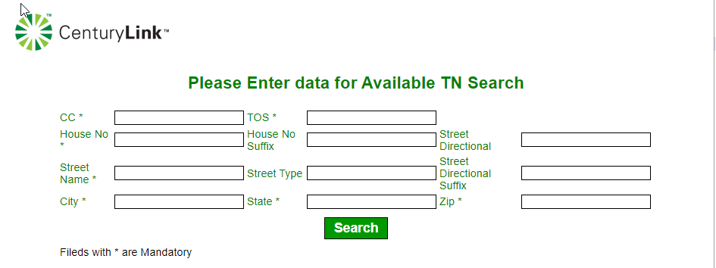
  3. | Enter the information to be retrieved and click .  Please Note: Some fields with the TN Assignment Screen are mandatory to populate. The fields are denoted with an asterisk (*) and have been listed below:
    Field | Populate
    CC | Company Code
    TOS | Type of Service (Enter up to 4 Alpha Number Characters such as 1BF-, 2)
    House NO | The assigned house number
    Street Name | The name of the street
    City | The name of the city
    State | The two-digit state abbreviation
    Zip | Valid Zip Code
  4. | The system will return the most current information available.

Available Services | During the LSR order creation, this option allows users to search for Available Services based on the entered criteria. Users will see a hyperlink in the PON that will allow them to LINK to this screen and obtain the needed information.
  Step | Action
  1 | From the Order tab, scroll to the External App Data tab. Move your cursor to the right and select Available Services from the displayed screen.  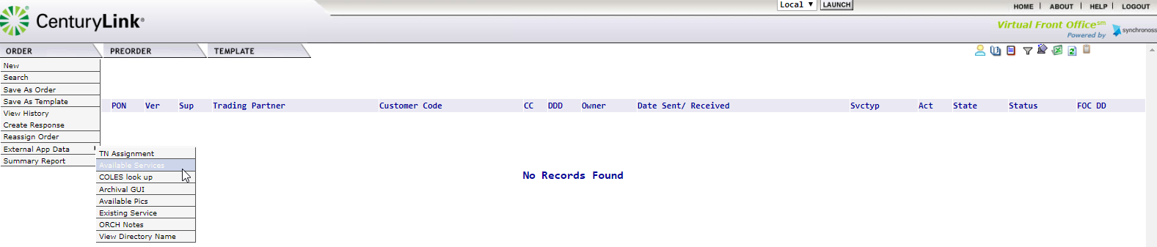
  2 | The Available Services Screen will be displayed.  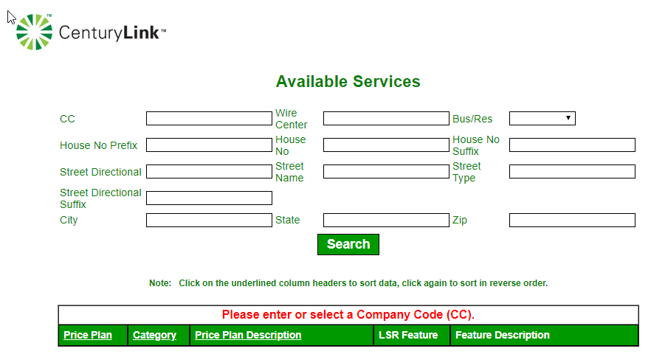
  3 | Enter the CC (Company Code) and the Wire Center and click .
  4 | The system will return the information based on the criteria entered.  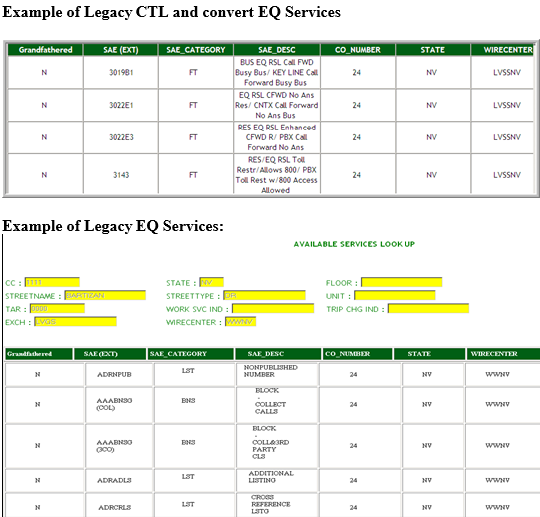
  5 | Scroll to find the access line choices and copy the S&E code for the line of choice.  Note: Select a line type that corresponds with the TOS entered.

COLES look up | During the LSR order creation, this option allows users to search for Available Services based on the entered criteria. Users will see a hyperlink in the PON that will allow them to LINK to this screen and obtain the needed information.
  Step | Action
  1 | From the Order tab, scroll to the External App Data tab. Move your cursor to the right and select Available Services from the displayed screen.  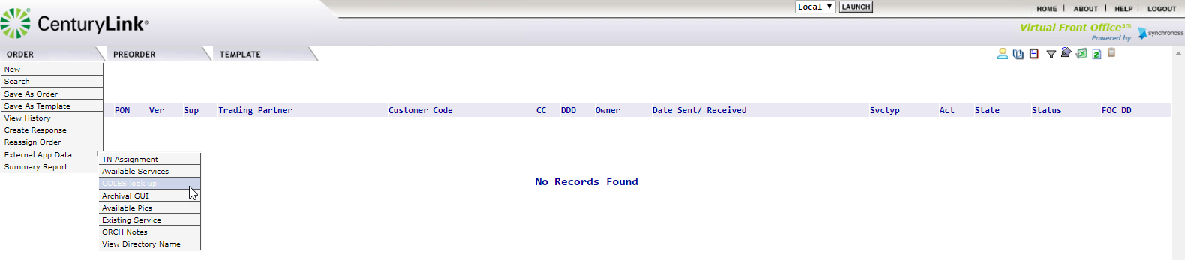
  2 | The VCOLE Directory Lookup screen will be displayed  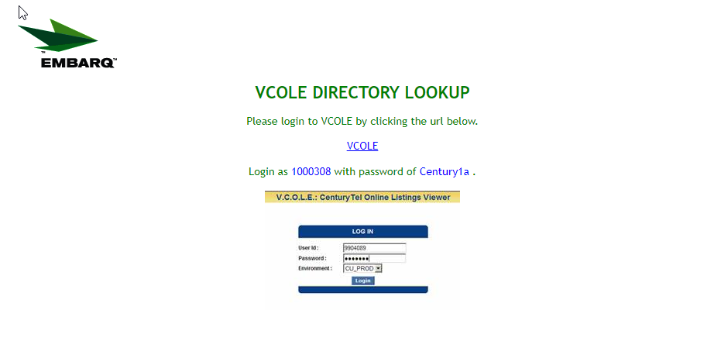
  3 | Click on the hyperlink for VCOLE in the center of the screen. You will be taken to the V.C.O.L.E: CenturyLink Online Listings Viewer.  To LOG IN, enter the following values in the User ID and Password fields.  Click on the button.
    Field | Value
    User Id: | 100308
    Password: | Century1a
    Environment: | DEPLOYI1 Leave as default

Archival GUI | EASE maintains a 2-year active history of PON (purchase order number) information. Accepted PONs that are older than 2-years will be archived. The archival GUI allows users to search for pons that have been archived in EASE. The archived information will only contain a subset of the original order information.
  Step | Action
  1 | From the Order tab, scroll to the External App Data tab. Move your cursor to the right and select the Archival GUI from the displayed menu.  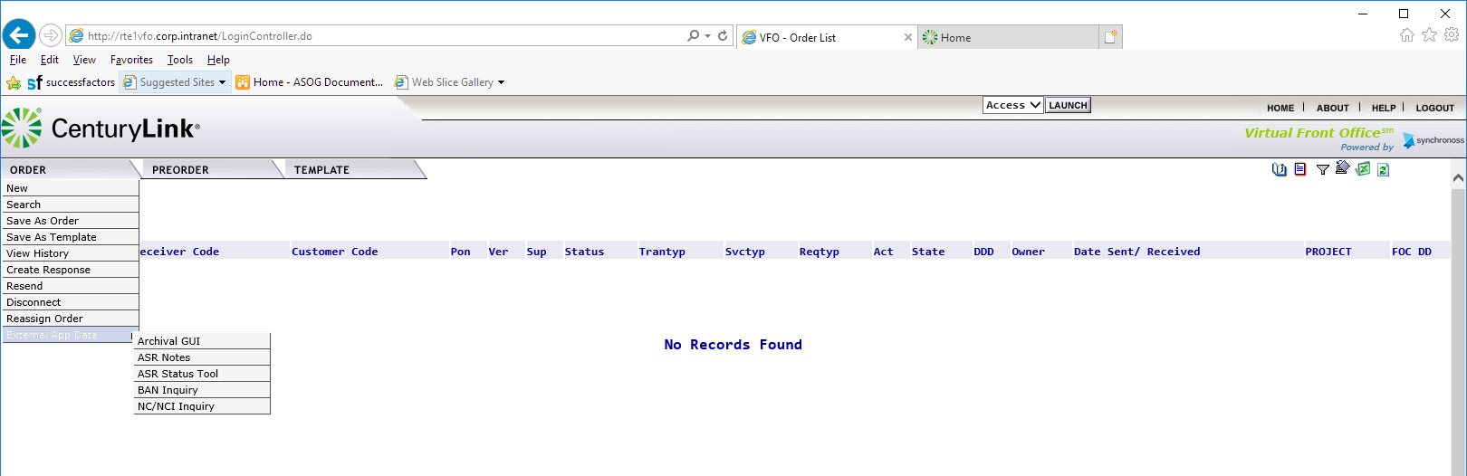
  2 | The Archival GUI will be displayed.  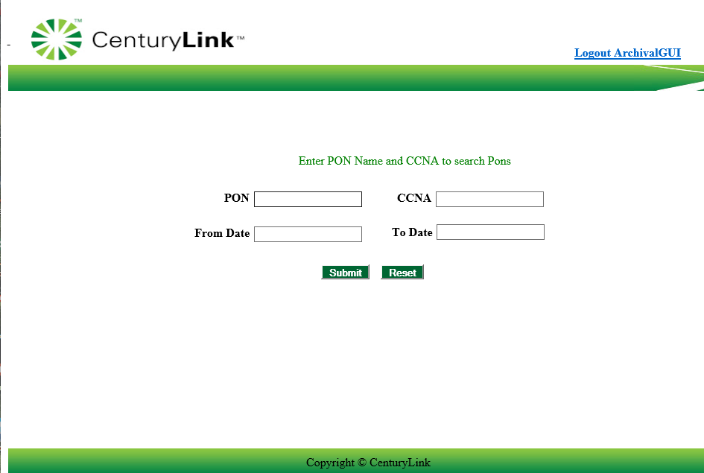
  3a | To search for a specific pon, enter the PON and CCNA.  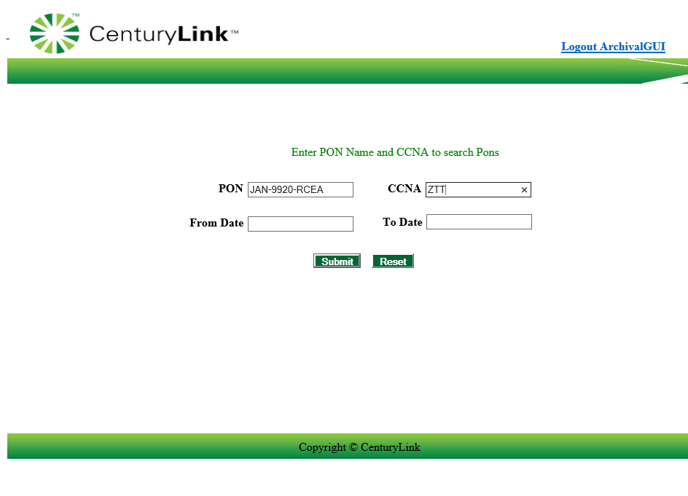
  3b | To search for a list of PONs, users can use a wildcard option by entering part of the PON information and then using the % key. The system will return all pons that meet the criteria entered.  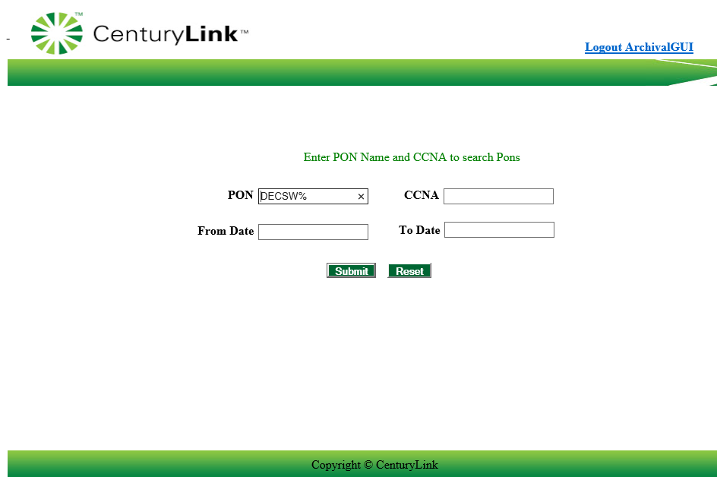
  3c | To search for a list of PONs within a certain date range, users can enter the From Date and To Date. This can be done by entering the date in the MM/DD/YYYY format or using the pop-up calendar to select a From and To Date.  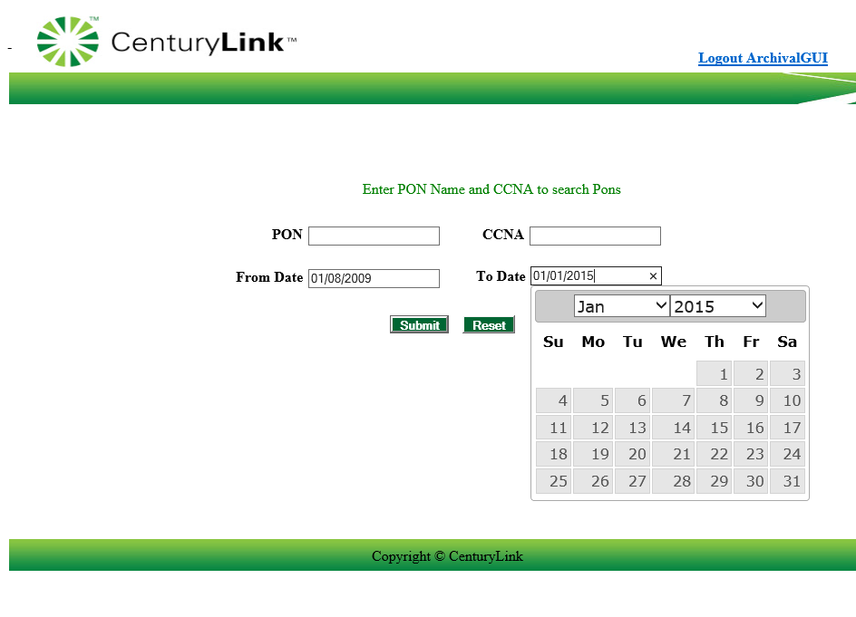  Please Note: this option requires both the From Date and To Date fields to be populated.
  4 | Click Submit to begin the Archival GUI Search or Reset to remove all field entry.
  5 | The system will return the archived information based on the criteria entered.  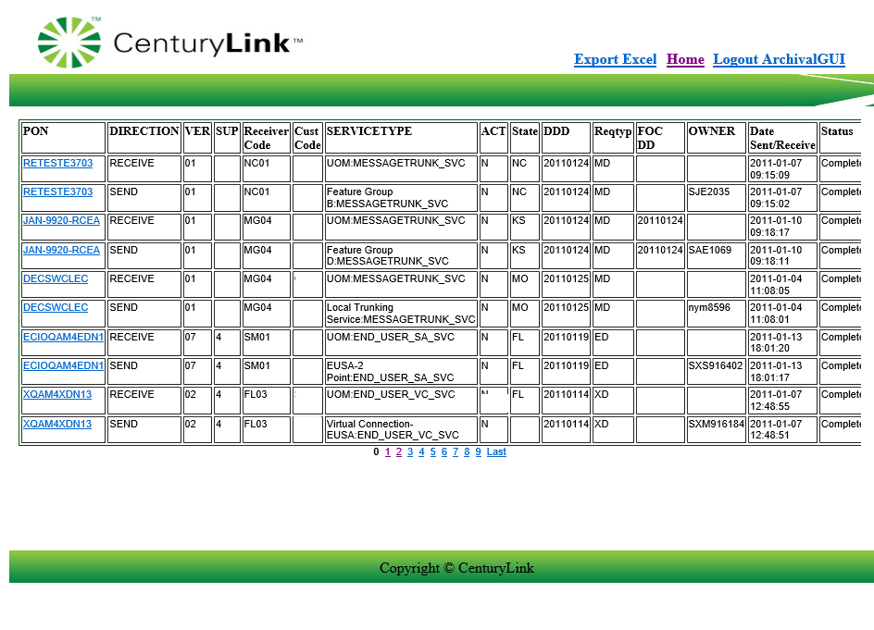  Please Note: users will have the ability to click on additional page numbers at the bottom of the screen to view additional results.
  6 | Users can click on the following hyperlinks within the Archival GUI. in the top right corner:
    Hyperlink | Resulting Action
    Export Excel | Allows the user to export the summarized PON information to Excel for further sorting.
    Home | Allows the user to return to the main Archival GUI screen.
    Logout ArchivalGUI | Allows the user to exit the External App. Users will be asked to close the screen.  

Available Pics | During the LSR order creation, this option allows users to search for Available Pics based on the entered criteria. Users will see a hyperlink in the PON that will allow them to LINK to this screen and obtain the needed information.
  Step | Action
  1 | From the Order tab, scroll to the External App Data tab. Move your cursor to the right and select Available Pics from the displayed screen.  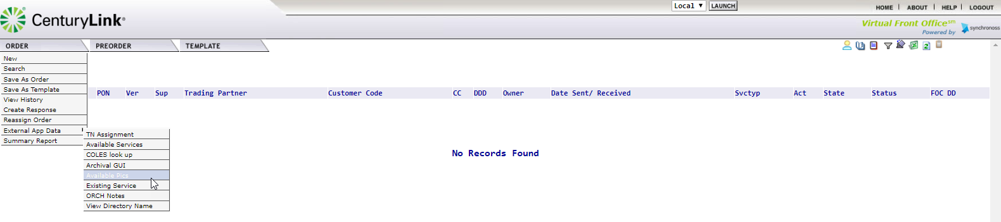
  2 | The Available Pics screen will be displayed.  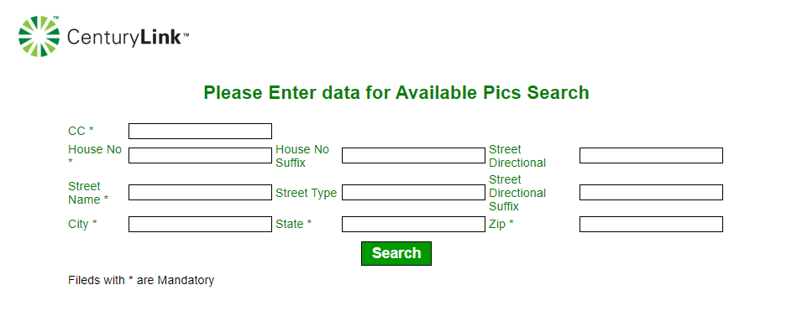
  3. | Enter the following mandatory fields  After all information as been entered, click .
    Field | Data
    CC | Company Code
    House No | Numeric House Number
    Street Name | Street Name
    City | City Name
    State | 2 digit state abbreviation
    Zip | Zip code
  4. | The system will return all information matching the requested information.

Existing Services | This option is used to identify existing services associated to a given telephon number.
  Step | Action
  1 | From the Order tab, scroll to the External App Data tab. Move your cursor to the right and select Available Pics from the displayed screen.
  2 | The Existing Services screen will be displayed.  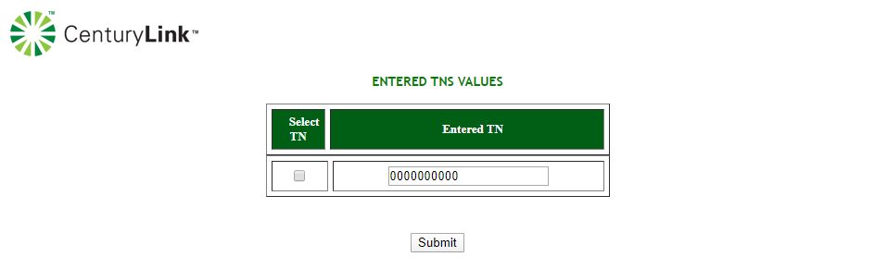  Enter the 10 digit TN number and click .
  3 | The system will return the existing services that are associated to the TN.

LSR ORCH Notes | LSR ORCH Notes can only be viewed by CenturyLink employees. External customers will receive an error when accessing this data.

View Directory Name | This option is used to identify the associated directory names for a given location.
  Step | Action
  1 | From the Order tab, scroll to the External App Data tab. Move your cursor to the right and select View Directory Name from the displayed screen  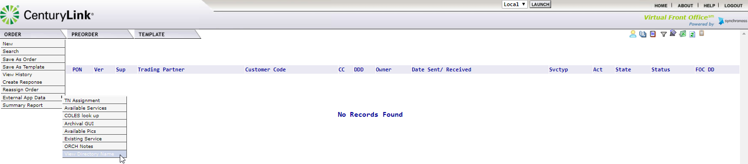
  2 | The View Directory name screen will be displayed.  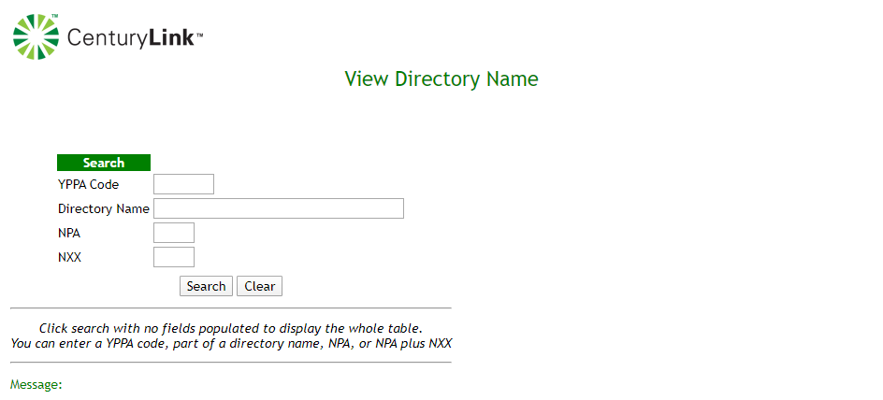  The information can be obtained by entering one of the following methods:  Click on Search to initiate the request, or clear to remove the entered information.
    Search by | Enter
    YPPA | Associated YPPA Code
    Directory | Enter the Directory Name
    Area Code/Prefix | Enter the NPA/NXX
  3 | The directory information will be displayed at the bottom of the screen in the Directory Name Results Section.  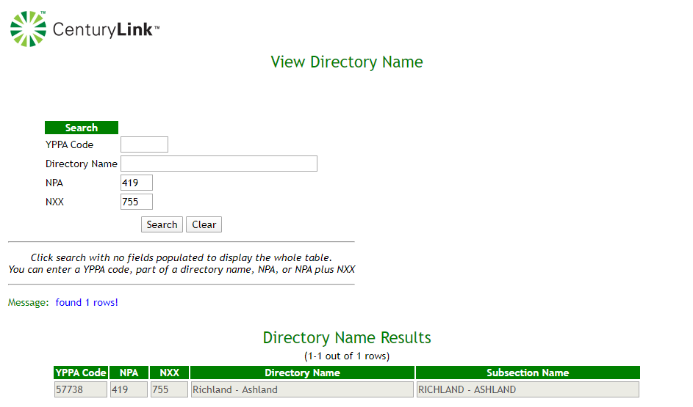

Summary Report | This option is not supported by CenturyLink at this time.

PREORDER Tab

Overview | The PreOrder tab provides the user with the ability to check and view information outside of an order. This section will provide details for starting a new preorder, searching for a saved pre-order query, along with the details of the types of preorders that can be performed.  PreOrder functions can also be done within the order by clicking the Pre-Order tab.

To start a Pre-order inquiry | The following steps can be used to begin a pre-order inquiry.
  Step | Action
  1 | Upon successful login, select the Pre-Order Tab from the menu bar. The options available are New and Search.  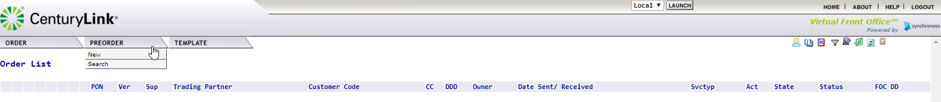
  2 | When you select ‘New’, the PreOrder Initiation screen will be displayed.  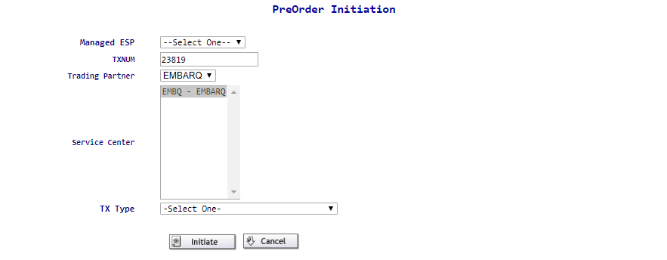  - The TXNUM field will be auto populated by the system with a sequence number. Users also have the ability to change this value. It is the recommendation to change this value to the PON that will be utilized on the LSR.  - The Trading Partner will remain as EMBARQ.  - The Service Enter will be defaulted to EMBQ – EMBARQ.
  3 | To begin the New PreOrder inquiry,  - Use the drop-down arrow to select the appropriate Managed ESP  - Use the drop-down arrow to select the appropriate PreOrder in the TX Type field.  - Click on the button to start the inquiry.  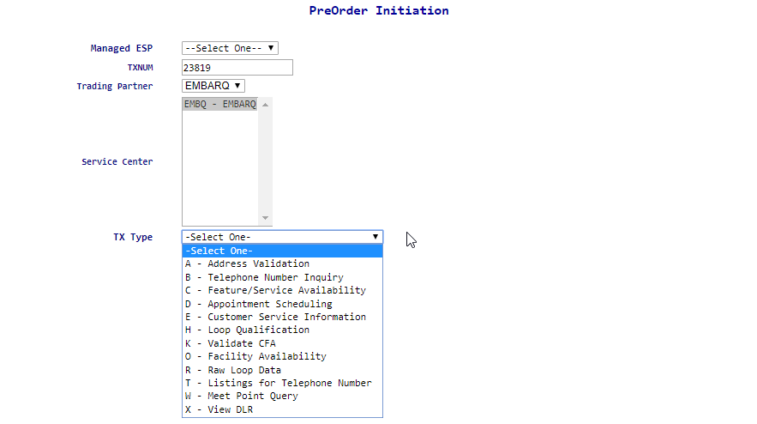
  Additional information regarding each specific PreOrder Inquiry is provided below.

Viewing the Saved Pre-orders | Any PreOrder that has been successfully run and SAVED, can be recalled at a later time using the Search option.
  Step | Action
  1 | Click on the Search option in the PREORDER tab.
  2 | The PreOrder Search screen will display.  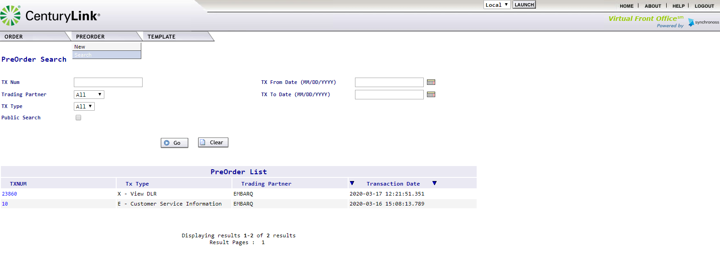
  3 | All saved preorder searches will be displayed on the bottom of the page. Users will have the ability to click on the TXNUM hyperlink to view the preorder, as well as scroll thru the display of results.  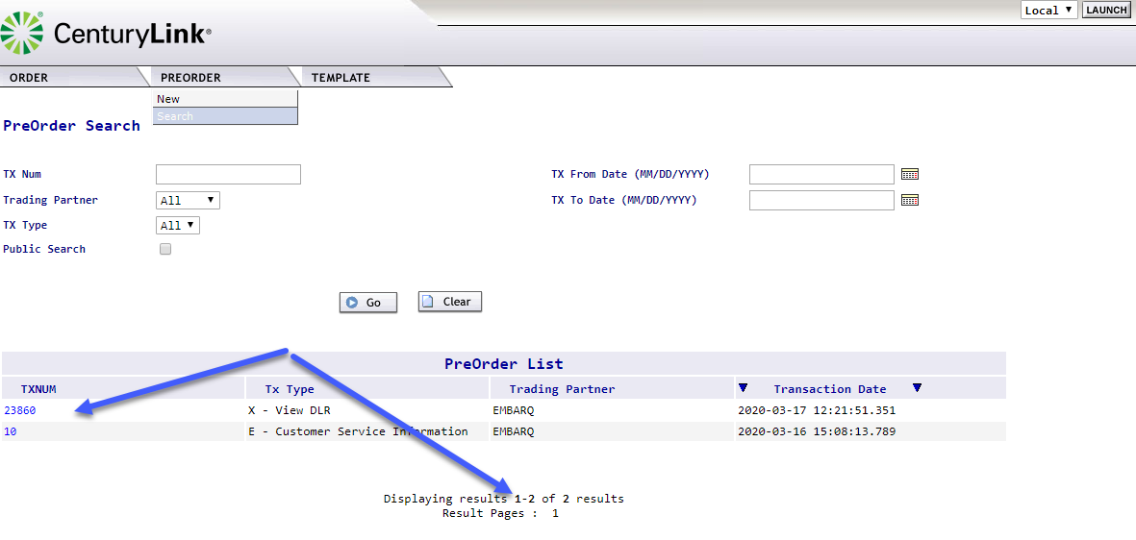
  4 | The TXNUM will appear on the bottom half the screen and users can click on the blue hyperlink TXNUM to open the PreOrder Inquiry / Results for viewing.  Please note: The information displayed will be in the Printable version.  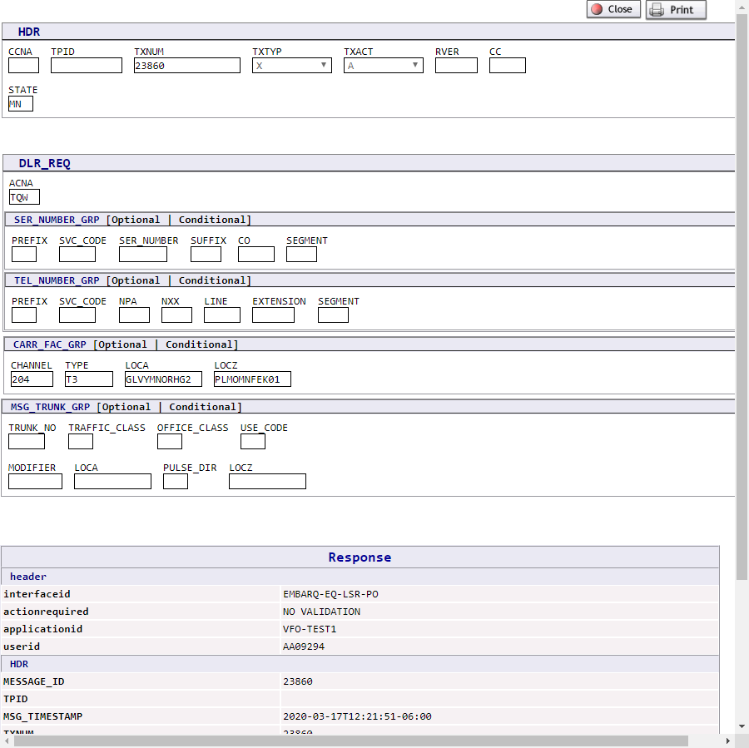  Users have the option to the saved TXNUM.

Searching for a Saved Pre-order | Any PreOrder that has been successfully run and SAVED, can be recalled using the Search option.
  Step | Action
  1 | Click on the Search option in the PREORDER tab.
  2 | The PreOrder Search screen will display.
  3 | Users can search for a specific saved PreOrder by entering the TX Num assigned to the saved search in the TX NUM box and clicking the button.  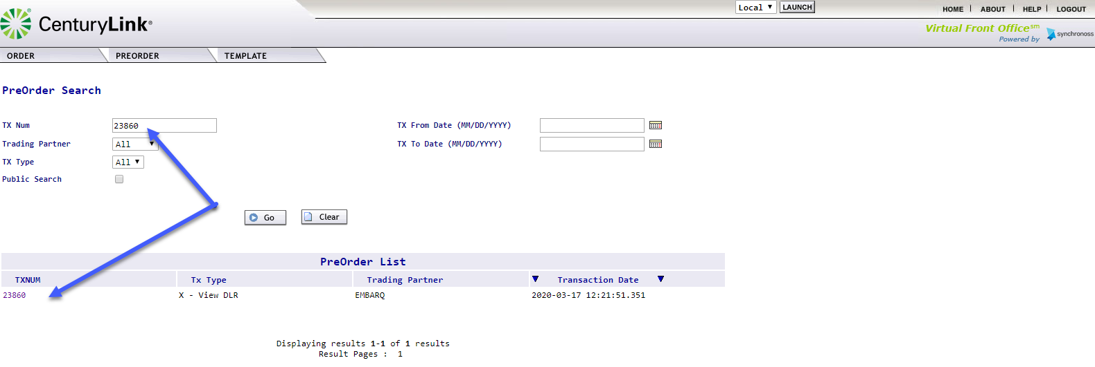  Users can remove the TXNUM entry to clicking on the button.
  4 | The TXNUM will appear on the bottom half the screen and users can click on the blue hyperlink number to open the PreOrder Inquiry / Results for viewing. The information displayed will be in the Printable version.  Users have the option to the saved TXNUM.
  3 | All saved preorder searches will be displayed on the bottom of the page. Users will have the ability to click on the TXNUM hyperlink to view the preorder, as well as scroll thru the display of results.

Address Validation Inquiry
Starting the Address Validation Inquiry | The following steps will describe specific instructions for performing an EASE Address Validation Inquiry and will be done after starting the EASE Pre-Order Inquiry process.
  Step | Action
  1 | Begin the PreOrder Inquiry by selecting the A - Address Validation Inquiry option.
  2 | The Address Validation screen will be displayed  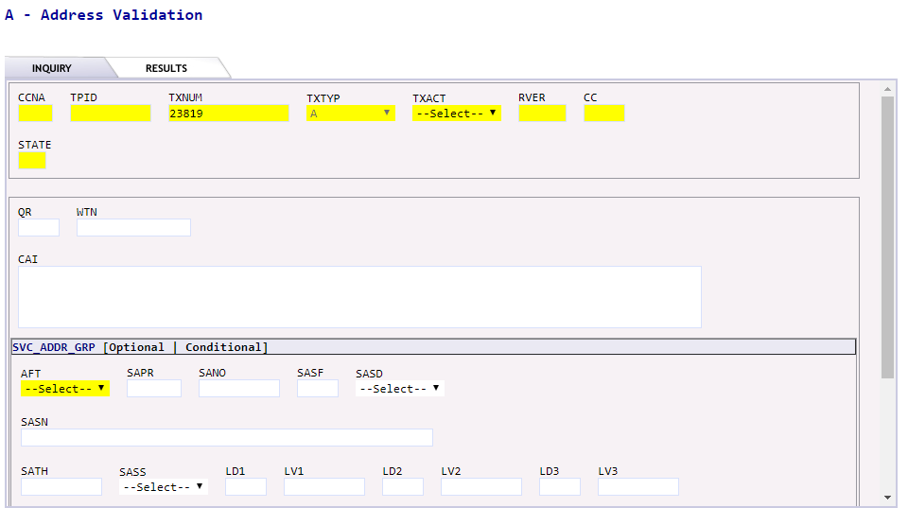  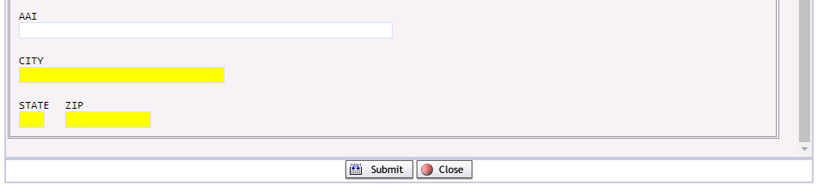  The INQUIRY ADDITIONAL HEADER section is a required section. Many of the fields provided are mandatory and must be provided.  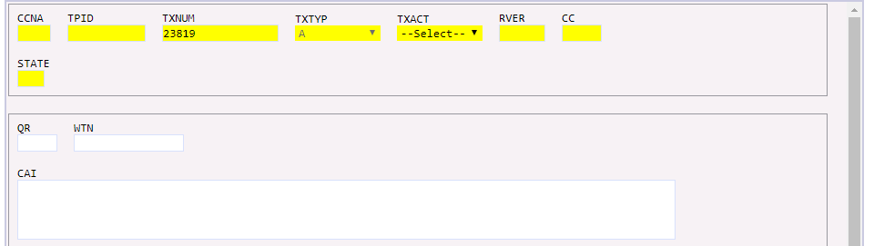  Users will see three additional options for performing a location inquiry displayed.
    Required fields:
    CCNA | Customer Name Abbreviation
    TXNUM | This screen will be prepopulated by the system.  Recommendation: Use the PON that will be utilized on the LSR.  Note: This can be up to twenty-five alpha, numeric, or alpha-numeric characters.
    TXACT | Transaction Activity.
      Letter | Usage
      A | New Inquiry
    STATE | Enter the correct 2-digit state abbreviation for the inquiry
    QR  (QUANTITY REQUESTED) | This option is not supported by CenturyLink at this time
    WTN
    (WORKING TELEPHONE NUMBER)
    CAI  (WORKING CIRCUIT INFORMATION) | This option is not supported by CenturyLink at this time
  3a | Entering the Address Information  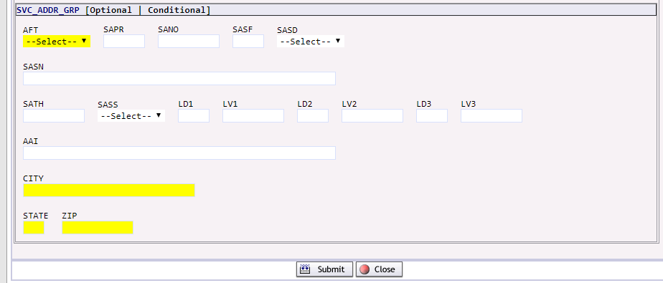
    AFT | AFT identifies the format of the address being supplied. Valid entries:  A = Rural Route and/or box number  B = Unnumbered  C = Provider Assigned house number  D = Descriptive  E = Provisioning Address
    SAPR | SAPR identifies the prefix for the address number of the service address
    SANO | SANO identifies the number of the service address
    SASF | SASF identifies the suffix for the address number of the service address
    SASD | SASD identifies the street directional prefix for the service address. Use the drop-down to select a valid entry  E = East  W= West  N = North  S = South  NE = Northeast  NW = Northwest  SE = Southeast  SW=Southwest
    SASN | SASN identifies the street name of the service address
    SATH | SATH identifies the thoroughfare portion of the service address, such as LN (lane) or BLVD (boulevard)
    SASS | SASS identifies the street directional suffix for the service address. Use the drop down to select one of the Valid entries shown below.  E = East  W= West  N = North  S = South  NE = Northeast  NW = Northwest  SE = Southeast  SW = Southwest  NOTE: This is not the same as DIR and the two cannot be used interchangeably in the address
    LD1,  LD2,  LD3 | The LD1, LD2, LD3 identifies additional specific complex address information related to the address. The supported abbreviations have been determined based on the US Postal Service Publication 28. Valid entries include:  - UNIT  - ROOM  - APT  - RM  - STE  - FL  - FLR  - BLDG  - COMP
    LV1,  LV2,  LV3 | LV1, LV2, LV3 identifies the value associated with the location designator
    AAI | Additional Address Information
    CITY | City identifies the city, village, or township
    STATE | State identifies the abbreviation for the state or province
    ZIP | Zip identifies the ZIP or postal code
  3b | Performing a LOCATION inquiry using QUANTITY REQUESTED  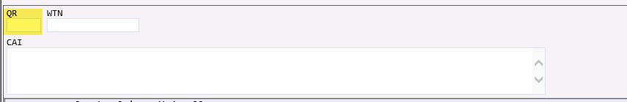  At this time, CenturyLink does not support this option.
  3c | Performing a LOCATION inquiry using WORKING TELEPHONE NUMBER INQUIRY  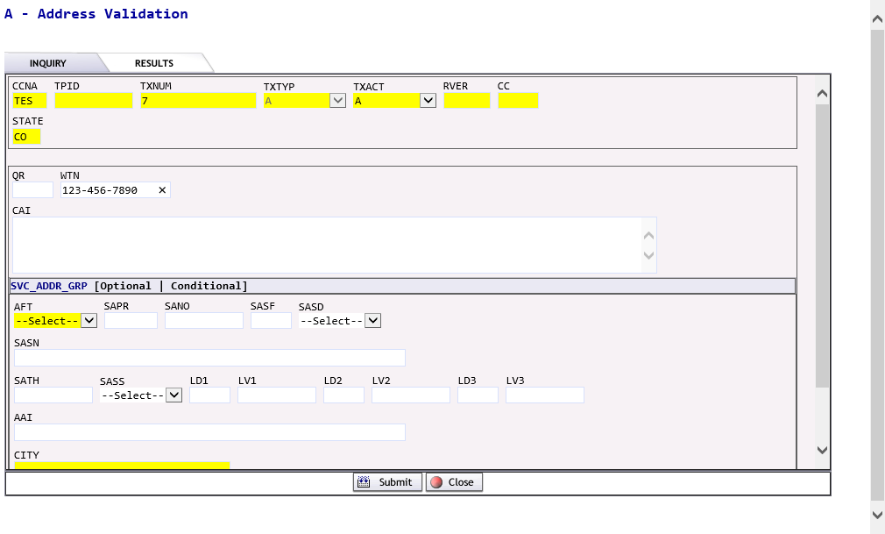
    WTN | Enter the 10-Digit Working Telephone Number
  3d | Performing a LOCATION inquiry using WORKING CIRCUIT INQUIRY  At this time, CenturyLink does not support this inquiry
  4 | Click the SUBMIT button to initiate or CLOSE button to exit from the inquiry
  5 | If the SUBMIT button has been clicked the user will see a message that the inquiry has executed, and the system is waiting for a PreOrder Response ……  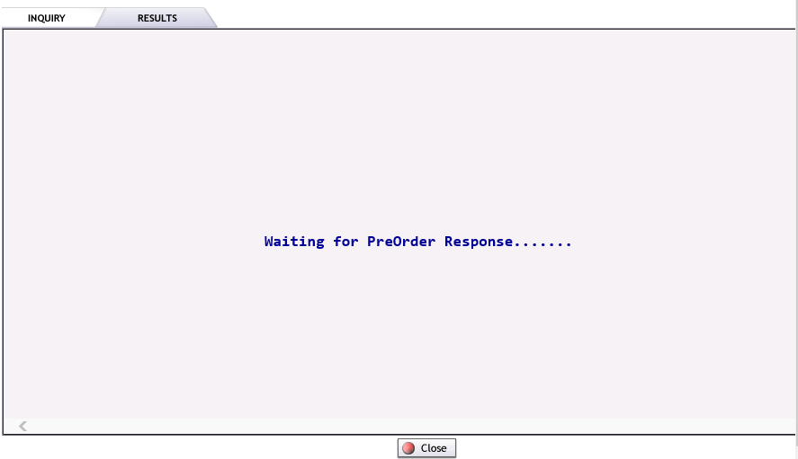  Please note: If the CLOSE button is selected from this screen, the inquiry will be stopped.
  6 | Upon completion of the Pre-Order, the system will execute the request and provide a response upon submission.  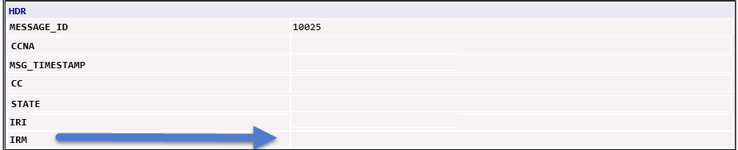  The results of the inquiry will be displayed in the IRM field.  Possible options are:
    Address Near Match Found | Multiple options exist for the information provided. Additional information in the LD/LV values has been listed for consideration.
    Exact Address Match Found | The information provided was an exact match to the address databases. This message will include the appropriate CenturyLink operating territory.
    Alternatives Exist | The information provided more than one address that is similar to the request. The first 20 responses will be returned.  If the inquiry is performed within the service order, users will have the ability to use the radial button on the left-hand side to select the address and transfer it to the SALI section.
    No match found for | The information provided was not able to be validated. Users will have the ability to click CHANGE, alter the inquiry and resubmit.

Viewing the results from an address validation inquiry | 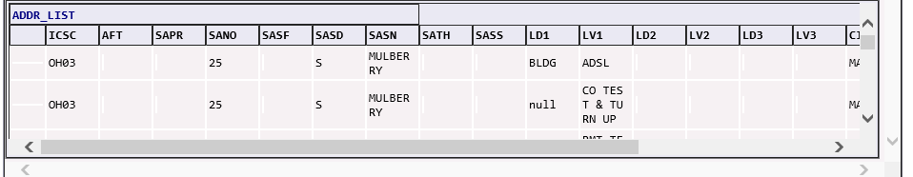  Users can use the scroll bar at the bottom of the screen to access the various fields returned in the response.  Please note: When a response contains more than 1 match, the system will only return the top 20 matches to the address. Users will be able to use the scroll bars on the right-hand side to view the available responses.
  ADDR_LIST | The following fields will be returned in the response
  ICSC | The CenturyLink ICSC associated with the address
  AFT | AFT identifies the format of the address being supplied.
  SAPR | SAPR identifies the prefix for the address number of the service address
  SANO | SANO identifies the number of the service address
  SASF | SASF identifies the suffix for the address number of the service address
  SASD | SASD identifies the street directional prefix for the service address.
  SASN | SASN identifies the street name of the service address
  SATH | SATH identifies the thoroughfare portion of the service address, such as LN (lane) or BLVD (boulevard)
  SASS | SASS identifies the street directional suffix for the service address.
  LD1,  LD2,  LD3 | The LD1, LD2, LD3 identifies additional complex address information specific information related to the address.
  LV1,  LV2,  LV3 | LV1, LV2, LV3 identifies the value associated with the location designator
  CITY | Identifies the city, village, or township
  STATE | Identifies the 2-digit abbreviation for the state or province
  ZIP | Identifies the ZIP or postal code
  Step | Action
  1 | At times, inquires can receive a message that the inquiry has timed out. Users have the option to click the CHANGE button and resubmit the inquiry.  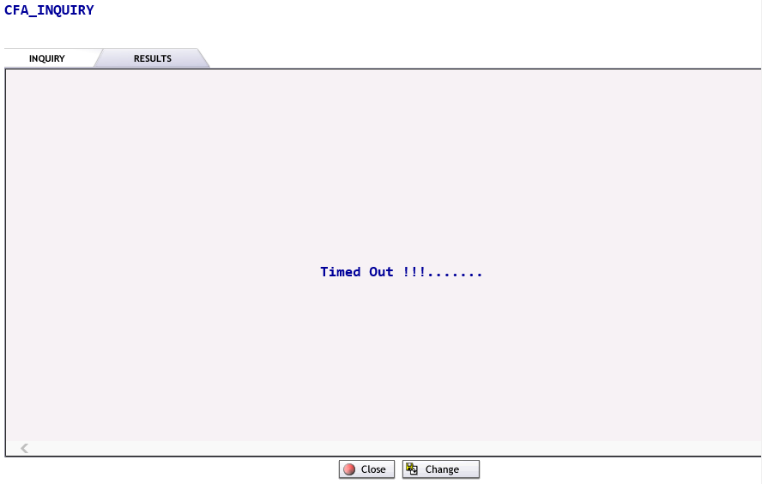
  2 | Users can Save, Print, Close or Change the information on the inquiry by pressing the appropriate button.

Telephone Number Inquiry
Starting the Telephone Number Inquiry | The following steps will describe specific instructions for performing an EASE Address Validation Inquiry and will be done after starting the EASE Pre-Order Inquiry process.
  Step | Action
  1 | Begin the Pre-Order Inquiry by selecting the B – Telephone Number Inquiry option.
  2 | The B - Telephone Number Inquiry screen will be displayed. User can scroll thru the screen using the slider bar on the right-hand side of the screen.  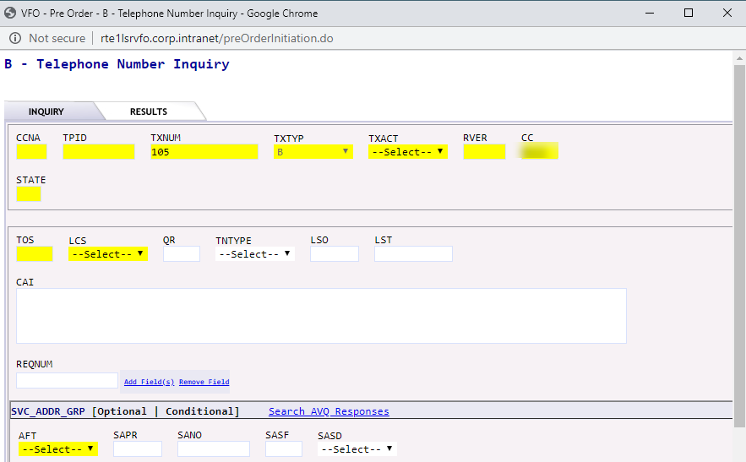  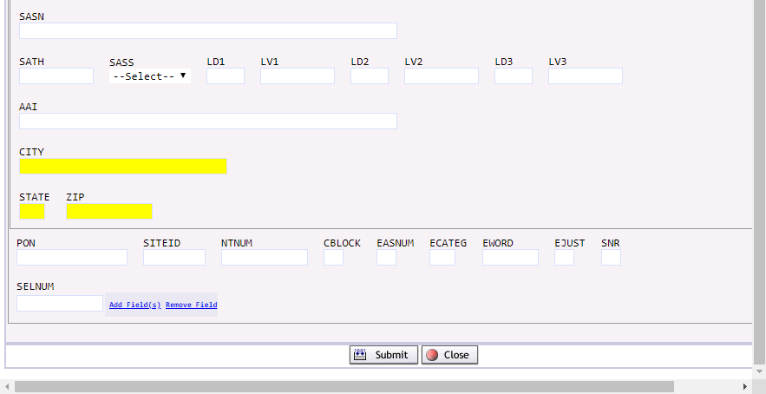  Additional Optional Field CenturyLink Specific Details
    Required fields:
    CCNA | Customer Name Abbreviation
    TXACT | Transaction Activity.
      Letter | Usage
      A | New Inquiry
    STATE | Two-Digit State abbreviation
    TOS | Type of Service (Enter up to 4 Alpha Number Characters such as 1BF-, 2)
    TNTYP | Telephone Number Type
      Letter | Usage
      D | Specific Numbers
      N | New Random Numbers
      R | Range of Numbers
      S | Sequential Numbers
    QR | Quantity requested (10 is the maximum number permitted)
    SVC_ADDR_GRP
    Enter in associated fields for valid address
    Optional field details:
    LCS | Local Calling Scope
      Letter | Usage
      A | Local Service
    LSO | Local Serving Office. Preferred NPA/NXX for telephone number(s) requested (optional)
    REQNUM | Requested Number – enter telephone number(s), or range of numbers requested. This field is dependent on the TNTYP field entered.
      TNTYP | Usage | REQNUM EXAMPLE
      D | Specific Numbers | 7403921437
      N | New Random Numbers | Leave blank
      R | Range of Numbers | 7403929714-9718
      S | Sequential Numbers | Leave blank
  3 | Click the SUBMIT button to initiate or CLOSE button to exit from the inquiry
  4 | If the SUBMIT button has been clicked the user will see a message that the inquiry has executed, and the system is waiting for a PreOrder Response ……  Please note: If the CLOSE button is selected from this screen, the inquiry will be stopped.
  5 | The successful query will be displayed on the Results tab.
  6 | If the pre-order information is incorrect, users will have the opportunity to correct the information by clicking on the Change button.
  7 | To cancel the request and return to the PreOrder screen, click on the Close button.
  8 | To obtain a printable version of the successful information, click on Printable Version.
  9 | To save the PreOrder inquiry, click on the Save button. Users will have the option to reference the saved information by the TXNUM of the inquiry.

Viewing the results from the Telephone Number Inquiry Screen | The system will return the telephone numbers based on the criteria entered.  To use the TN in the order, use the following steps:
  Step | Action
  1 | Select the TNs to be used by click on the check box to the LEFT of the TNRES field  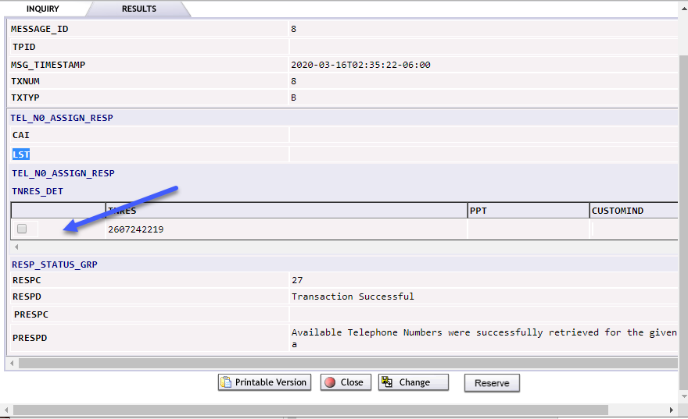
  2. | Click on .
  3. | The user will receive a Transaction Successful message that the TN has been successfully reserved.  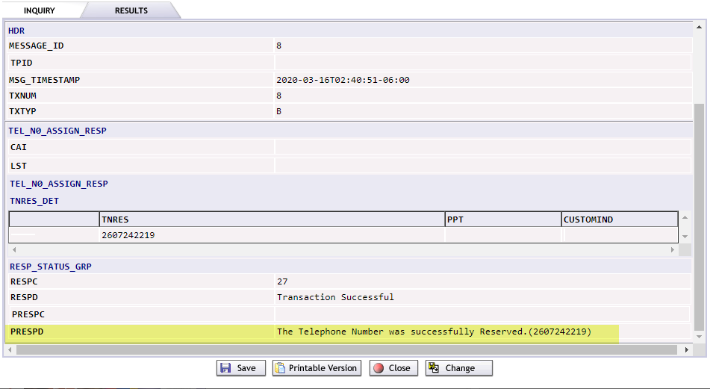
  3 | Click the SUBMIT button to initiate or CLOSE button to exit from the inquiry
  4 | If the SUBMIT button has been clicked the user will see a message that the inquiry has executed, and the system is waiting for a PreOrder Response ……  Please note: If the CLOSE button is selected from this screen, the inquiry will be stopped.
  5 | To obtain a printable version of the successful information, click on Printable Version.
  6 | To save the PreOrder inquiry, click on the Save button. Users will have the option to reference the saved information by the TXNUM of the inquiry.

Feature / Service Availability
Starting the Address Validation Inquiry - | The following steps will describe specific instructions for performing an EASE Address Validation Inquiry and will be done after starting the EASE Pre-Order Inquiry process.
  Step | Action
  1 | Begin the Pre-Order Inquiry by selecting the C = Feature / Service Availability option.
  2 | The C – Feature/Service Availability screen will be displayed  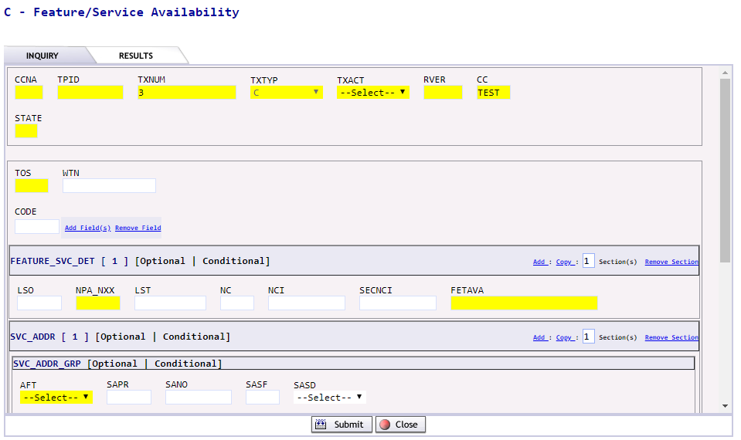
  2a | To Perform the query by WTN
    Required fields:
    CCNA | Customer Name Abbreviation
    TXACT | Transaction Activity.
      Letter | Usage
      A | New Inquiry
    STATE | Two Digit State abbreviation
    TOS | Type of Service (Enter up to 4 Alpha Number Characters such as 1BF-, 2)
    WTN
    NPA/NXX
  2b | To Perform the query by WTN
    Required fields:
    CCNA | Customer Name Abbreviation
    TXACT | Transaction Activity.
      Letter | Usage
      A | New Inquiry
    STATE | Two Digit State abbreviation
    TOS | Type of Service (Enter up to 4 Alpha Number Characters such as 1BF-, 2)
    NPA/NXX
    SVC-ADDR_GRP – Provide details regarding the address
  3 | Click the SUBMIT button to initiate or CLOSE button to exit from the inquiry
  4 | If the SUBMIT button has been clicked the user will see a message that the inquiry has executed, and the system is waiting for a PreOrder Response ……  Please note: If the CLOSE button is selected from this screen, the inquiry will be stopped.
  5 | The successful query will be displayed on the Results tab.

Viewing the Results from the Feature / Service Availability Screen | The results from the Feature / Service Availability screen are displayed below.  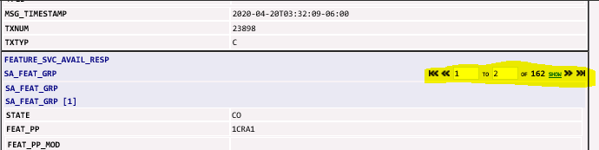
  If the pre-order information is incorrect, users will be have the opportunity to correct the information by clicking on the Change button.
  To cancel the request and return to the PreOrder screen, click on the Close button.
  To obtain a printable version of the successful information, click on Printable Version.
  To save the PreOrder inquiry, click on the Save button. Users will have the option to reference the saved information by the TXNUM of the inquiry.

Appointment Scheduling
Starting the Address Validation Inquiry - | The following steps will describe specific instructions for performing an EASE Address Validation Inquiry and will be done after starting the EASE Pre-Order Inquiry process.
  Step | Action
  1 | Begin the Pre-Order Inquiry by selecting the D – Appointment Scheduling option.
  2 | The D – Appointment Scheduling screen will be displayed  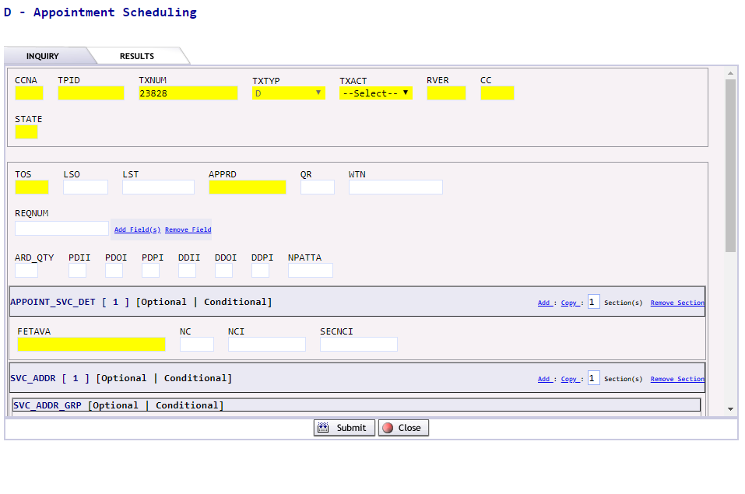
    Required fields:
    CCNA | Carrier Customer Name Abbreviation
    TXACT | Transaction Activity.
      Letter | Usage
      A | New Inquiry
    STATE | Two-digit abbreviation for the requested state
    TOS | Type of Service (Enter up to 4 Alpha Number Characters such as 1BF-, 2)
    LSO | The 6-numeric NPA/NXX for associated area
    WTN | The WTN field may be used in place of the LSO. The WTN may be entered as just the NPA-NXX, or the full NPA-NXX-LINE. Hyphens must be used when entering the WTN information.
    QR | Populate only if specific quantity requested (10 is the maximum number permitted)
    PON | Purchase Order Number
    FEAT_PP | Feature / USOC code. This is an optional field that when populated will ensure that the allotted appointment time will accommodate the order request.  Please note: To add additional USOC/Feature Codes, click on the hyperlink.
  3 | Click the SUBMIT button to initiate or CLOSE button to exit from the inquiry
  4 | If the SUBMIT button has been clicked the user will see a message that the inquiry has executed, and the system is waiting for a PreOrder Response ……  Please note: If the CLOSE button is selected from this screen, the inquiry will be stopped.
  5 | Upon completion of the Pre-Order, the system will execute the request and provide a response upon submission.  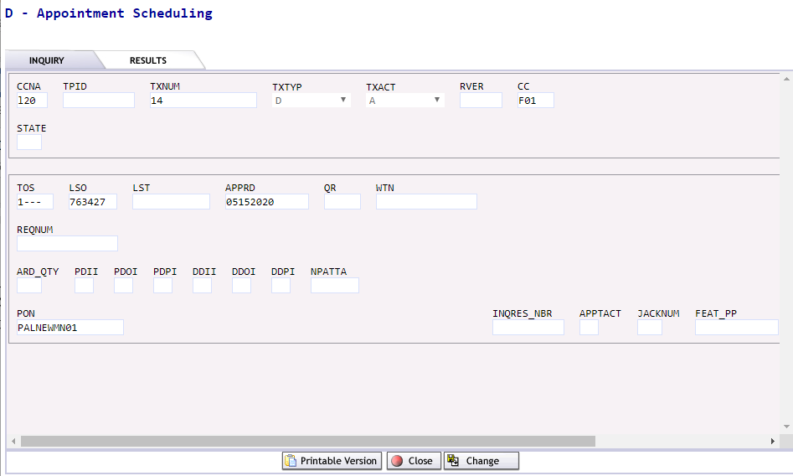
    If the pre-order information is incorrect, users will have the opportunity to correct the information by clicking on the Change button.
    To cancel the request and return to the PreOrder screen, click on the Close button.

Viewing results from the Appointment Scheduling Screen | The results from the Appointment Scheduling Preorder can be seen below:  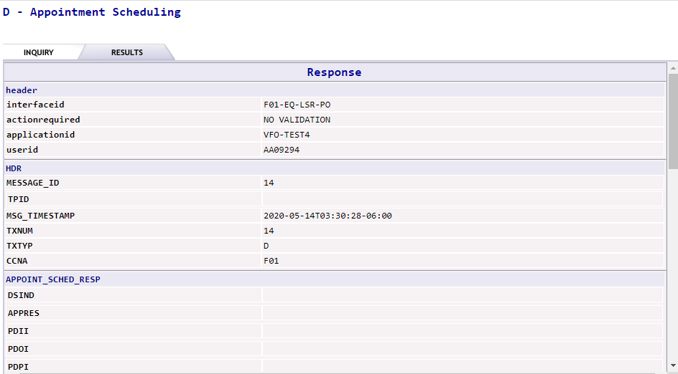  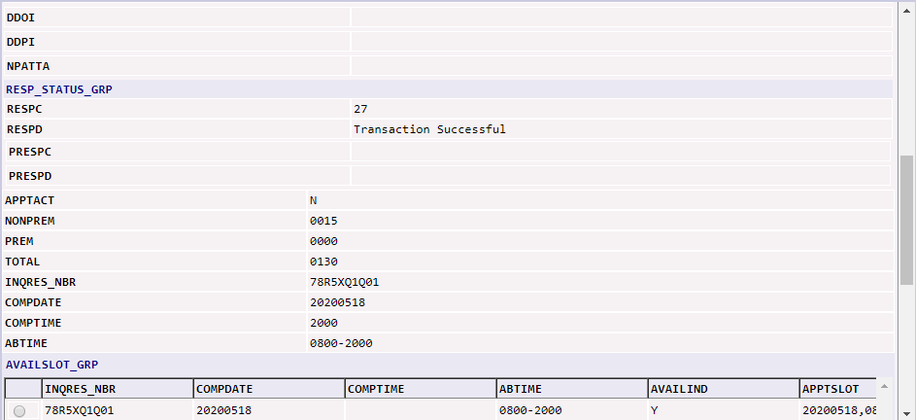  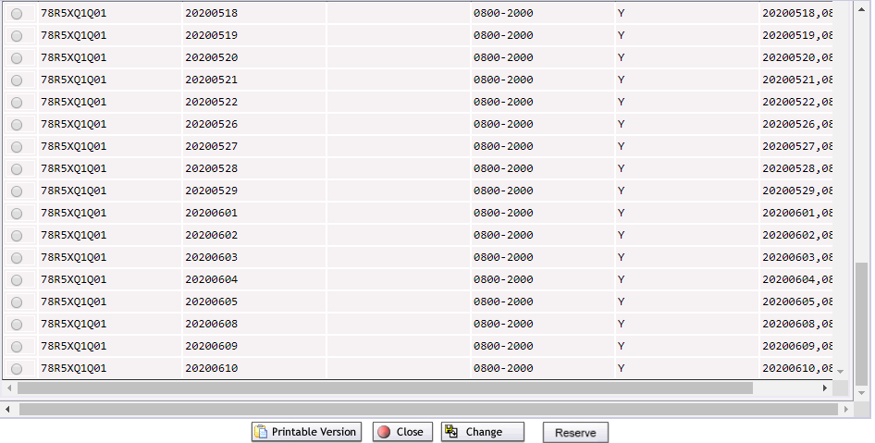  To Reserve an appointment, click on the radial button to the left of the Appointments can be selected by clicking on the radial button located to the left of the INQRES_NBR field.
  To obtain a printable version of the successful information, click on Printable Version.
  To save the PreOrder inquiry, click on the Save button. Users will have the option to reference the saved information by the TXNUM of the inquiry.

Reserving an Appointment | To reserve an appointment in EASE for use on a PON, please use the following steps:
  Step | Action
  1 | Complete an Appointment Scheduling Pre-order and obtain the valid results.
  2 | From the RESULTS tab, select the desired Appointment and time by clicking on the radial button to the left of the desired appointment.  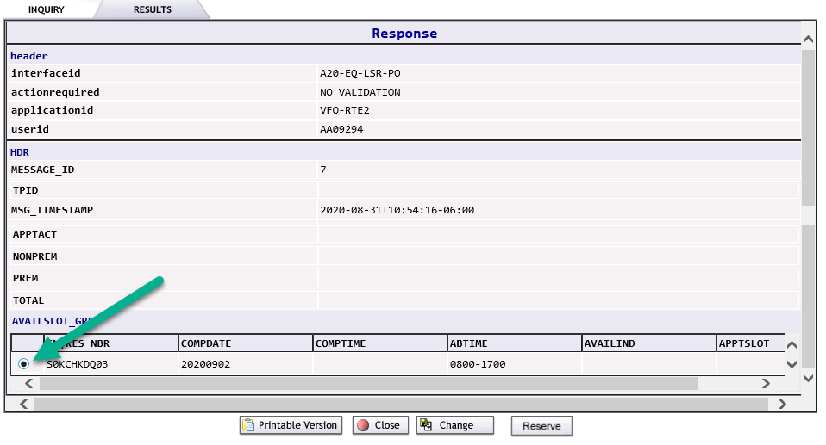
  3 | Click on the Reserve button at the bottom of the preorder Results screen.
  4 | A secondary screen will display with the appointment information.  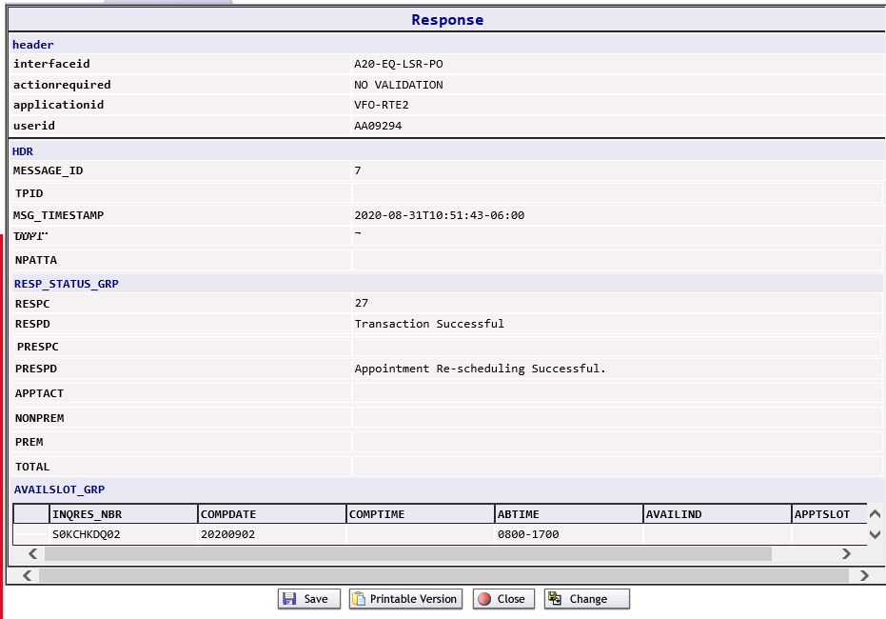
  5 | Click SAVE to save the appointment.  Please Note: Saved Appointments will be retained for a period of 24 hours.

Customer Service Information
Starting the Customer Service Information inquiry | The following steps will describe specific instructions for performing a Customer Service Information Inquiry and will be done after starting the EASE Pre-Order Inquiry process.
  Step | Action
  1 | Begin the Pre-Order Inquiry by selecting the E – Customer Service Information option.
  2 | The E – Customer Service Information screen will be displayed  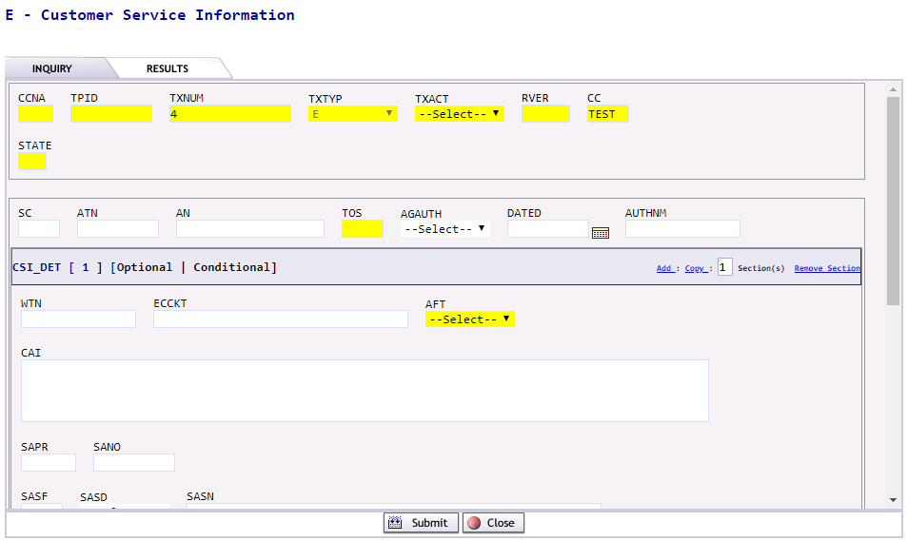
    Required fields:
    CCNA | Customer Name Abbreviation
    TXACT | Transaction Activity.
      Letter | Usage
      A | New Inquiry
    STATE | The 2 digit abbreviation for the state
    AGAUTH | Authorization
    DATED | LOA Authorization Date
    WTN | Working Telephone Number
    CSR_Date | Users have the option in date formatted fields to use the calendar () ICON to select a specific date. When the ICON is clicked, a calendar will be displayed allowing the user to select a specific date.  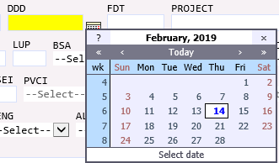  Upon selecting a specific date, the date will be formatted to the field format expected
    SERVIND | Populate with the value of:
      Letter | Usage
      N | ECCKT
      T | TN
    TXACT | Populate with a A
    RTNMETH | Populate with a N
  3 | Click the SUBMIT button to initiate or CLOSE button to exit from the inquiry
  4 | If the SUBMIT button has been clicked the user will see a message that the inquiry has executed, and the system is waiting for a PreOrder Response ……  Please note: If the CLOSE button is selected from this screen, the inquiry will be stopped.
  5 | Upon completion of the Pre-Order, the system will execute the request and provide a response upon submission.

Viewing results from the Customer Service Information Screen | The information from the Customer Service Information Inquiry will be displayed.  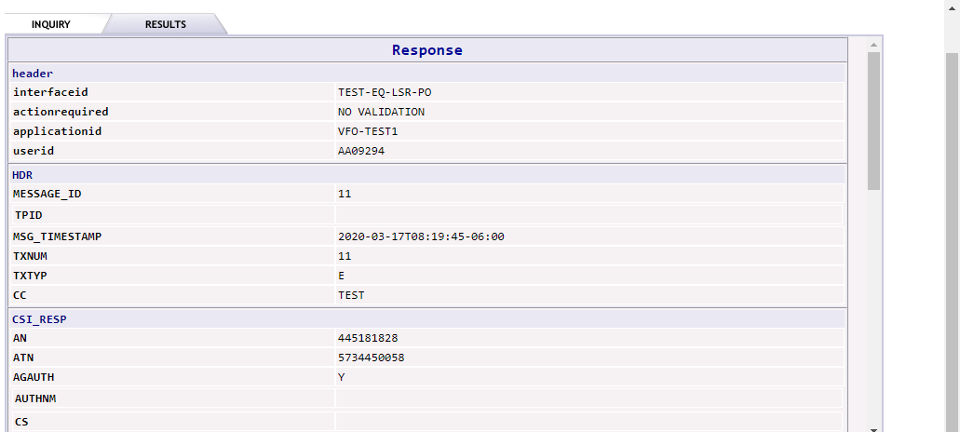  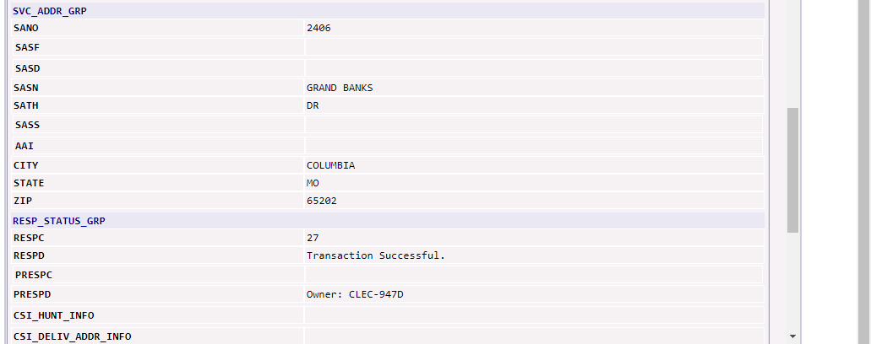  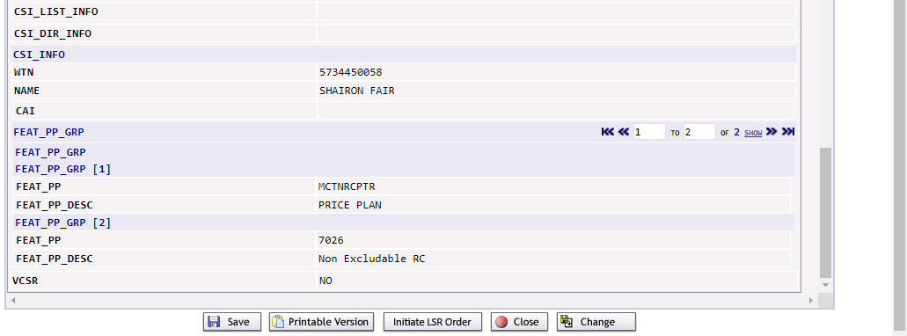
  1 | If the pre-order information is incorrect, users will have the opportunity to correct the information by clicking on the Change button.
  2 | To cancel the request and return to the PreOrder screen, click on the Close button.
  3 | To obtain a printable version of the successful information, click on Printable Version.
  4 | To save the PreOrder inquiry, click on the Save button. Users will have the option to reference the saved information by the TXNUM of the inquiry.
  5 | To begin a new LSR order, click on the Initiate LSR button. Users will be taken to the Order Creation screen. The information from the preorder will not be transferred to the new order.

Loop Qualification
Starting the Address Validation Inquiry | The following steps will describe specific instructions for performing an EASE Address Validation Inquiry and will be done after starting the EASE Pre-Order Inquiry process.
  Step | Action
  1 | Begin the Pre-Order Inquiry by selecting the H – Loop Qualification option.
  2 | The H – Loop Qualification screen will be displayed. Users will be able to scroll thru the screen by using the slider bar on the right-hand side of the screen.  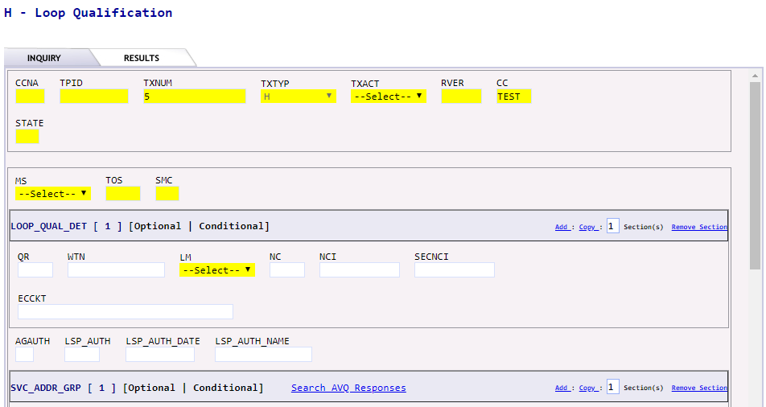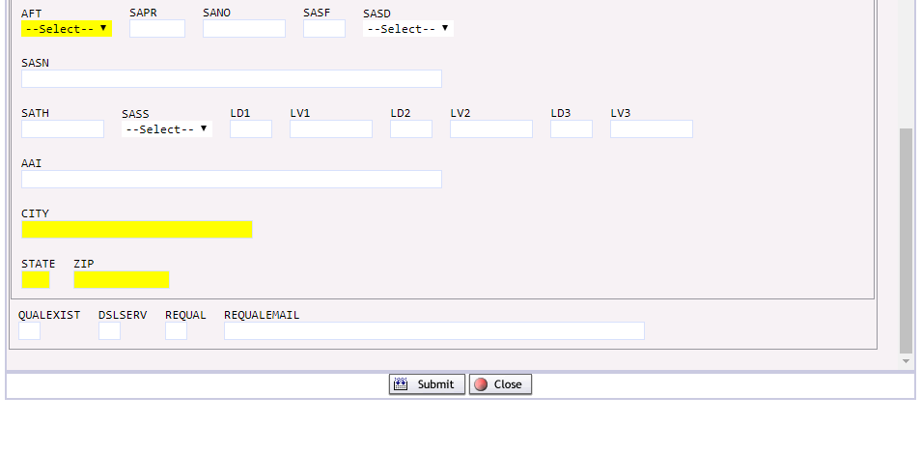
    Required fields:
    CCNA | Customer Name Abbreviation
    TXACT | Transaction Activity.
      Letter | Usage
      A | New Inquiry
    STATE | 2 Digit State abbreviation
    MS | Type of service
      Letter | Usage
      A | Resale
      B | UNE
    Select one of the following options:
    WTN | Working Telephone Number
    SVC_ADDR_GRP | Enter in a valid service address in the fields provided
  3 | Click the SUBMIT button to initiate or CLOSE button to exit from the inquiry
  4 | If the SUBMIT button has been clicked the user will see a message that the inquiry has executed, and the system is waiting for a PreOrder Response ……  Please note: If the CLOSE button is selected from this screen, the inquiry will be stopped.
  5 | Upon completion of the Pre-Order, the system will execute the request and provide a response upon submission.

Viewing results from the Loop Qualification Screen | The information from the Loop Qualification Inquiry will be displayed.  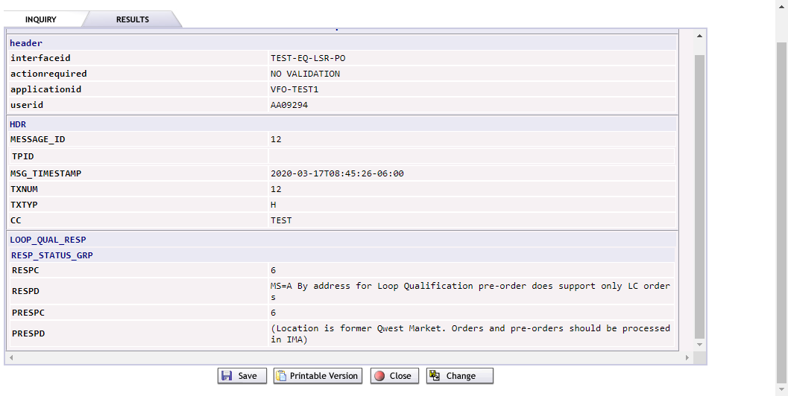
  If the pre-order information is incorrect, users will have the opportunity to correct the information by clicking on the Change button.
  To cancel the request and return to the PreOrder screen, click on the Close button.
  To obtain a printable version of the successful information, click on Printable Version.
  To save the PreOrder inquiry, click on the Save button. Users will have the option to reference the saved information by the TXNUM of the inquiry.

Validate CFA
Starting the Validate CFA Inquiry | The following steps will describe specific instructions for performing an EASE Validate CFA Inquiry and will be done after starting the EASE Pre-Order Inquiry process.
  Step | Action
  1 | Begin the Pre-Order Inquiry by selecting the K – Validate CFA option.
  2 | The K – Validate CFA screen will be displayed  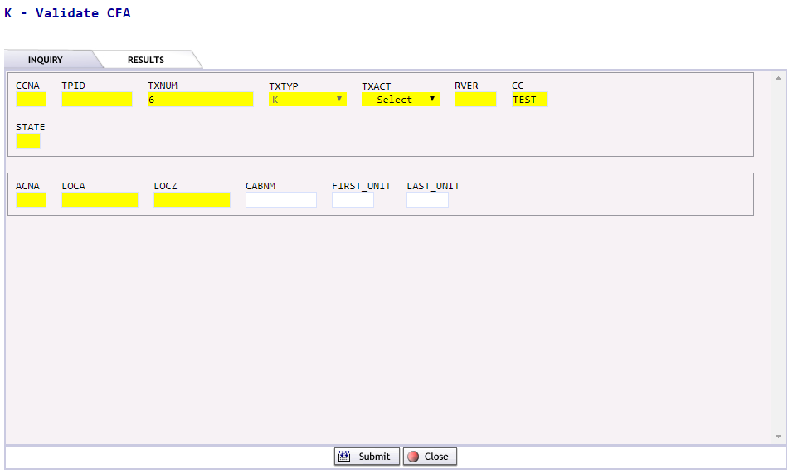
    Required fields:
    CCNA | Customer Name Abbreviation
    TXACT | Transaction Activity.
      Letter | Usage
      A | New Inquiry
    STATE | 2 Digit State abbreviation
    ACNA | The 4-character ACNA of the facility owner.
    LOCA | The location A CLLI code associated to the facility
    LOCZ | The location Z CLLI code associated to the facility.
  3 | Click the SUBMIT button to initiate or CLOSE button to exit from the inquiry
  4 | If the SUBMIT button has been clicked the user will see a message that the inquiry has executed, and the system is waiting for a PreOrder Response ……  Please note: If the CLOSE button is selected from this screen, the inquiry will be stopped.
  5 | Upon completion of the Pre-Order, the system will execute the request and provide a response upon submission.

Viewing results from the Validate CFA Screen | The results from the Validate CFA inquiry will be displayed. Users can use the scroll bar on the right-hand side of the screen to advance thru the provided response.  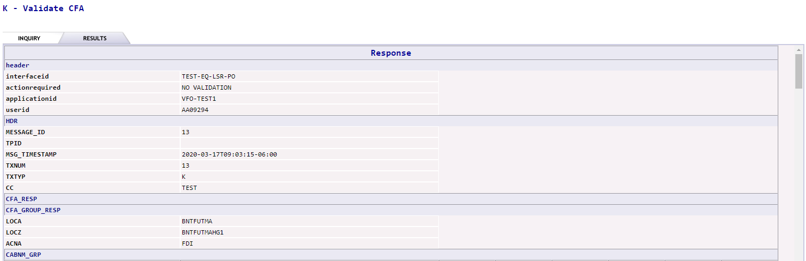  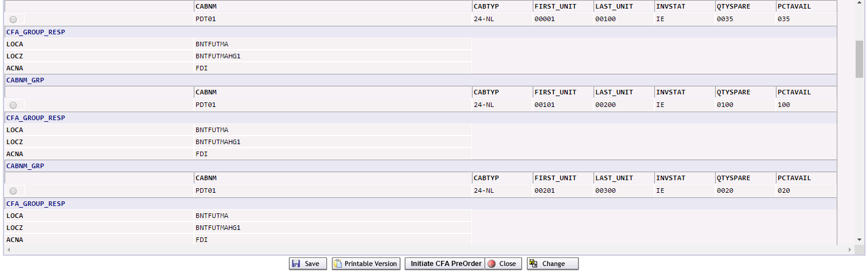
  If the pre-order information is incorrect, users will have the opportunity to correct the information by clicking on the Change button.
  To cancel the request and return to the PreOrder screen, click on the Close button.
  To obtain a printable version of the successful information, click on Printable Version.
  To save the PreOrder inquiry, click on the Save button. Users will have the option to reference the saved information by the TXNUM of the inquiry.
  To initiate a new CFA PreOrder, click on the Initiate CFA PreOrder button.

Facility Availability
Starting the Address Validation Inquiry - | The following steps will describe specific instructions for performing an EASE Address Validation Inquiry and will be done after starting the EASE Pre-Order Inquiry process.
  Step | Action
  1 | Begin the Pre-Order Inquiry by selecting the O – Facility Availability option.
  2 | The O – Facility Availability screen will be displayed  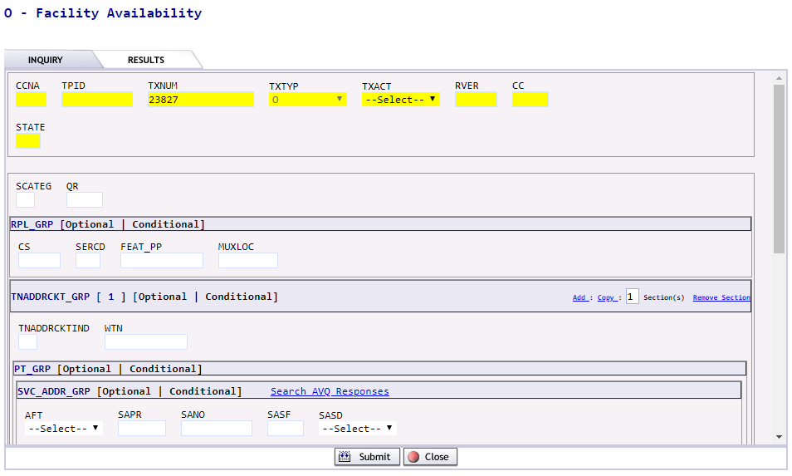
    Required fields:
    CCNA | Customer Name Abbreviation
    TXACT | Transaction Activity.
      Letter | Usage
      A | New Inquiry
    SCATEG | Enter value of D, H, I, P or U
      Letter | Usage
      D | Design Service (DSO)
      H | Hi Capacity (DS1,DS3)
      I | ISDN
      P | POTS, PAL
      U | Unbundled Loop
    QR | The quantity of facilities requested – up to 10 will be supported
    TNADDRCKTIND | The TN address circuit Indicator
    SVC-ADDR_GRP – Provide details regarding the address
    LSO |  | The NPA NXX associated to the address
    WTN |  | Required if you are searching by TN
  4 | Click the SUBMIT button to initiate or CLOSE button to exit from the inquiry
  5 | If the SUBMIT button has been clicked the user will see a message that the inquiry has executed, and the system is waiting for a PreOrder Response ……  Please note: If the CLOSE button is selected from this screen, the inquiry will be stopped.
  6 | Upon completion of the Pre-Order, the system will execute the request and provide a response upon submission.

Viewing results from the Facility Availability Screen | The results from the Facility Availability Inquiry will be displayed.  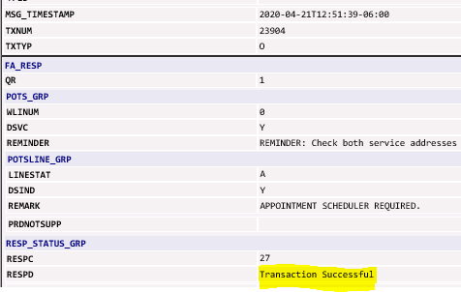
  If the pre-order information is incorrect, users will have the opportunity to correct the information by clicking on the Change button.
  To cancel the request and return to the PreOrder screen, click on the Close button.
  To obtain a printable version of the successful information, click on Printable Version.
  To save the PreOrder inquiry, click on the Save button. Users will have the option to reference the saved information by the TXNUM of the inquiry.

Raw Loop Data
Starting the Raw Loop Data Inquiry - | The following steps will describe specific instructions for performing a Raw Loop Data Inquiry and will be done after starting the EASE Pre-Order Inquiry process.
  Step | Action
  1 | Begin the Pre-Order Inquiry by selecting the R – Raw Loop Data option.
  2 | The R – Raw Loop Data screen will be displayed  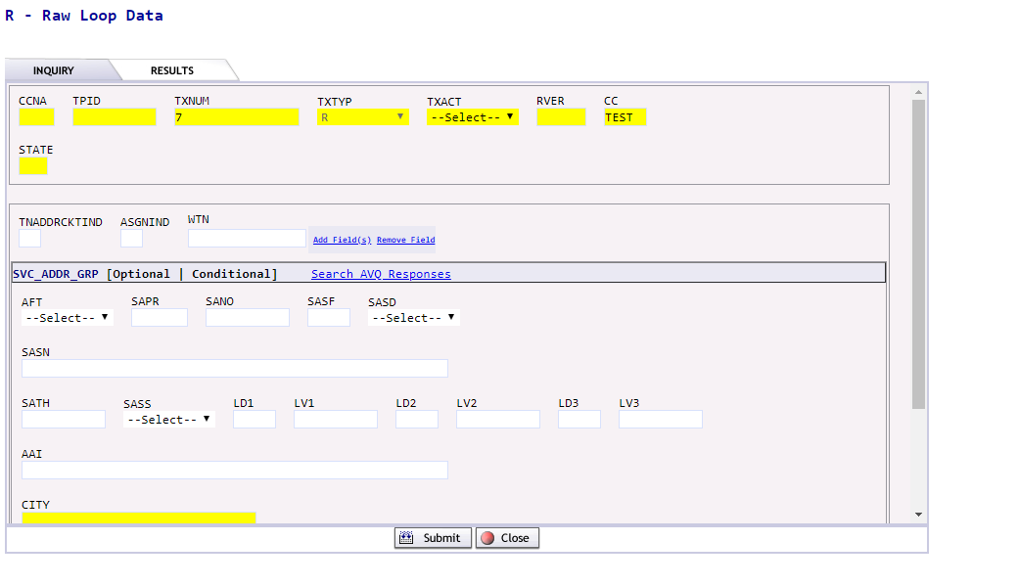
    Required fields:
    CCNA | Customer Name Abbreviation
    TXACT | Transaction Activity.
      Letter | Usage
      A | New Inquiry
    TNADDRCKTIND | Enter a value from the list below
      Letter | Usage
      A | Address
      C | Circuit
      T | Telephone Number
    ASGNIND | Enter a value from the list below:
      Letter | Usage
      A | Assigned
      U | Unassigned or spare
    SVC_ADDR_GRP | Enter the valid address
    State | Enter the valid 2-digit State Abbreviation
  4 | Click the SUBMIT button to initiate or CLOSE button to exit from the inquiry
  5 | If the SUBMIT button has been clicked the user will see a message that the inquiry has executed, and the system is waiting for a PreOrder Response ……  Please note: If the CLOSE button is selected from this screen, the inquiry will be stopped.
  6 | Upon completion of the Pre-Order, the system will execute the request and provide a response upon submission.

Viewing the results from the Raw Loop Data Screen | The information from the Raw Loop Data Inquiry will be displayed.  The Information from the Raw Loop Data Inquiry will be displayed. As users scroll thru the response, they may notice that additional records are present.  Users can use the Right / Left arrows to view all responses that are available.  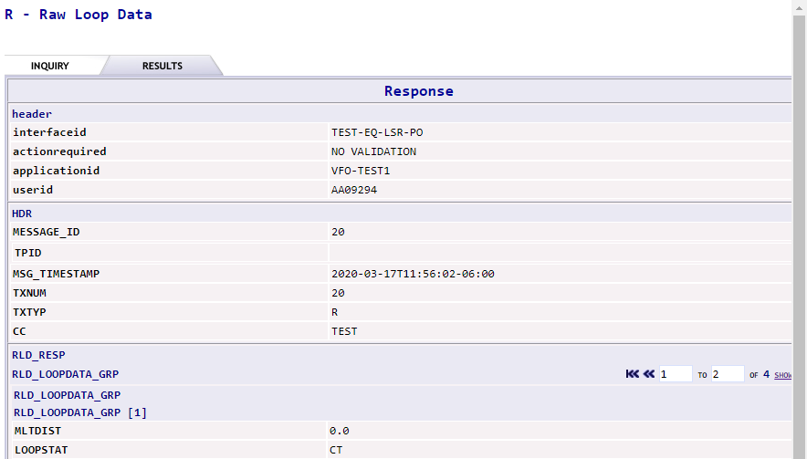  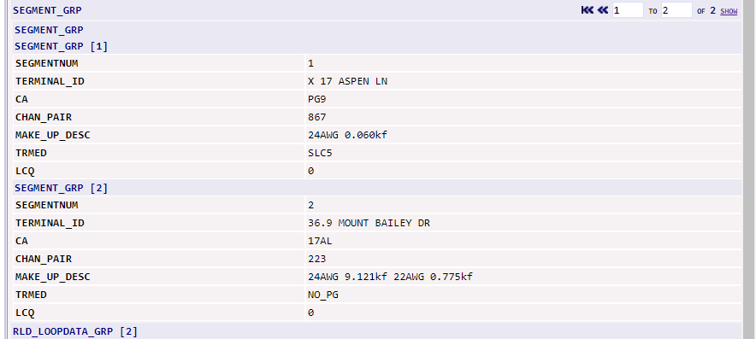  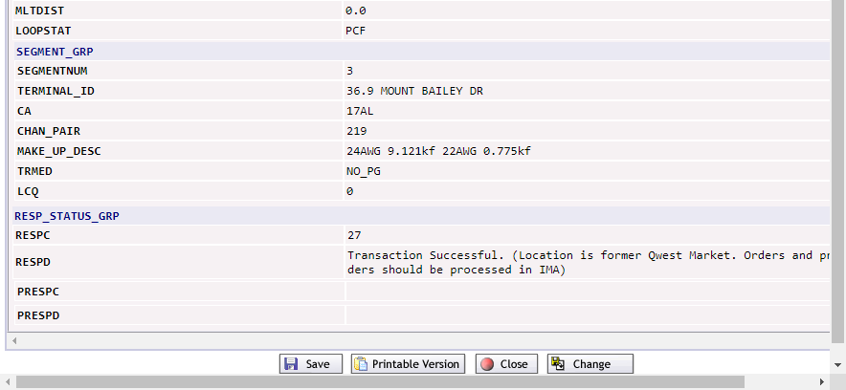
  If the pre-order information is incorrect, users will have the opportunity to correct the information by clicking on the Change button.
  To cancel the request and return to the PreOrder screen, click on the Close button.
  To obtain a printable version of the successful information, click on Printable Version.
  To save the PreOrder inquiry, click on the Save button. Users will have the option to reference the saved information by the TXNUM of the inquiry.

Listing for Telephone Number
Starting the Listing for Telephone Number Inquiry | The following steps will describe specific instructions for performing an Telephone Number Listing and will be done after starting the EASE Pre-Order Inquiry process.
  Step | Action
  1 | Begin the Pre-Order Inquiry by selecting the T – Listings for Telephone Number option.
  2 | The T- Listings for Telephone Number screen will be displayed  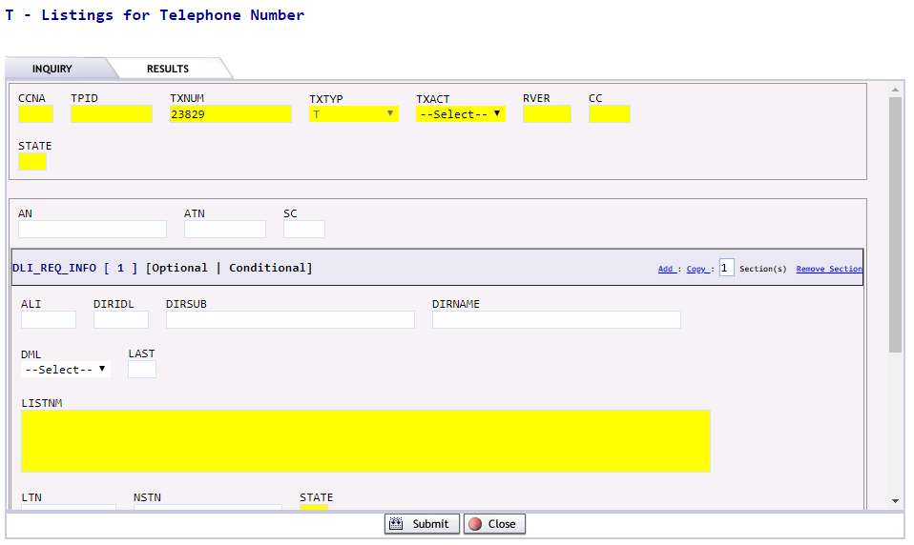
    Required fields:
    CCNA | Customer Name Abbreviation
    TXACT | Transaction Activity
      Letter | Usage
      A | New Inquiry
    STATE | Enter the 2-digit abbreviation for the state
    AN | Account Number
    DIRNAME | Enter the City Name
    LTN | Enter the valid 10-digit Listing Number
    STATE | Enter the 2-digit State Abbreviation
    TXACT (in-body) | For inquiries in the Legacy Qwest area, select a value from the list below:
      Letter | Usage
      A | Account Telephone Number
      C | Caption Listing
      N | Non-Standard Telephone Number
      S | Straight Line Under
      T | Listed Telephone Number
  4 | Click the SUBMIT button to initiate or CLOSE button to exit from the inquiry
  5 | If the SUBMIT button has been clicked the user will see a message that the inquiry has executed, and the system is waiting for a PreOrder Response ……  Please note: If the CLOSE button is selected from this screen, the inquiry will be stopped.
  6 | Upon completion of the Pre-Order, the system will execute the request and provide a response upon submission.

Viewing results from the Telephone Number Listings Screen | The results from the Telephone Number Listing Screen will be displayed.  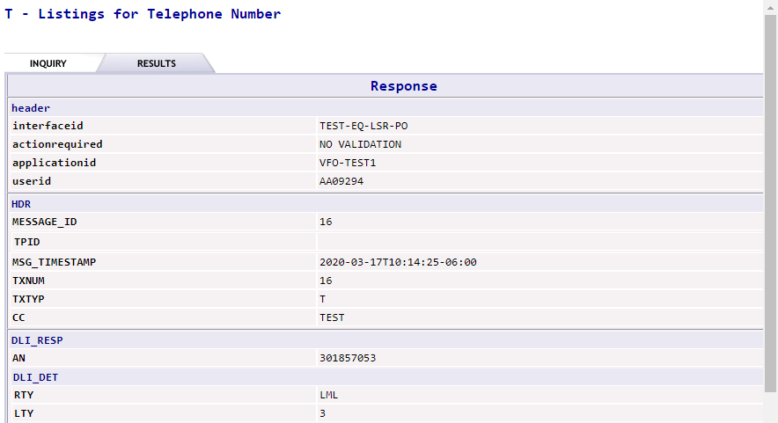  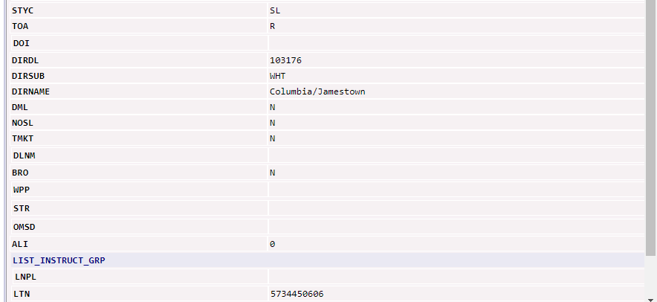  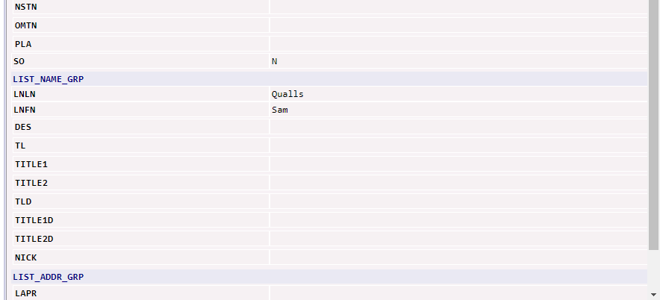  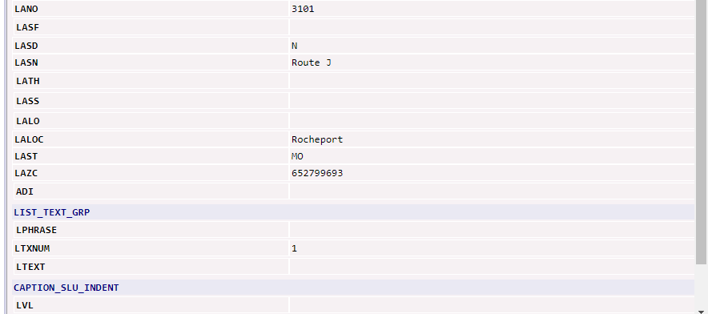  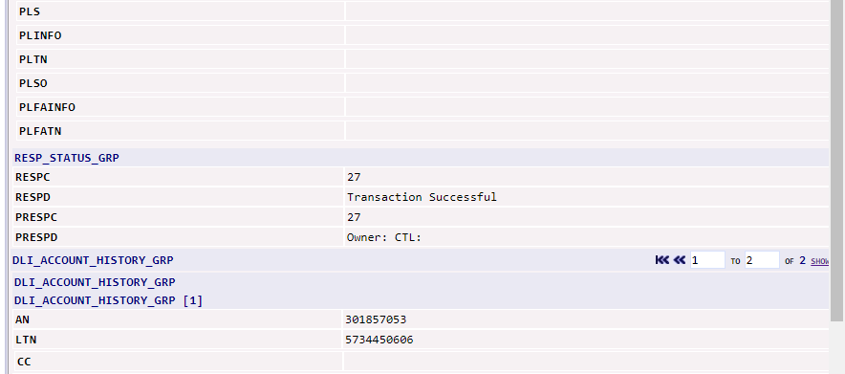  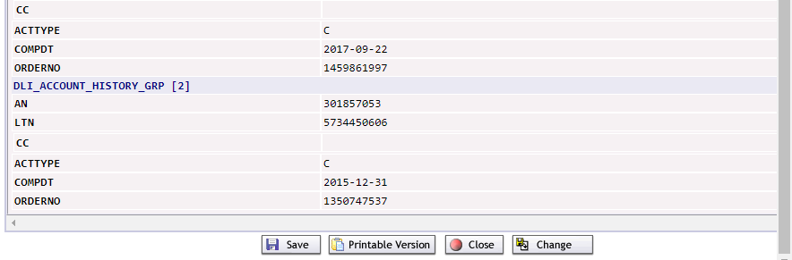
  If the pre-order information is incorrect, users will have the opportunity to correct the information by clicking on the Change button.
  To cancel the request and return to the PreOrder screen, click on the Close button.
  To obtain a printable version of the successful information, click on Printable Version.
  To save the PreOrder inquiry, click on the Save button. Users will have the option to reference the saved information by the TXNUM of the inquiry.

Meet Point Query
Starting the Meet Point Query | The following steps will describe specific instructions for performing an EASE Address Validation Inquiry and will be done after starting the EASE Pre-Order Inquiry process.
  Step | Action
  1 | Begin the Pre-Order Inquiry by selecting the W – Meet Point Query option.
  2 | The W – Meet Point Query screen will be displayed  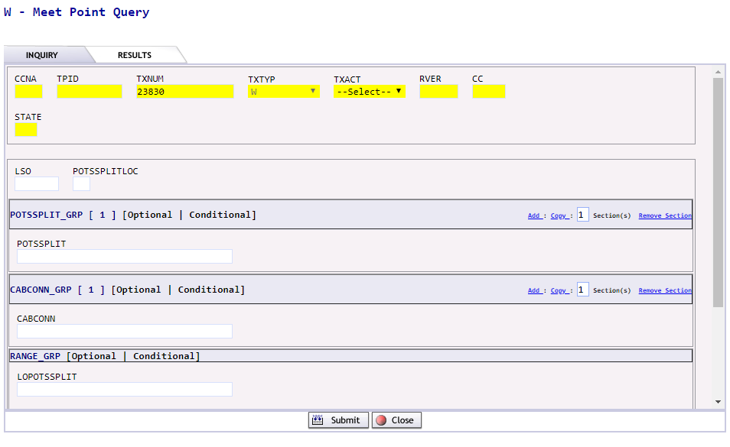
    Required fields:
    CCNA – or -  CC | The CCNA  The Company Code
    STATE | The 2-digit State abbreviation
    LSO | The NPA/NXX being queried
    POTSSPLICLOC | Enter O or I
    POTSPLIT | Enter the POTSPLIT info
  3 | Click the SUBMIT button to initiate or CLOSE button to exit from the inquiry
  4 | If the SUBMIT button has been clicked the user will see a message that the inquiry has executed, and the system is waiting for a PreOrder Response ……  Please note: If the CLOSE button is selected from this screen, the inquiry will be stopped.
  5 | Upon completion of the Pre-Order, the system will execute the request and provide a response upon submission.

Viewing the results from the Meet Point Inquiry Screen | The details from the Meet Point Inquiry will be displayed.  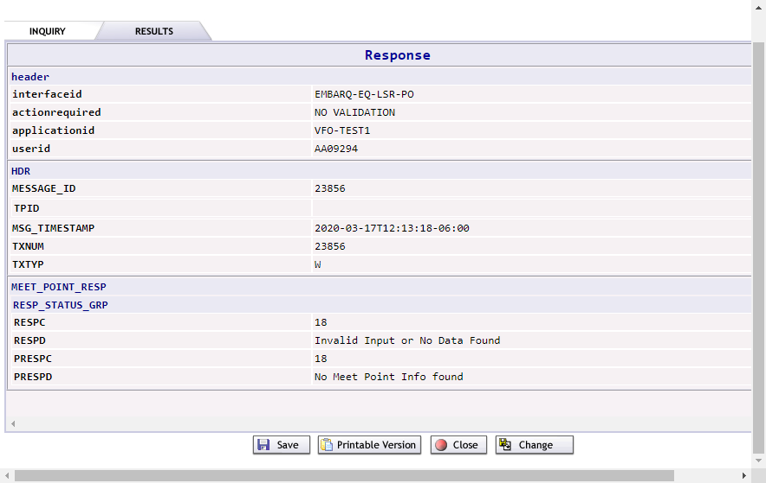
  If the pre-order information is incorrect, users will have the opportunity to correct the information by clicking on the Change button.
  To cancel the request and return to the PreOrder screen, click on the Close button.
  To obtain a printable version of the successful information, click on Printable Version.
  To save the PreOrder inquiry, click on the Save button. Users will have the option to reference the saved information by the TXNUM of the inquiry.

View DLR
Starting the View DLR Inquiry | The following steps will describe specific instructions for performing an EASE Address Validation Inquiry and will be done after starting the EASE Pre-Order Inquiry process.
  Step | Action
  1 | Begin the Pre-Order Inquiry by selecting option X – View DLR option.
  2 | The X – View DLR screen will be displayed  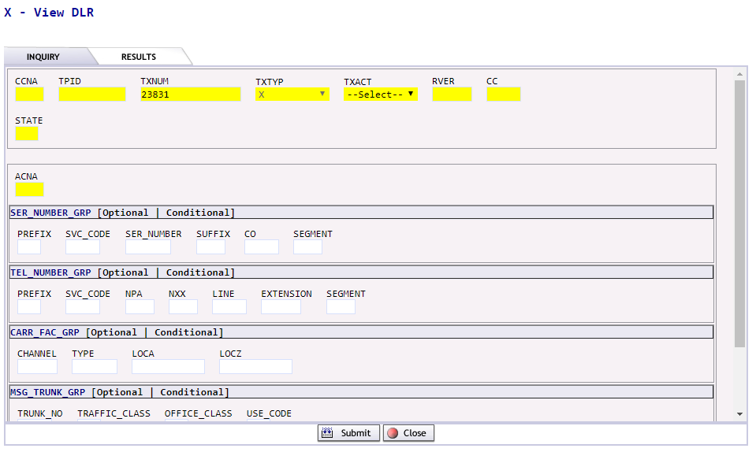
    Required fields:
    TXACT | Transaction Activity.
      Letter | Usage
      A | New Inquiry
    STATE | Enter the 2-digit abbreviation for the state
    ACNA | Enter the 3-digit abbreviation for the ACNA
    CIRCUIT DETAILS
    One section of circuit details must be populated
    SER_NUMBER_GRP |  | Serial Number Group
    TEL_NUMBER_GRP |  | Telephone Number Group
    CARR_FAC_GRP |  | Carrier Facility Group
    MSG_TRUNK_GRP |  | Message Trunk Group
  3 | Click the SUBMIT button to initiate or CLOSE button to exit from the inquiry
  4 | If the SUBMIT button has been clicked the user will see a message that the inquiry has executed, and the system is waiting for a PreOrder Response ……  Please note: If the CLOSE button is selected from this screen, the inquiry will be stopped.
  5 | Upon completion of the Pre-Order, the system will execute the request and provide a response upon submission.

Viewing the results from View DLR | The View DLR results screen will be displayed.  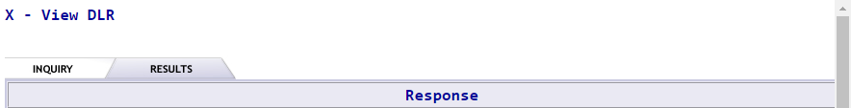  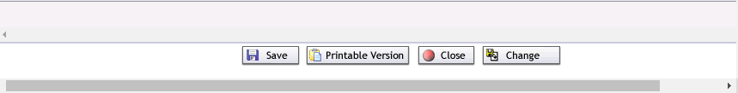
  header
  interfaceid | EMBARQ-EQ-LSR-PO
  actionrequired | NO VALIDATION
  applicationid | VFO-TEST4
  userid | AA08978
  HDR
  MESSAGE_ID | 28321
  TPID
  MSG_TIMESTAMP | 2020-03-16T01:32:04-06:00
  TXNUM | 28321
  TXTYP | X
  DLR_RESP
  ECCKT_FORMAT | C
  ECCKT | 204/T3/GLVYMNORHG2/PLMOMNFEK01
  DLR_HDR_GRP
  DLR_HDR
  ADMINISTRATIVE SECTION
  IC TQW PON N6454108SA12 VER ECIA PG D001 OF 004
  CKR 6006.T3X1.MPLTMNFJK01.PLMOMNF E#VM ISS 11-02-10
  CO NWMN ORD C77771167 DLR 001 OF 001 ISS NO 01
  ECCKT 204 /T3 /GLVYMNORHG2/PLMOMNFEK01 REFNUM
  DLR_DET_GRP
  DLR_DET
  TSC CLO MNC355438001 TSP DSGCON NANCY GEE
  TEL 972-578-3791- EC DSGCON LAYNE ARGYLE EC TEL 888-678-8080-
  EC MCO 888-678-8080- EC OCO 888-678-8080-
  PTD 11-08-10 DD 11-15-10
  REMARKS
  DESIGN SECTION
  ACTL GLVYMNORHG2 LT APOT SLC TCIC CKLT PLMOMNFE
  CSPC - - PRILOC SPOT (PRI)
  ECSPC - - SECLOC C PLMOMNFEK01 SPOT (SEC)
  NC HF-M NCI 04QB6.33 . TLV T R
  SECNCI . . SECTLV T R
  N LOCN EQPT/FAC RR/FACTYPE UN/CH SV Z-A A-Z INC MI MISC
  GLVYMNORHG2 1:4 FZZ
  PDV02 35-COA 00039 X4 1:0
  .0M MN 61
  1:4 F16/08/RL05/27
  GLVYMNOR
  DESIGN SECTION
  N LOCN EQPT/FAC RR/FACTYPE UN/CH SV Z-A A-Z INC MI MISC
  LOCB SNMS
  LOCB
  STS1
  003.9M MNMN
  LOCC
  SNMS
  T1MB
  T3C1
  T3DA
  1 PLMOMNFEK01
  PRIMARY LOCATION SECTION
  EU STREET EU BLDG
  EU FLR EU ROOM EU CITY EU STATE
  EU TERM E RCV E XMT
  EU TERM 4W E XMT 4W
  SECONDARY LOCATION SECTION
  EU STREET 710 MENDELSSOHN AVE N EU BLDG
  EU FLR EU ROOM EU CITY GLDN VLY EU STATE MN
  EU TERM DEMARC E XMT E RCV
  EU TERM 4W DEMARC E RCV 4W
  NOTES SECTION
  1 EGJ1A
  RESP_STATUS_GRP
  RESPC | 27
  RESPD | Transaction Successful
  If the pre-order information is incorrect, users will have the opportunity to correct the information by clicking on the Change button.
  To cancel the request and return to the PreOrder screen, click on the Close button.
  To obtain a printable version of the successful information, click on Printable Version.
  To save the PreOrder inquiry, click on the Save button. Users will have the option to reference the saved information by the TXNUM of the inquiry.

TEMPLATE Tab

Overview | The Template tab allows users to create templates in EASE VFO for future order entry. A template allows the user to quickly create orders that contain the same information. For that reason, it is best to keep the information in a template very basic. The template is created using the same LSOG version, Order Activity and Type of order.  In the template tab, users can create a NEW template or SEARCH for an existing template.  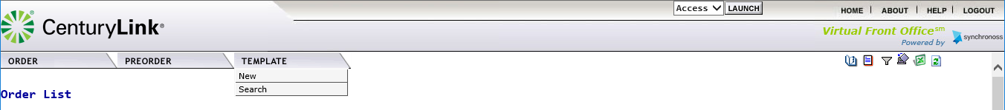

Creating a NEW Template | The following steps can be used to create a new template.
  Step | Action
  1 | Select NEW from the Template Tab drop down menu.
  2 | Users will be taken to the Template Initiation Screen  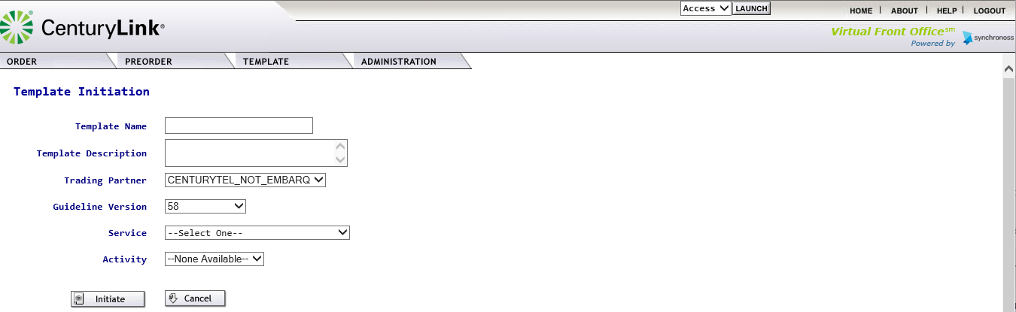
  3 | Users will enter the information in the following fields
    Field | Description
    Template Name | Enter a unique template name up to 20 characters long
    Template Description | Additional details regarding the template can be entered
    Trading Partner | It is recommended that this field not be altered.
    Guideline Version | This will default to the most current LSOG version in EASE. It is recommended that this field not be altered.
    Service | Select the Service Type from the drop- down menu.  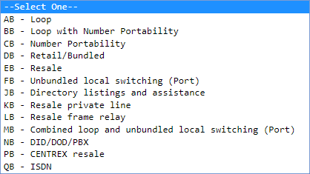
    Activity | Select the Activity from the drop-down menu. The values displayed identify the activity types permitted per ordering guidelines.
      Activity | Used for
      B | Restore
      C | Change an existing account
      D | Disconnection
      L | Seasonal Suspension
      N | New Installation
      S | Suspension
      T | Outside move
      V | Conversion
      W | Conversion as is
      Y | Combined Loop
  4a | Click Initiate to begin the template creation  
  4b | Click Cancel to cancel the request and be returned to the EASE main menu.
  5 | If the template is initiated, users will be taken to the Template Screens where they have the ability to enter information in each of the associated order screens.  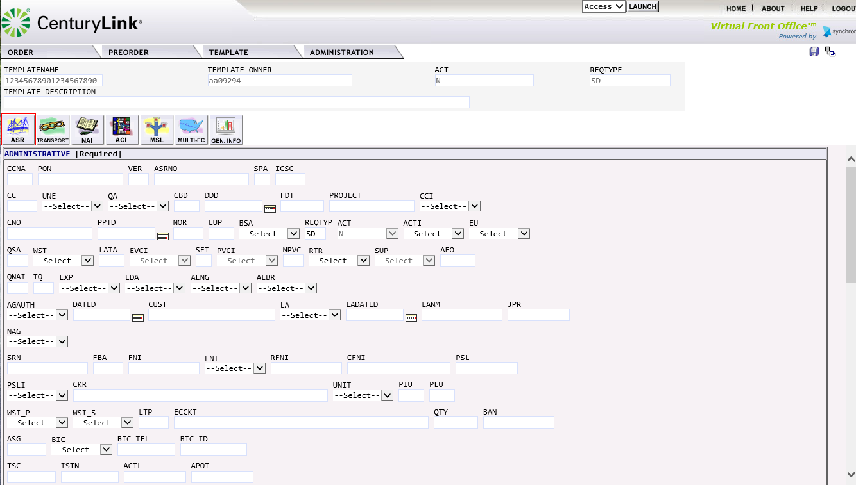
  6 | Users can move between the order sections by clicking on the various ICONs for each of the order pages.
  7 | When the template is finished, click the save icon ( )located in the top right-hand corner to save the template for future use.
  8 | Users will see a message displayed under the order tab – Record Successfully Saved.  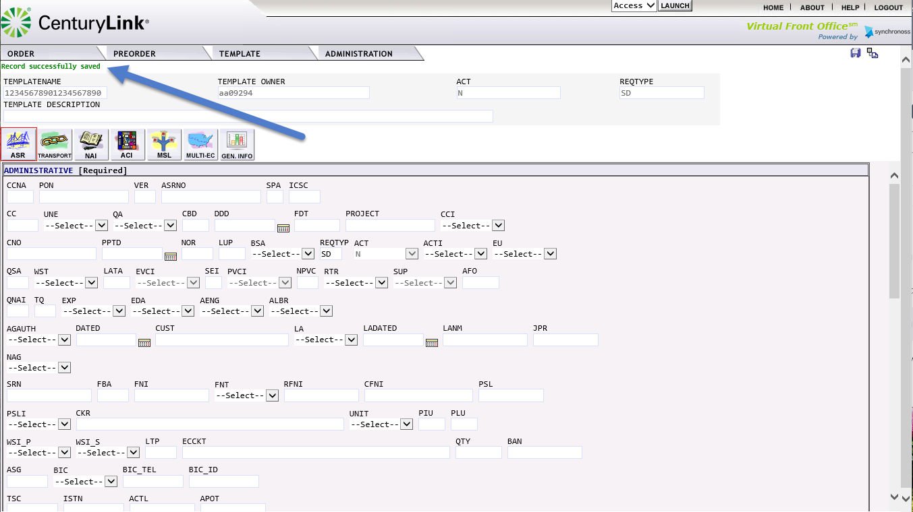
  9 | To return to the Template Tab Main menu, click on the return to list icon () located in the top right-hand corner.

Using SEARCH in the Template Tab | The following steps can be used to Search for a template Name.
  Step | Action
  1 | Select Search from the Template Tab drop down menu.
  2 | Users will be taken to the Template List Screen.  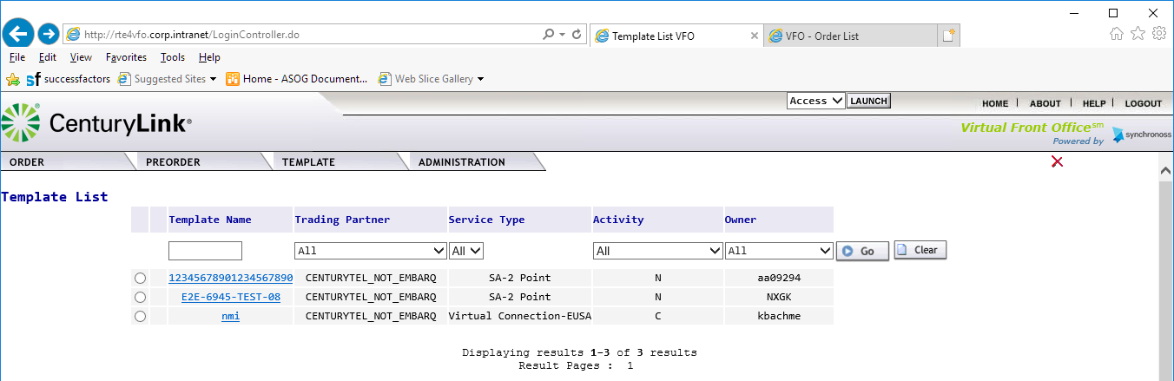

Viewing the Template List | A list of all saved templates can be viewed in the Template List.  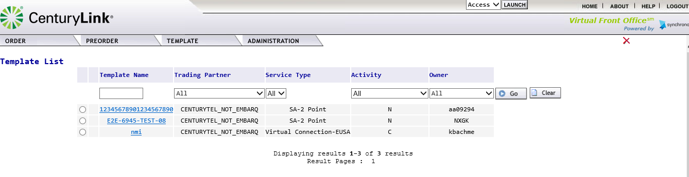  Users can sort the saved templates by using the column drop down options. Note: To reset the Template List, click on the CLEAR button

Selecting a Template | To open a specific template, users should use the following steps.
  Step | Action
  1 | Click on Template Name.
  2 | The template will be opened. Users have the ability at this point to make and save changes to the template.

Deleting a Template | To delete a specific template, users should follow the following steps.
  Step | Action
  1 | Click the radial button to the left of the template name that is to be deleted.  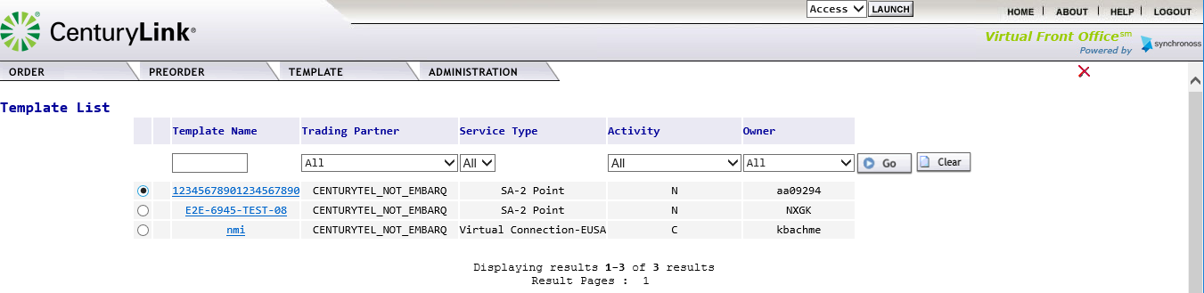
  2 | Click on the red X located in the top right-hand corner of the screen.  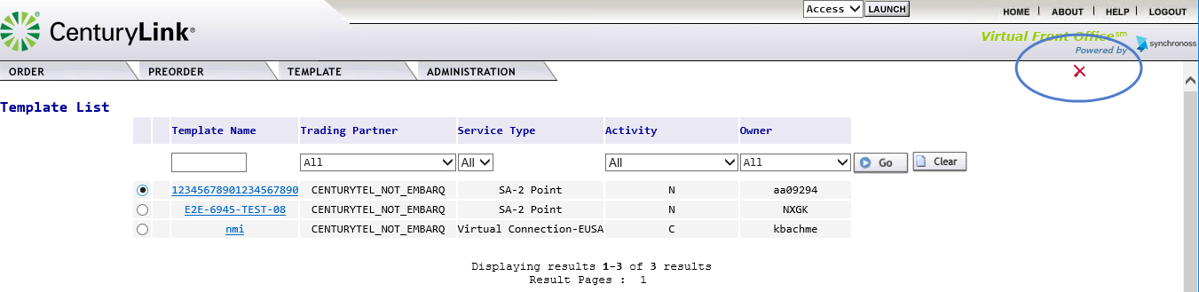
  3 | Users will receive a pop-up screen to confirm the deletion of the record.  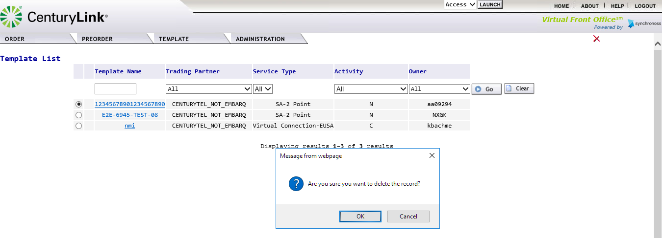
  4 | Click OK to delete the record  
  5 | Click Cancel to exit the delete request and return to the Template List.

Creating an Order in EASE VFO
Overview | This section is creating an LSR in EASE VFO. Because of the requirements for each LSR type and activity, this section is not meant to represent all edits and field entries.

EASE Helpdesk contact information | The EASE helpdesk can be contacted  - Telephone at: 1-888-796-9102, option 2, 2 for LSR  Monday-Friday 6:00 a.m. to 5:30 p.m. (Mountain Time) Saturday 7:00 a.m. to 2:00 p.m. (Mountain Time)  - Via email at: Helpdesk.EASE@CenturyLink.com

Additional Resources | The following additional resources are also available:  - The LSR Order page URL: http://ease.centurylink.com  - The LSOG document is available from ATIS.org.

Beginning an Order in VFO | The following steps should be used to create a manual order within EASE VFO
  Step | Action
  1 | From the Order Tab, Select NEW to begin the order creation.  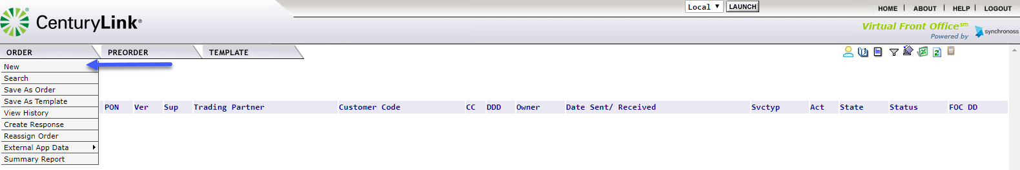
  2 | Users will be taken to the Order Initiation to set the initial order requirements.  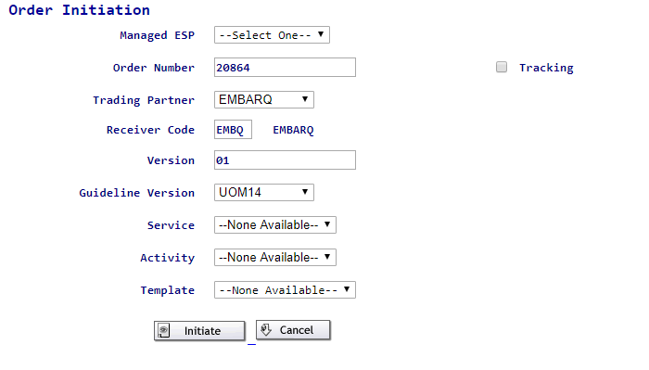
    Field | Definition
    Managed ESP | Identifies the managed customer group. Use the drop-down menu to select the managed customer group.
    Order Number | This will become the PON. Users can keep the system generated number or enter a unique 16 alpha-numeric name.  Please note: PON names cannot be re-used within a 2-year window.
    Trading Partner | This field should be left as EMBARQ to route properly.
    Receiver Code | This field should be left as EMBQ to route properly.
    Version | This will always be defaulted to 01. It is recommended that this value not be altered.
    Guideline Version
    Service | Select a Service from the drop-down menu  Please note: CLECs will receive an error if a selected service is not supporting by the existing contract.
      --Select One --
      AB | - | Loop
      BB | - | Loop with Number Portability
      CB | - | Number Portability
      DB | - | Retail / Bundled
      EB | - | Resale
      FB | - | Unbundled local switching (Port)
      JB | - | Directory listings and assistance
      KB | - | Resale private line
      LB | - | Resale frame relay
      MB | - | Combined loop and unbundled local switching (Port)
      NB | - | DID/DOD/PBX
      OB | - | CENTREX resale
      QB | - | ISDN
      Error code | VFO_0409
      Error Message | SELECTED SERVICE TYPE NOT SUPPORTED
    Activity | Select an Activity from the drop-down menu  Please note: The above list is a comprehensive list of all activities supported in EASE. EASE will auto display the valid activities based on the Service Selected.
      --Select One --
      B | - | Restore
      C | - | Change an existing account
      D | - | Disconnection
      L |  | Seasonal suspension
      N |  | New installation
      S |  | Suspension
      T | - | Outside move
      V |  | Conversion
      W |  | Conversion as is
      Y |  | Combined Loop
    Template | Select the Template from the drop-down menu if applicable. This menu will only display a template name if one is available.
  3a | Click on Initiate to create the order  Please note: Once the order has been initiated, the above values cannot be altered.
  3b | Click on Cancel to cancel the request and be returned to the EASE main menu.
  4 | A new window will be opened for the newly created order based on the fields selected.  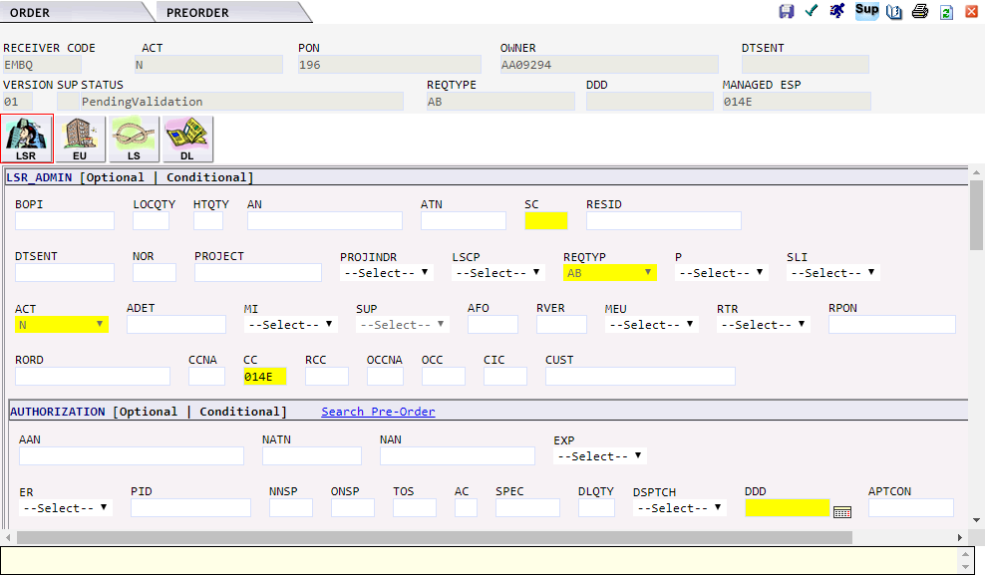

Navigating the Order Screen | The order screen is broken down into 5 basic areas:  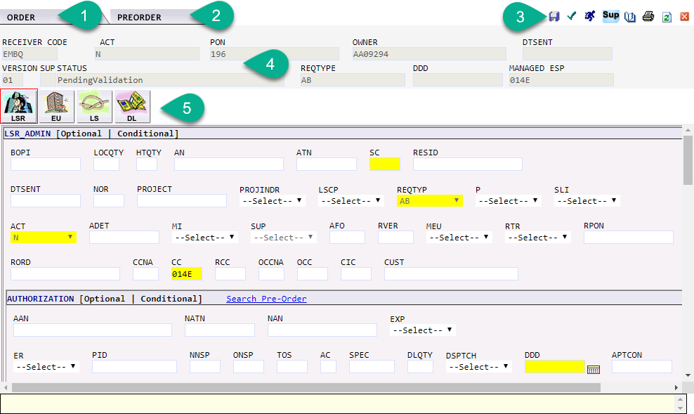  Each of these sections will be further defined below.
  Section |  | Function
  1 | ORDER Tab | This menu will provide various actions that can be performed while working with the order.
  2 | PREORDER tab | This menu will allow the user to perform PREORDER validations
  3 | Order ICONs | This section provides quick links to various order activities.
  4 | Order Header Information | This section defines the order header. The fields contained in the information defined on the Order Initiation screen.  Customer Code: The user must select the appropriate CCNA from drop-down menu. Only CCNAs associated to the customer group are available for selection.
  5 | Associated LSR Forms | EASE will display the associated LSR forms based on the Service Type selected on the Order Initiation Screen.
ORDER Tab | The ORDER tab defines various activities that can occur within an order. In some cases, the same activity is available thru an ICON on the top right-hand side. Users can use the order tab or the ICON to perform the requested action.  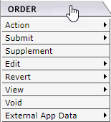
  Order Action | Defined activity
  Action | Provides the ability for a user to
    Action | Definition
    Save Order | System will save all field entries on the order.
    Save As Order | Allows the user to save the order under a different PON name. User will be taken back to the order Initiation Screen where additional fields can be altered.
    Save As Template | This allows the user to create a template from the order entry information.
    Validate | Allows the user to validate the order information.
  Submit | Provides the ability for the user to
    Action | Definition
    Validate and Submit | Validate the information entered on the LSR. If no errors are present, the order will be submitted to CenturyLink.
    Submit without Validate | This option is available to CenturyLink Administrators. This will allow an order with non-fatal errors to be submitted/accepted.
  Supplement | Provides the ability for the user to
    Action | Definition | EASE will alter the SUP field to
    Cancel | Cancel the LSR | 1
    DDD Change | Modify the DDD field | 2
    Others | Modify the accepted LSR  *PRE-FOC  *POST-FOC | 4  3
  Edit | Provides the ability for the user to
    Action | Definition
    Create Response | This option is only available for CenturyLink users to provide a customer response.
    Apply Template | Allow the user to apply fielded template information to the order in progress.
    Resubmit Original Order | Allows the user to revert to previously submitted order.
    Inactivate Order | This reverts the order to inactive and stops the ordering process.
  Revert | Allows the user to revert the order to a previous state/version
    Action | Definition
    Revert to Last Saved | Revert the order to the last saved version. This is only available while working in the current order state.
    Revert to Last Submitted | Revert the order to the previously submitted version of the LSR.
  View | Allows the user to view various information regarding the order:
    Action | Definition
    View History | View all History associated to the order, including all versions and order status information.
    View Error List | View all Errors associated with the current non-submitted version of the order. Users will have the ability to click on the error message to navigate to the field in error where possible.
    View Printable Version | View the PDF version of the order. This option will initiate a separate print-friendly screen. Users will have the ability to print or save the order information.
    Refresh | Refresh the information on the screen
  Void | Void the order information. This option can only be used on orders that have not been submitted to CenturyLink. The PON name associated with the voided pon cannot be reused during the 2-year window.
  External App Data | Allows the user to access the External App Data.  For a full explanation of this option, please see the External App section in the Order Tab provided earlier in this document.

PREORDER Tab | The PREORDER tab provides the user with the ability to check and view information outside of an order. Within the order itself, users can only initiate NEW preorder inquiries.  Detailed information regarding each of the pre-order inquiries can be found in the PREORDER Tab Section of this guide.

Order ICONs | The upper right-hand corner of the VFO Order Screen has 8 action icons to select.
  ICON | Definition
   | Save the Order
   | Validate the Order
   | Validate and Submit the Order
   | Sup the submitted order information
   | Validate and Submit with Errors.
   | View Order History
   | Print the Order
   | Refresh the Page
   | Exit the order without saving the information. Any unsaved changes will be lost.

Order Header Information | The Order Header Information identifies the order control information. Information created during the Order Initiation is transferred over into this section and is grayed out, prohibiting any change to the information.  Additional fields are populated based on user or system processing.
  Field | Additional information
  RECEIVER CODE | This field is defaulted to CenturyLink and cannot be altered.
  ACT | Activity. This field will be populated with the Activity selected by the user in the order creation.
  PON | Purchase Order Number
  OWNER | The VFO user working the order.
  DTSENT | Date/Time Sent. This field will be populated with the Date/Time the order was accepted by CenturyLink
  VERSION | The Version of the order. This is defaulted to 01 upon initial order creation.
  SUP | SUP indicator.
  STATUS | This is the current status of the order. Additional information regarding the status can be found in Appendix 1.
  REQTYPE | Request Type. This field will be populated with the Request Type selected by the user in the order creation.
  DDD | This is the Desired Due Date for the order request.
  MANAGED ESP | Identifies the managed customer group.

Associated LSR forms | Depending on the Service selected, all associated LSR forms will be displayed. Users can navigate to each form by clicking on the associated ICON. Information regarding the form can be found in the Local Service Order Guidelines (LSOG).
  ICON | LSOG form
  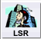 | LSR Administration Form
   | End User Information Form
   | Loop Service Form
  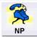 | Number Portability Form
   | Loop Service with Number Portability Form
   | Resale Service
   | Resale Private Line
  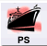 | Port Service
  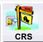 | Centrex Resale Service
  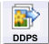 | DID / DOD / PBX Form
   | Hunt Group Information Form
  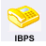 | ISDN BRI PRI Service Form
   | Directory Listing Form
   | Data Unified Form

Navigating within the Created Order | Once the order is created, any LSR form that could be generated with the Service selected is displayed for the user. The first screen visible for the user will be the LSR form. This is the main ADMIN form available for every order type. Users will notice that some of the fields have been highlighted in yellow. The fields selected for highlighting is a vendor choice. There should not be any assumption made that the field would be required or prohibited for the created order.  Users will have the ability to click on the various forms to easily move within the form. To move within a specific form, users can use the TAB key to move between the fields. Users can also take their cursor and click on a field to move directly to a specific field.

Entering the field data | Entry in the EASE VFO fields can be submitted in one of three formats:
  Method | Used For
  Keystroke | Direct entry into a field. Users should use UPPERCASE for all field entry.
  Drop-Down menu | EASE VFO will provide a valid list of possible entries. Users should select one of the options displayed.
  Calendar Selection | Users have the option in date formatted fields to use the calendar () ICON to select a specific date. When the ICON is clicked, a calendar will be displayed allowing the user to select a specific date.  Upon selecting a specific date, the date will be formatted to the field format expected.

Viewing the Field Help Text | Help text is available for each field once in an order in EASE VFO. As a user navigates thru the various field, formatted field help text is displayed in a pale-yellow box at the bottom of the screen. This text provides a brief field definition, field format and an example of the field entry.  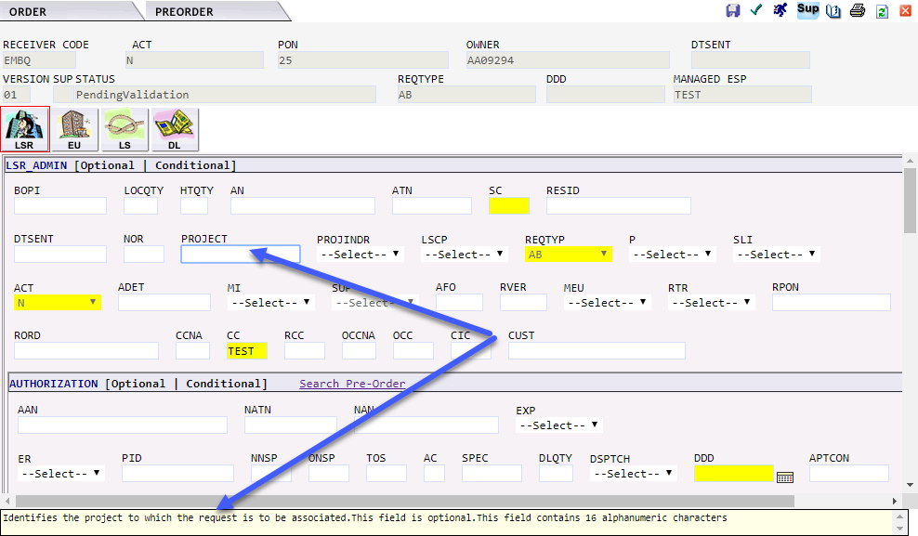

Hyperlinking to Pre-order Capability | Within the EASE screens, hyperlinks have been added that allow the user to link to the EASE Pre-Order Screen to view a saved Pre-Order response.  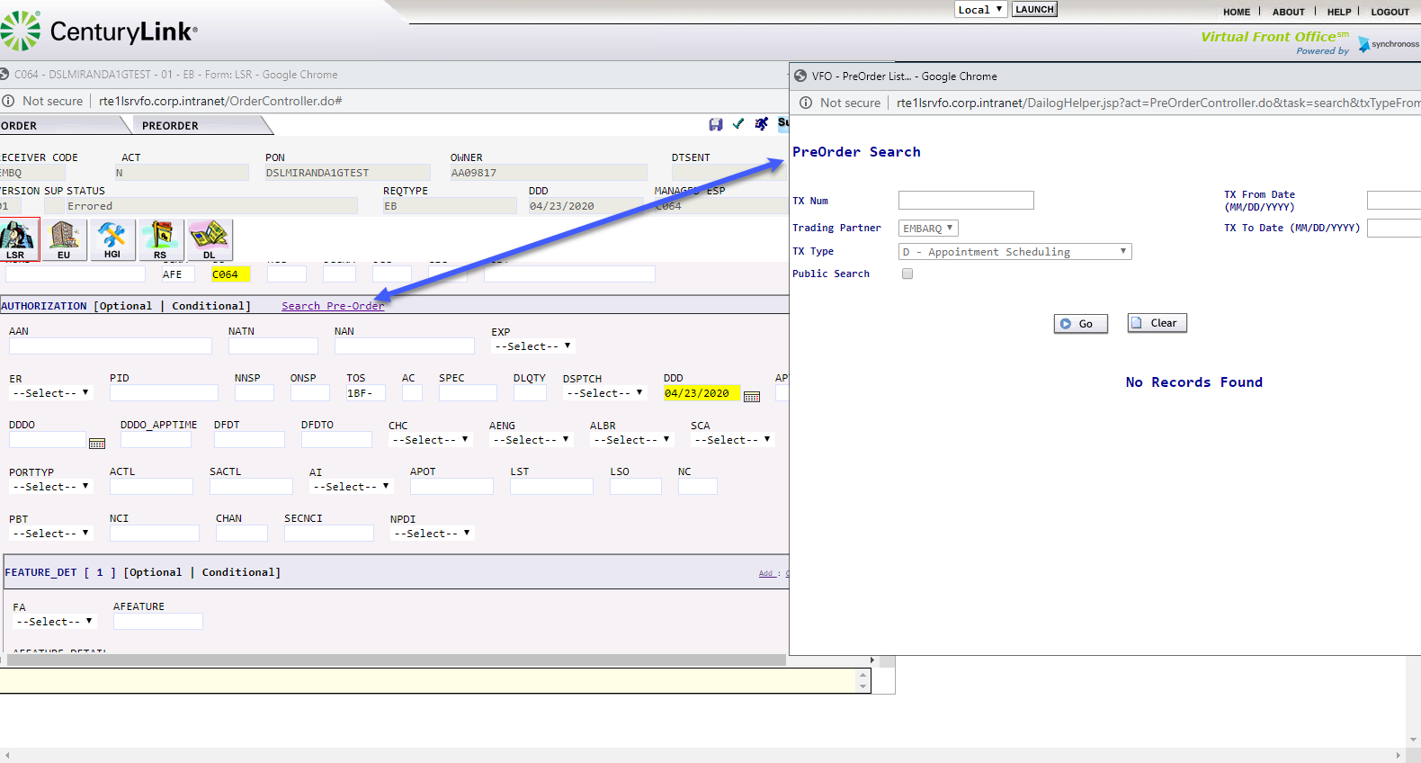

Adding a new section in EASE | EASE can add in sections to a pending order. The option will be displayed on the right-hand side of the order when available. The fields added will be blank and not contain any values.  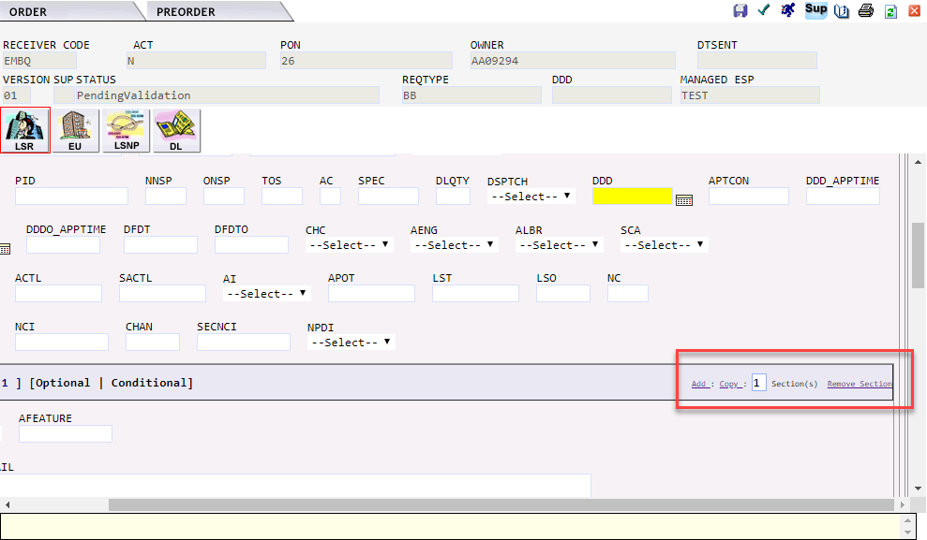  To add a new section, follow the steps below
  Step | Action
  1 | Click on the hyperlink. The default will be 1 section. To increase the number to be added, change the value to the quantity desired.
  2 | The new section(s) will be added directly below the existing section.

Copying a new section in EASE | EASE can COPY additional sections to a pending order. The option will be displayed on the right-hand side of the order when available.  To copy a section, follow the steps below
  Step | Action
  1 | Click on the hyperlink. The default will be 1 section. To increase the number to be added, change the value to the quantity desired.
  2 | The copied section(s) will be added directly below the existing section.

Deleting section(s) in EASE | EASE can REMOVE sections to a pending order. The option will be displayed on the right-hand side of the order when available.  To copy a section, follow the steps below
  Step | Action
  1 | Click on the hyperlink.
  2 | The section(s) will be removed from the pending order. This action cannot be undone. If an entire section is removed in error, the order will need to be voided and re-entered.

Validating the order | Clicking the validate button will allow the user to validate the order entries. This can be done at any time during the order entry and display all initial errors regarding to the LSR field entry.

Viewing the order errors | After an order has been validated, EASE VFO will display an associated order errors in a new pop-up window.  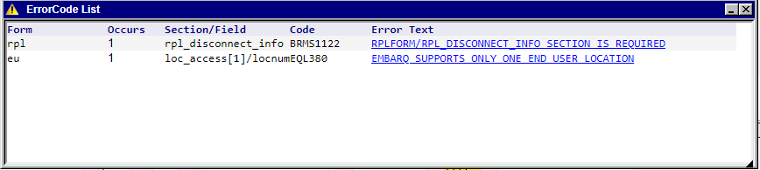
  Column | Description
  Form | Identifies the specific form where the field/error occurs
  Occurs | How many times this error occurred during a specific validation
  Section/Field | The Field/Section the error is located in
  Code | The associated error code.
    Error Starts with | Will be
    RTE….. | Industry Standard edit
    G….. | Industry Standard edit
    #### | Industry Standard edit
    BRMS…. | CenturyLink specific edit for field entry
    CTLV | CenturyLink JMS error
  Error Text | This contains the error message.

Resolving the errors | Each error will have a blue hyperlink displaying the Error Text. Users can click on this hyperlink and expect one of two options to occur:  In either instance, once the error has been viewed, the blue hypertext will be change to purple.  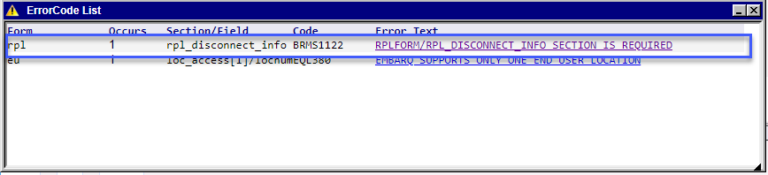  Users can use the scroll bar on the far-right hand side to scroll thru all the returned errors.  Please note: Users may receive additional errors as additional fields are entered and information corrected/ removed.
   | What will occur
  Manually navigate to the field | The user will receive a pop-up box stating that they must manually search for the first occurrence of the field.  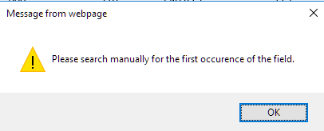
  Jump to the field in error | The user will be directed to the field in error on the screen. The field in error will be highlighted in RED and the cursor will be automatically directed to the first character in the field.  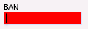

Validate within the order | Some fields within EASE VFO to validate the entered information. When available, users will see Validate as a hyperlink beside the field or following a section name.  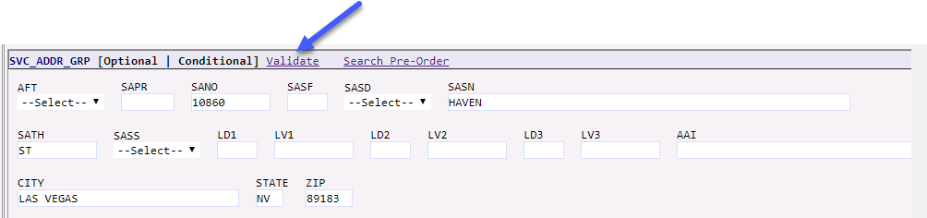  After entering the information in the field or section, users can click on the Validate hyperlink. EASE VFO will automatically initiate the appropriate PREORDER inquiry.  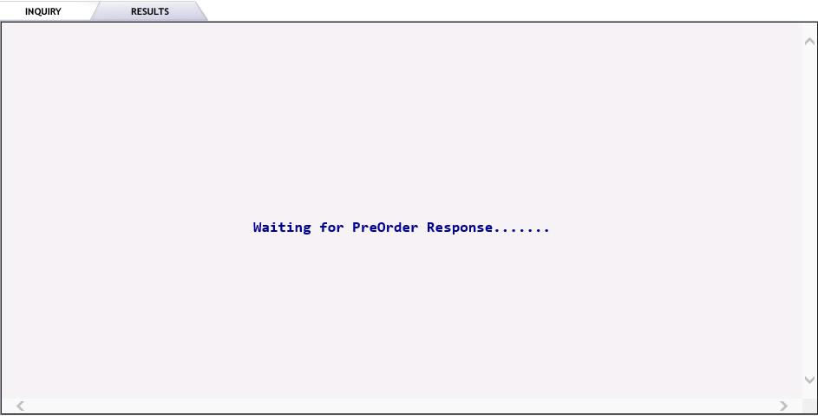  When the inquiry is complete, users will see the results for the inquiry.  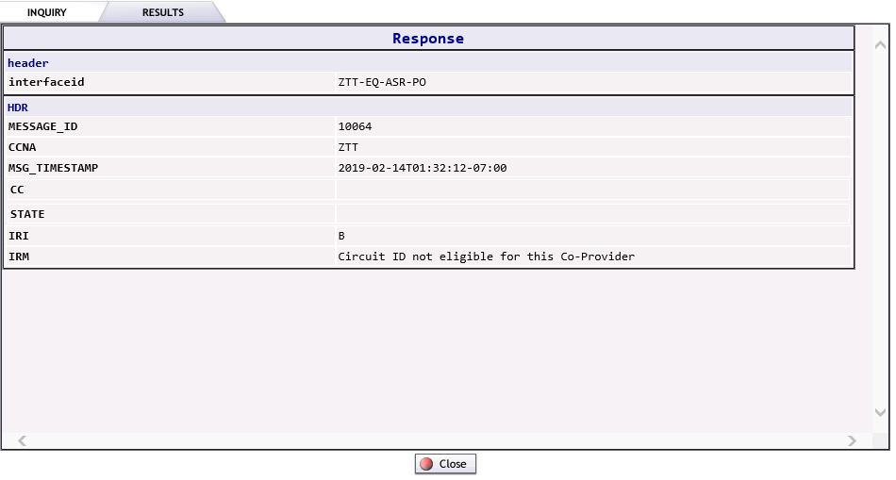  Depending on the inquiry / response, users may have the option to close the inquiry or transfer the validated information directly back into the pending order.

Search Pre-Order | This option allows the user to preform Pre-Order validations.  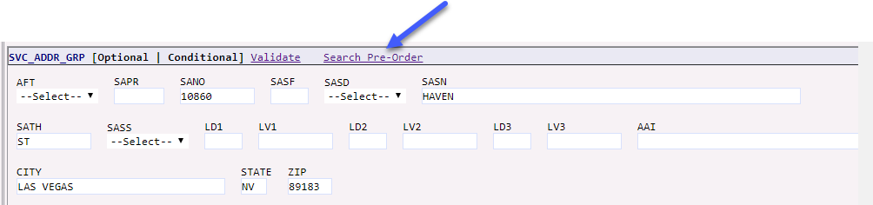  For details on how to preform Pre-Order searches, please see the PreOrder tab provided in this document.

Submitting the Order | Once all errors on the order have been resolved, the order status will be altered to validated.  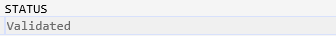  To submit the pon, users can choose a submit option from the order tab or click on the SUBMIT ICON. The system will revalidate the order and submit the order to CenturyLink. If no errors exist, users will see the order STATUS field changed to Submitted.  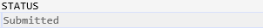

Appendix 1 - Order Status

The matrix below defines the various Order Status values, definition and user action for each status.

Status | Definition | Send/Rcv or Receive | User Action
Accepted | The Access Provider (Trading Partner) has received the order and sent a positive acknowledgement for the order. Exchange Path has updated the status, stored the message in the Exchange Path database, and sent a notification message to VFO to update the status. The LSR has passed fatal validations and will begin the order processing process. | Send/Rcv | Order will begin CenturyLink provisioning process.
Accepted | The Access Provider (Trading Partner) has received the order and it has passed fatal validations. | Receive | The response goes to Accept Submitted, so it can be transmitted to the order originator.
Accepted Sent | The Accepted response has been transmitted to the LSR originator. | Receive | The user can create and submit.
Accepted Submitted | The Accepted response is sitting in queue waiting to be transmitted to the LSR Originator. | Receive | Once the Accepted status has been transmitted, the status is changed to Accepted Sent.
Accepted System Errored | The Accepted response could not be transmitted to the LSR originator. | Receive | Once the system errors have been resolved, the Accept response can be Submitted again.
Cancel Accepted | The AP has returned a positive acknowledgement of canceling an LSR. Exchange Path has updated the status, stored the message in the Exchange Path Database, and sent a notification message to VFO. | Sent/Rcv | No Action
Cancel Received | The Cancel request has been received by the AP. | Send/Rcv | No Action
Cancel Rejected | The AP has returned a negative rejection acknowledgment for a cancellation. | Send/Rcv | View the reject reason and take the recommended action.
Cancel Resent | The Cancel request has been resent. | Send/Rcv | No Action
Cancel Sent | A Cancel request has been sent to the AP. | Send/Rcv | No Action
Cancel Submitted | The Cancel request has been sent to Exchange Path (behind the scenes EASE interface) for validation and subsequent processing. | Send/Rcv | No Action
Cancel Tracked | An order that is for tracking only has been cancelled. | Send/Rcv | No Action
Cancelled | The order has been supplemented with a cancel request. | Send/Rcv | No Action
Clarification Submitted | The Clarification response is sitting in queue, waiting to be transmitted to the LSR originator. | Receive | Once the Clarification response has been transmitted, the status is sent to Clarification Sent.
Clarification | The AP has initiated a Clarification message. Exchange Path has updated the status, stored the message in the Exchange Path Database, and sent a message to VFO to update the status. | Send/Rcv | Review the Clarification and take the recommended action.
Clarification Cleared Invalidated | The Trading Partner has returned a Clarification Cleared message for the Access Order and Exchange Path has sent a notification message to VFO to update the status. | Send/Rcv | No Action
Clarification Cleared Invalidated | The AP has initiated a Clarification Cleared message for the order, but the Clarification was not validated. | Send/Rcv | No Action
Clarification Cleared Saved | The Clarification Cleared has been cancelled and a response notification has been created and saved by the user in VFO | Receive | A Clarification Cleared response is submitted by the user.
Clarification Cleared Sent | The Clarification Cleared response has been transmitted to the LSR originator. | Receive | The user can create and submit any of the subsequent statuses.
Clarification Cleared Submitted | The Clarification Cleared response is sitting in que waiting to be Transmitted to the LSR originator. | Receive | One the Clarification Cleared response has been transmitted, the status is changed to Clarification Cleared Sent.
Clarification Cleared System Errored | The Clarification Cleared response could not be transmitted to the LSR originator. | Receive | Once the system errors have been resolved, the Clarification Cleared response can be submitted again.
Clarification Invalidated | The AP has initiated a Clarification message for the order, but the clarification was not validated. | Send/Rcv | Review the Clarification and take the recommended action.
Clarification Sent | The Clarification response has been transmitted to the LSR originator. | Receive | Review the Clarification and take the recommended action.
Clarification System Errored | The Clarification response could not be transmitted to the LSR originator. | Receive | Once the system errors have been resolved, the Clarification cleared response can be submitted again.
Clarification Validated | The Clarification has been initiated and validated, but not sent or submitted. (It is viewable online, but will not be sent back via e-mail, fax, or batch.) | Receive | Submit the Clarification.
Clarification Saved | There are issues/questions about an LSR and a Clarification response has been created and saved by the user in VFO. | Receive | The Clarification response is submitted by the user. Review the Clarification and take the recommended action.
Complete Sent | The Completed response has been transmitted to the LSR originator. | Receive | No further updates are allowed once the order is a Completed Sent status.
Completed | The VFO user has manually updated the LSR status to Completed or the AP has initiated a Completed message. | Send/Rcv | Review Response
Completed Invalidated | The AP has initiated a completion message, but the completion was not validated by the internal EP system. | Receive | No Action
Completed Submitted | The Completed response is sitting in queue, waiting to be transmitted to the LSR originator. | Receive | Once the Completed response has been transmitted, the status is changed to Completed Sent.
Completed System Errored | The Completed response could not be transmitted to the LSR originator. | Receive | Once the system errors have been resolved, the Completion response can be submitted again.
Completion Saved | The LSR has been Completed and a response has been created and Saved by the user in VFO | Receive | The Completed response is submitted by the user.
Confirmed | The AP has returned a Confirmation message for the order. Exchange Path has updated the status, stored the message in the EP database, and sent a notification message to VFO to update the status. | Send/Rcv | Review Response
Confirmed Saved | The Confirmation response has been created and saved by the user in VFO. | Receive | The Confirmed response is submitted by the user.
Confirmed Sent | Indicated that the Confirmed response has been transmitted to the LSR originator | Receive | User can create and submit any of the subsequent statuses.
Confirmed Submitted | The Confirmed response is sitting in queue, waiting to be transmitted to the LSR originator. | Receive | Once the Confirmed response has been transmitted, the status is changed to Confirmed Sent.
Confirmed System Errored | The Confirmation response could not be transmitted to the LSR originator. | Receive | Once the system errors have been resolved, the Confirmed response can be submitted again.
Design Order Confirmed | The AP has returned a Design Order Confirmation message for the order. Exchange Path has sent a notification message to VFO to update the status. | Send/Rcv | Review Response
Design Order Confirmed Saved | The DOC response has been created and saved by the user in VFO. | Receive | The DOC response is submitted by the user.
Design Order Confirmed Sent | The DOC response has been transmitted to the LSR originator. | Receive | The user can create and submit any of the subsequent statuses.
Design Order Confirmed Submitted | The DOC response is sitting in queue waiting to be transmitted to the LSR originator. | Receive | Once the DOC response has been transmitted, the status is changed to Design Order Confirmed Sent.
Design Order Confirmed System Errored | The DOC response could not be transmitted to the LSR originator. | Receive | Once the system errors have been resolved, the DOC response can be submitted again.
DLR Saved | The DLR response has been created and saved by the user in VFO. | Receive | The DLR response is submitted by the user.
DLR Sent | The DLR response has been transmitted to the LSR originator. | Sent | The user can create and submit any of the subsequent statuses.
DLR Submitted | The DLR response is sitting in queue, waiting to be transmitted to the LSR | Receive | Review Response
DLR System Errored | The DLR response could not be transmitted to the LSR originator. | Receive | Once the system errors have been resolved, the DLR response can be submitted again.
DLR/Design | The AP has returned a DLR for the order. Exchange Path has updated the status, stored the message in the EP database, and sent a notification message to VFO to update the status. | Send/Rcv | Review Response
Errored | The LSR has failed the validation process. Exchange Path has updated the Request Status, stored the LSR, and sent an Error Notification to VFO. | Receive | Correct the error and validate again.
Jeopardy | Jeopardy status indicates that there are situations that may jeopardize critical dates of the LSR. | Send/Rcv | Review the Jeopardy and take the recommended action.
Jeopardy Invalidated | The Jeopardy was initiated and not validated. (It is viewable online, but will not be sent back via e-mail, fax, or batch. | Receive | Validate and submit the Jeopardy response.
Jeopardy Saved | The FOC date is in jeopardy and a response has been created and saved by the user in VFO. | Receive | The Jeopardy response is submitted by the user. Review the Jeopardy and take the recommended action.
Jeopardy Sent | The Jeopardy response has been transmitted to the LSR originator. | Receive | The user can create and submit any of the subsequent statuses.
Jeopardy Submitted | The Jeopardy response is sitting in queue waiting to be transmitted to the LSR originator. | Receive | Once the Jeopardy response has been transmitted, the status is changed to Jeopardy Sent.
Jeopardy System Errored | The Jeopardy response could not be transmitted to the LSR originator. | Receive | Once the system errors have been resolved, the Jeopardy response can be submitted again.
Jeopardy with Errors | Indicates there are situations that may jeopardize critical dates of the LSR and there are errors with the request. | Send/Rcv | Review the Jeopardy and take the recommended action.
Jeopardy with Errors Invalidated | The Jeopardy was initiated, not validated, and contains errors. | Send/Rcv | Validate and submit the Jeopardy response.
Jeopardy with Errors Saved | The FOC date is in Jeopardy due to errors on the LSR and a response has been created and saved by the user in VFO. | Receive | The Jeopardy with Errors response is submitted by the user.
Jeopardy with Errors Sent | The Jeopardy with Errors response has been transmitted to the LSR originator. | Receive | The user can create and submit any of the subsequent statuses.
Jeopardy with Errors Submitted | The Jeopardy with Errors response is sitting in queue waiting to be Transmitted to the LSR originator. | Receive | Once the Jeopardy with Errors response has been transmitted, the status is changed to Jeopardy with Errors Sent.
Jeopardy with Errors System Errored | The Jeopardy with Errors Response could not be transmitted to the LSR originator | Receive | Once the system errors have been responded, the Jeopardy with errors response can be submitted again.
Pending Completion | The Exchange Path Monitor process determines that a Completion Notice has not been received in the time allotted and issues a notification message to VFO to update the status | Send/Rcv | Contact the AP to find out the cause of the delay in response.
Pending Confirmation | The Exchange Path Monitor process determines that the Firm Order Confirmation (FOC) has not been received in the time allotted and issues a notification message to VFO to update the status. | Send/Rcv | Contact the AP to find out the cause of the delay in response.
Pending Design | The Exchange Path Monitor process determines the DLR or Design information has not been received in the time allotted and a notification message is sent to VFO to update the status. | Send/Rcv | Contact the AP to find out the cause of the delay in response.
Pending Response | The Exchange Path Monitor process determines a Response has not been received in the time allotted and a notification message is sent to VFO to update the status. | Send/Rcv | Contact the AP to find out the cause of the delay in response.
Pending Validation | An initial request or a change to a request (other than Cancel) has been created, but the request has not been sent to Exchange Path for validation or submission to the AP. After selecting Submit or Validate, the resulting response from Exchange Path will be Validated or Errored. | Send/Rcv | Finish entering the order and submit.
Received | This status appears when service requests are sent to VFO for processing. This indicates the customer’s request has been received. | Send/Rcv | The Accept response is generated by the system if fatal validations are passed.
Rejected | The AP has returned a negative (rejection) acknowledgment. Exchange Path has updated the status, stored the message in the Exchange Path Database, and sent a notification message to VFO to update the status. | Send/Rcv | Review the response and take the recommended action.
Resent | Another copy of the last submitted version of the LSR is sent to the AP. | Send/Rcv | No Action
Sent | The order is sent to the AP, the status is updated, and a notification message is sent to VFO to update the status. | Send/Rcv | No Action
Sent Failed | An attempt to send the order to the AP fails. | Receive | Try to send the order again.
Submitted | This status indicates that an initial request or a change to a request has been sent to the AP for validation and subsequent processing—status does not apply to a cancel request. | Send/Rcv | No Action
Supplement Received | The customer has sent a supplement to the previously received service request. | Send/Rcv | The Accept response is generated by the system if fatal validations are passed.
Supplemented | The order has been supplemented. | Receive | No Action
System Errored | VFO has received a system error message from Exchange Path. | Send/Rcv | Read the error message, correct it, and submit the order again.
TP Cancelled | The Access Provider has cancelled the customer’s order due to no response to a Clarification/Notification Request. | Send/Rcv | Create a new order if one is still needed.
TP Cancelled Invalidated | The AP (also known as the Trading Partner (TP)) has cancelled the customer’s LSR due to no response to a Clarification/Notification Request (internal EP did not validate cancellation). | Receive | Create a new order if one is still needed.
TP Cancelled Saved | The LSR is being cancelled by the Access Provider because Clarifications have not been resolved and a response has been created and saved by the user in VFO | Receive | The TP Cancelled response is submitted by the user.
TP Cancelled Sent | The TP Cancelled response has been transmitted to the LSR originator. | Receive | The user can create and submit any of the subsequent statuses.
TP Cancelled Submitted | The TP Cancelled response is sitting in queue waiting to be transmitted to the LSR originator. | Receive | Once the TP Cancelled has been transmitted, the status is changed to TP Cancelled Sent.
TP Cancelled Submitted | The TP Cancelled response is sitting in queue waiting to be transmitted to the LSR originator. | Receive | Once the TP Cancelled response has been transmitted, the status is changed to TP Cancelled Sent.
TP Cancelled System Errored | The TP Cancelled response could not be transmitted to the LSR originator. | Receive | Once the system errors have been resolved, the TP Cancelled response can be submitted again.
TP Errored | The Trading Partner has returned one or more error messages for the order. Exchange Path has updated the status, stored the message in the Exchange Path Database, and sent a notification message to VFO to update the status. | Send/Rcv | Review the response and take the recommended action.
TP Errored Saved | The LSR has validation errors and a response has been created and saved by the user in VFO. | Receive | The TP Errored response is submitted by the user.
TP Errored Sent | The TP Errored response has been transmitted to the LSR Originator. | Receive | The user can create and submit any of the subsequent statuses.
TP Errored Submitted | The TP Errored response is sitting in queue waiting to be transmitted to the LSR originator. | Receive | Once the TP Errored response has been transmitted, the status changes to TP Errored Sent.
TP Errored System Errored | The TP Errored response could not be transmitted to the LSR originator. | Receive | Once the system errors have been resolved, the TP Errored response can be submitted again.
Tracked | The order was initiated as a “Tracking Only” request and is not be transmitted to the AP. This is used when the order was sent manually outside of VFO and user wants to track the order progress manually in VFO. | Send/Rcv | No Action
Validated | This indicates that an order has been successfully validated and there are no errors. | Send/Rcv | No Action
Voided | An order that was never submitted can be voided to indicate that the order should not be transmitted to the AP. | Send/Rcv | No Action

Appendix 2 - Order Types

The Order Type matrix below provides the Request/Order Type, CenturyLink product, EASE VFO Form, and Notes.

Request/Order Type | CenturyLink Product | EASE VFO Forms | Notes
AB – Loop | IMA PRODUCTS  - Enhanced Extended Loop (EEL)  - Line Sharing / Shared Loop Line Sharing  - Unbundled Distribution Loop (UDL)  - Unbundled Feeder Loop (UFL)  - Unbundled Local Loop  - Unbundled Local Loop Split  CENTURYLINK PRODUCTS | LSR  EU  LS  DL
BB – Loop with Number Portability | - Unbundled Distribution Loop (UDL/Local Number Portability (LNP)  - Unbundled Local Loop / Local Number Portability (LNP)  - Unbundled Local Loop Split / Local Number Portability (LNP) | LSR  EU  LSNP  DL
CB – Number Portability | - Local Number Portability (LNP) | LSR  EU  NP  DL
DB – Retail / Bundled |  | LSR  EU  HGI  RS  PS  DL
EB – Resale / Data Unified | CENTURYLINK PRODUCTS  - Resale – POTS, RCF, Key, PBX | LSR  EU  HGI  RS  DL  DU
FB – Unbundled Local Switching (PORT) | CENTURYLINK PRODUCTS  - ISP | LSR  EU  HGI  PB  DL
JB – Directory Listings and assistance | - Directory Listings and Assistance | LSR  EU  DL
KB – Resale Private Line | - Resale – Private Line Transport (PLT) – non switched | LSR  EU  RPL  DL
LB – Resale Frame Relay |  |  | GRANDFATHERED
MB – Combined Loop and unbundled Local Switching (PORT) | - UNE-P Centrex 21  - UNE-P Centrex 21 – SPLIT  - UNE-P Centrex PLUS  - UNE-P Centron  - UNE-P POTS  - UNE-P POTS – SPLIT  CENTURYLINK PRODUCTS  - LWS – POTS, Key, PBX, Centrex | LSR  EU  HGI  RS  CRS  DL
NB – DID/DOD/PBX | - Resale – DID IN only Trunks  - Resale – PBX Trunk Service  - Resale – PBX Trunk Service – Designed  - UNE-P PBX/DID Trunks  - UNE-P PBX Trunks | LSR  EU  HGI  DDPS  DL
PB – CENTREX Resale | - Resale – Centrex 21  - Resale – Centrex PLUS and Centron  CENTURYLINK PRODUCTS  - Resale Centrex  - Centrex | LSR  EU  HGI  CRS  DL
QB - ISDN | - Resale – ISDN BRI  - Resale – ISDN PRI Facility  - Resale – ISDN PRI Trunks  - UNE-P ISDN BRI | LSR  EU  HGI  IBPS  DL
ZB - BULK | - BULK | LSR  EU

Appendix 3 – EASE UOM Implementation Guidelines

Initial Communication | The initial communications phase will be considered complete with an agreement to either move forward with an implementation or to suspend or halt progress due to limitations on the CLEC/IXC/WSP side. This agreement and rationale will be documented in the meeting minutes by the project manager. Additional team meetings will be held as agreed upon.

Project Plan Development / Negotiation | An Implementation/Migration Project Plan represents the milestones and responsibilities of all parties throughout the planned EASE implementation process. These milestones will be mutually agreed upon. Regularly scheduled conference calls will be conducted as needed to review progress, answer questions, and identify and communicate resolution of issues. The assigned project manager will be responsible for maintaining and monitoring progress within the Project Plan. A mutual negotiation and approval process will be used to manage changes to schedules as recommended or required by either party. All parties will give sufficient advance notice to the other party to allow adequate analysis of the impact of any proposed schedule changes.  The inability of either party to meet any of the milestones contained in the Implementation Project Plan/Industry Upgrade Test Plan on the date(s) identified may result in the need to renegotiate a revised Project Plan/Test Plan. All revised plans will be developed based on the availability of resources from within the respective organizations and may contain dates that are substantially different from those described in the original plan.  The development of, and agreement to, a formal Implementation/Migration Project Plan is the pre-requisite to continuing to the remaining Implementation Process activities.

Project Plan Development / Negotiation Activities | The following activities will occur during the Project Plan development and approval process:  - CenturyLink IPM will provide a draft project plan for the customer’s review.  - Project plan will contain all of the milestones that are required for either a new implementation of a LSOG release, or a migration of an existing customer to the next lSOG industry release.  - The customer will review the proposed project plan and ask any questions about the content of the plan  - The IPM will work with the customer to incorporate changes to the project plan and reissue, if necessary, for a final review and approval.  - The customer will review the final project plan proposal and approve it when there is mutual agreement with the plan. This will be the final approved project plan for the implementation/migration.

Requirements Review | A critical factor in a successful implementation is a thorough understanding by the CLEC/IXC/WSP of EASE. The requirements review phase of implementation will provide the CLEC/IXC/WSP with an opportunity to develop a clear understanding of these requirements. This review is critical to the customer who must:  - Develop and define the business processes and procedures necessary to support the use of their LSR interface for transactions.  - Develop the appropriate documentation (i.e., Methods and Procedures) necessary to support the use of EASE by CLEC/IXC/WSP personnel.  - Perform any necessary database gap analysis for the purpose of ensuring that all data fields that carry the LSR information can be successfully populated.  - Identify appropriate data values.  - Select Pre-Order transactions to support the intended products to be ordered through the Gateway.  - NOTE: CenturyLink strongly recommends the use of Pre-Order transactions to assist CLECs/IXCs/WSPs in achieving Order content accuracy, reducing rejection rates, and improving Service Order flow-through. Pre-Order transactions can be submitted via EASE. Information on the use of EASE is documented on the CenturyLink Wholesale website at: http://www.centurylink.com/wholesale/systems/ossconsolid.html.

Requirements Review Activities | While it is the CLEC/IXC/WSP’s responsibility to perform a thorough review of all CenturyLink requirements, CenturyLink will provide support to clarify issues and answer questions regarding EASE business rules, requirements, and the Implementation Process. CenturyLink recommends the following process to ensure that the CLEC/IXC/WSP has a thorough understanding of the answers to each question:  - The CLEC/IXC/WSP reviews CenturyLink requirements as documented in the CenturyLink Specific Business Rules document and other documents listed in the “CenturyLink Document Overview” section of this document.  - Questions arising from the CLEC/IXC/WSP’s review of LSR requirements will be captured on a Question Log by the CLEC/IXC/WSP.  - The Question Log, with questions populated by the CLEC/IXC/WSP, will be submitted to CenturyLink.  - CenturyLink will either provide a response to the question or identify those questions requiring further investigation and research.  - CenturyLink will provide answers to outstanding questions and the CLEC/IXC/WSP will update the log to reflect their understanding of the answers provided.  - CenturyLink will review the answers entered by the CLEC/IXC/WSP in the log after which the CLEC/IXC/WSP may indicate that a question may be closed if it has been adequately answered.  If this process becomes cumbersome to a CLEC/IXC/WSP, the process can be negotiated to allow the customer and CenturyLink to work together most efficiently while maintaining their ability to thoroughly understand the answers to the questions.  The Requirements Review phase of the implementation will be considered complete when the CLEC/IXC/WSP determines that they have adequately reviewed all of CenturyLink’s requirements documentation and have a thorough understanding of them. This understanding will be critical to the effective development of the customer’s interface with CenturyLink.  The CLEC/IXC/WSP may decide to continue use of the Question Log throughout the implementation.

Establishing Connectivity Testing Activities for EASE VFO | CenturyLink UOM XML Pre-Order tools are available on the public internet through a secured (SSL) connection. Security is provided by the industry-standard Basic authentication method (Base-64 encoded).  For a CLEC/IXC/WSP to gain access to the CenturyLink UOM XML Pre-Order tools, a user account needs to be created, including a negotiated user name and password combination. After a CenturyLink administrator creates the user account, the CenturyLink UOM Pre-Order tools become immediately available.  The Implementation Manager will work with the CLEC/IXC/WSP to agree upon the user name and password that will be used for Pre-Order access. The Implementation Manager will also work with the appropriate internal organizations to create the user account in the Pre-Order system and then test access with the CLEC/IXC/WSP.  The Connectivity Phase will be considered complete when continuity tested between the end to end applications. This does not guarantee that specific order/pre-order transactions can be transmitted successfully from the customer to CenturyLink. It simply establishes that connectivity is proved between the two companies.

Implementation/Industry Upgrade Testing Process | The Implementation/Industry Upgrade Testing process is as follows:  - CenturyLink and the customer will agree on a test plan for the implementation/migration  - The CenturyLink test environment will be available for testing during posted times.  - The CLEC/IXC/WSP submits test transactions, according to the agreed-upon test plan.  - CenturyLink generates the responses dependent on the transaction passing the edits.  - A call may be scheduled (typically on an as needed basis) to provide an opportunity for CLEC/IXC/WSP and the CenturyLink testing representative to interact and discuss the testing results. Testing communication may also be done via email if unattended testing is selected.  The Test Phase will be considered complete when the CLEC/IXC/WSP has successfully tested the Test Plan scenarios in the test environment for new implementation and/or the Industry Upgrade cut-over has occurred.

Implementation/Industry Upgrade Testing Activities | - CenturyLink will notify the customers when the test window will be for Industry Upgrades. The CLEC/IXC/WSP will call CenturyLink to schedule their testing period within the overall test window.  - For new Implementations, the Project Plan will determine when testing will occur.  - The customer submits a proposed test plan which includes the number and types of LSRs which will be submitted for testing.  - Purchase Order Numbers (PON) and REQTYPs to be tested will be part of the plan as well as how many/which one will need a Firm Order Confirmation (FOC) upon completion.  - Proposed test plans may follow industry guidelines or be of the customer’s own creation. There are no minimum test requirements, however for a new implementation, it is suggested that all REQTYPs be tested that will be in production.  - The CLEC/IXC/WSP will notify the IPM when they begin sending in order files for testing.  - The IPM will track incoming files and notify the customer of the status of the test scenarios.  - When Business Processing Layer (BPL) errors occur, the IPM will notify the customer and provide any assistance to them to resolve the issue.  - All test scenarios submitted from the plan will receive successful acknowledgments from CenturyLink.  - The customer will request when they want to receive any FOCs from the test plan. The IPM will advise the customer when the FOC is ready and a new file will be required from the customer to trigger the FOC back to them.  - The customer may notify the IPM when an error they receive does not follow OBF standards. The IPM will research the error and if a bug is determined by the technical team, CenturyLink will determine when the bug will be fixed. CenturyLink will notify the CLEC/IXC/WSPs of any such bugs that do not get fixed during the test process.

Test Plan | Test Planning will begin approximately two weeks prior to the start date of testing where the following will be reviewed and determined:
  Plan Criteria | Definition
  Test Case Creation: | It is expected that test cases will be documented that are required for successful test execution of LSR UOM capability. These test cases will be used as the basis for a successful testing phase..
  Test Case Execution Window: | Test cases will be executed during a defined testing window. This will be a mutually agreed upon time period. For example. 8-12 AM CST or 1-5 PM CST. This will ensure all resources are available during the planned testing timeline.
  Testing Success Rate: | Goal for execution and pass rate should be mutually determined during Test Planning.
  Testing Communications | During planning, the method, timing and frequency of communications for testing should be determined by CenturyLink and the customer. Periodically, CenturyLink refreshes the test databases, which may require CenturyLink to provide new test data.
  Testing Resources | Testing resources need to be confirmed prior to the start of testing. All testing resources should be readily available via phone, email or IM during the testing window. This will ensure testing stays on schedule and resolution incurs no delay.
  Testing Phases | During planning, the testing phases will be reviewed. Testing Phases include Connectivity, Systems and User Testing. These are detailed in the Test Execution Phase.
  Testing Timeline | During planning, the testing timelines should be solidified and confirmed for each phase. Guidelines are provided in the overall schedule section of this document.

Test Case Review | A review of the Test Cases to be executed should be held at least one week prior to the start of testing. The participants would be the Test Case creators and execution contacts from both companies. Test cases should cover all scenarios that would be executed through the UOM interface.
  Type of Testing | Definition
  System Testing | System Testing will be completed by CenturyLink to ensure core components are functioning prior to connectivity test start.
  Connectivity Testing | Connectivity testing is the first step to completing preparation for User Testing. Connectivity testing will ensure we have the interface connectivity setup correctly and transactions can be sent between CenturyLink and your company. It is critical that we have access to the individuals who can support and troubleshoot the Connectivity Testing. This is often where the entire process becomes delayed if not handled in a timely manner
  User Testing | User testing will be the execution of the User Created test plan. CenturyLink will be required to confirm transactions are received and responses are sent. This testing will be completed during the defined Testing Window.

Deployment Planning | Deployment Planning will begin approximately three weeks prior to the actual implementation date where the following will be reviewed and determined:
  Area | Description
  Detailed Project Plan | A detailed Project Plan will be created outlining the tasks, resources and timeframes for each activity to be completed during the implementation window. Both CenturyLink and the customer will be required to create one.
  Backout Plan | Each deployment plan will include a backout plan in the event an issue arises during deployment and/or testing that requires us to backout the changes.
  Implement Window | The implementation window will consist of an agreed upon timeframe of which the UOM code will be deployed into production. This is typically done after hours to avoid impact to any daily activities.
  Shakeout Testing | Testing will occur once the deployment is complete to ensure the new interface is working as designed and did not negatively impact the non-UOM business activities.
  Shakeout Testing Data | Data required for shakeout testing needs to be planned ahead of time to ensure adequate data for execution against the new UOM interface.
  Escalation | The Escalation point during Deployment will be through the CTL IT Primary POC who will then engage the CTL Business Escalation point. It is expected that the customer will utilize a similar process.
  Code Lock | It is customary to lock code one week prior to the actual deployment date. This allows time to finish preparation for implementation and ensures no hasty last minute changes jeopardize the success of the activities.
  GO/NO GO | A joint GO/NO GO meeting will be held with both CenturyLink and the customer to review the testing results, deployment planning readiness and provide the final GO or NO GO decision to implement the new UOM interface. This will be held at least 2 days prior to, and no more than five days prior to the actual deployment start.

Deployment Execution | There will be two issues covered during the Deployment execution:  Deployment Execution Communication: A joint conference bridge will be established at the start of the deployment activities. This will allow for easy communication between CenturyLink and the customer. All status and issues will be reported to this bridge. The bridge can be provided by either company.  Deployment Approval: Upon approval of the deployment and Shakeout testing activities, all key parties will gather on the joint bridge to discuss the status of the deployment. At this time, a GO/NO go decision will be made to move ahead with the new UOM interface.

Post Implementation Review | In order to ensure there are no production issues post initial deployment, post implementation meetings will be setup daily by the IT Main point of contact the week following to address any issues that may arise.

Milestones
Event/Milestone | Activities
Initial Customer Engagement Meeting | - Review UOM Implementation Process  - Identify IT/Business leads from customer and complete contact information  - Assess customer readiness/resource availability  - Discuss Next Steps
Joint Technical Meeting | - Confirm contact information  - Develop high-level schedule  - Discuss connectivity testing strategy/ time required  - Discuss technical requirements:  - Preferred connectivity option  - Connectivity Information  - Customer and CenturyLink - provide IP addresses; source/destination URLs (test and production environments)  - Type of security required
Timeline Confirmation Meeting | - Confirm customer timeline for implementation
Environment Readiness | - Interface/connectivity changes complete for CenturyLink and customer
Test Execution | - Connectivity & Application Testing  - Comparable support/troubleshooting contacts from the customer side
Deployment Planning | - Determine Implementation Window  - Consists of mutually agreed upon timeframe for production deployment. Typically done after hours to avoid impact to any daily activities.  - Develop Implementation Plan (Customer & CenturyLink)  - Should outline tasks, resource and timeframes for each activity/tasks to be completed during the implementation window.  - Develop Backout Plan  - Implementation plan will include a backout plan in the event an issue arises during deployment  - Escalation  - Escalation point during deployment will be through the CenturyLink IT contact.
Deployment Execution | - Deployment Execution Communication:  - A joint conference bridge will be established at the beginning of the deployment activities, to allow easy communication between CenturyLink and the customer.  - Upon approval of the deployment and verification testing activities, both companies will provide sign-off.
Post-Implementation Support | - To minimize and/or ensure that there are no production issues following the deployment, the EASE IT contact will monitor the daily activities of the new customer, for a minimum of 1 week, and address any issues that might arise.

